National Waterways Museum
Ellesmere Port
Access Statement
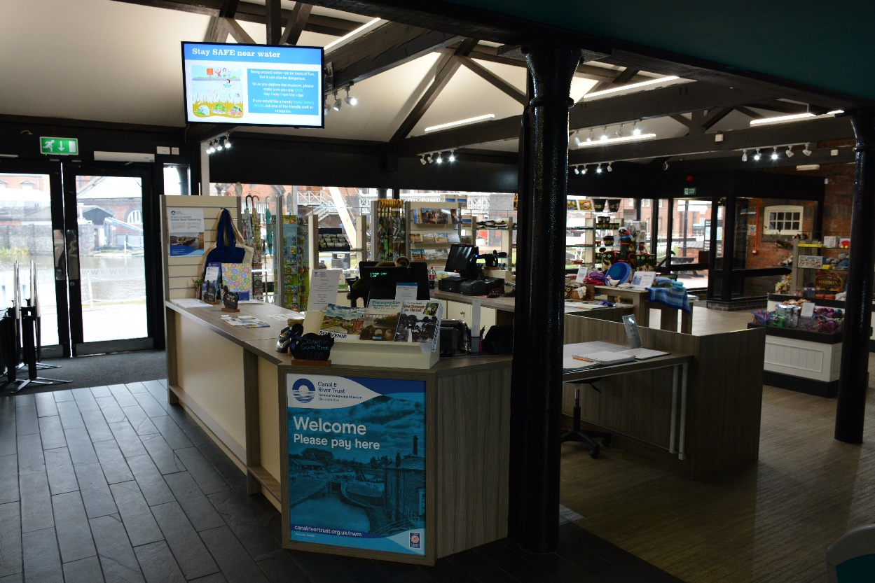

Contents
Introduction 3
3Pre-Arrival - Getting Here 3
Car Parking and Arrival 4
Main entrance 5
Toilets by reception 5
Reception Desk 6
Waterside Café 7
Shop 7
Introductory video room 8
Access into the museum 8
Slipway 8
Archives and Reading Room 12
Conference Centre including toilets 12
Blacksmith Forge 14
Education Centre 15
Power Hall 15
Old Gas Works 15
Stables 16
Pattern Shop 17
Locks 17
Toll House 18
Island Warehouse including toilets 18
Mossdale 24
Accessing Porters Row 24
Porters Row 26
Returning to reception 27

3

Introduction

The museum covers a 7.5 acre site with both indoor and outdoor exhibitions, some housed in listed buildings. The site is based on the working transhipment docks and the surfaces are uneven in places. We hope that this access statement will provide you with sufficient information prior to your visit so that you can have an enjoyable time. If there are areas which you think would be useful to include in this document please contact the museum.

Pre-Arrival - Getting Here

By train - The nearest train station is Ellesmere Port which is on the Liverpool to Ellesmere Port line via Birkenhead and Hooton and has connecting services to Chester. The station is 0.7 miles away – a 15 minute walk along pavements and passes through a subway under the M53. More details about the station and taxi services can be found at http://www.cheshirebytrain.co.uk/ellesmere-port/local-taxis/

By bus – Ellesmere Port bus station is 1.1 miles away – a 25 minute walk along pavements and passes through a subway under the M53. Local buses stop at nearer points – for more information, contact Traveline: 0871 200 2233.

By bike - the towpath alongside the Shropshire Union Canal runs right up to the museum. There is a bike rack facility available outside the museum.

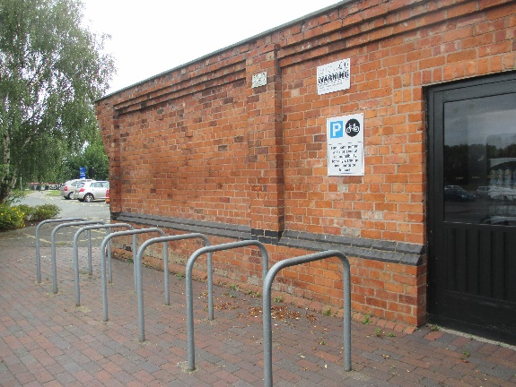

By boat - follow the Shropshire Union Canal all the way to the museum. We have some visitor moorings available in the docks

By road – follow the brown signs for Boat Museum. Once you have come off the M53 roundabout onto Oil Sites Road, look for the National Waterways Museum sign on the left-hand side and turn left into South Pier Road. The entrance to the car park is on the right-hand side opposite the museum entrance.

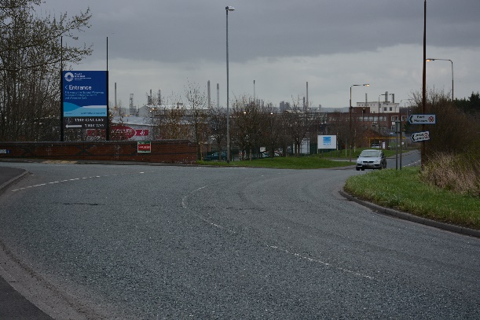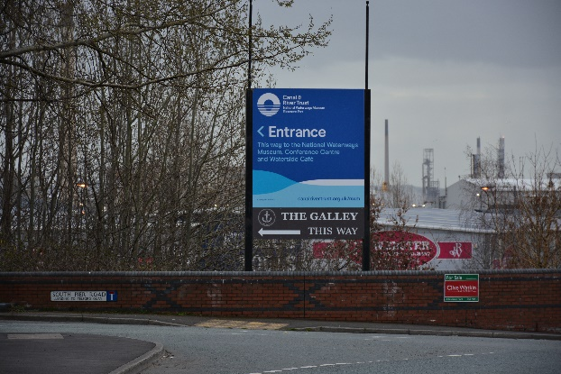

Car Parking and Arrival

There is a large visitor car park opposite to the main building with six accessible bays provided on the main visitor car park. In addition, there are seven accessible (Blue Badge) parking bays at the side of the road, approximately 50m from the museum with level access to the main doorway.

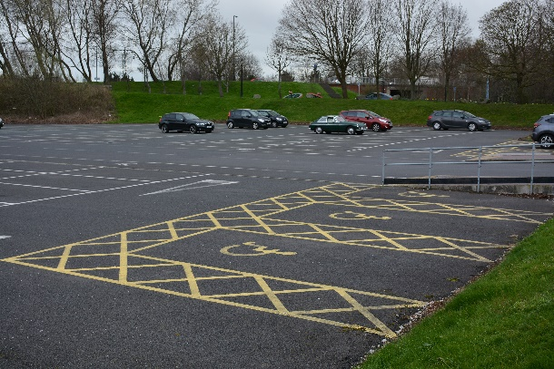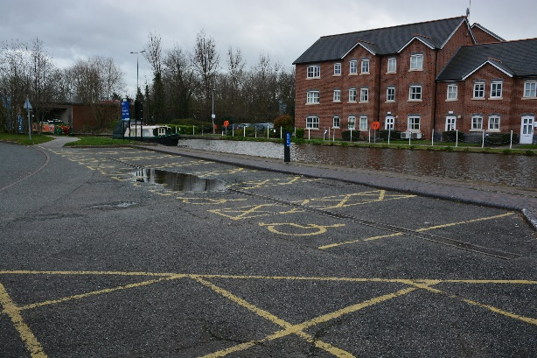
Main Car Park Disabled bays on road

The path from the road to the entrance of the museum is in slate and then becomes a composite resin flooring. On the left-hand side of the path towards the entrance to the museum, there is an electronic push pad to open the large automatic door into the museum. The height of the push pad is approximately one metre.

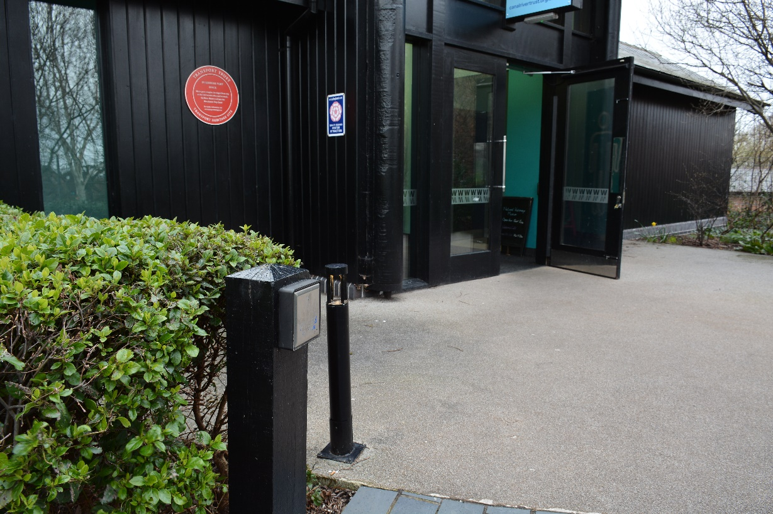

Main entrance

As you walk into the museum entrance, the flooring changes to a dark coloured mat which then moves into slate in the main area and cream tiles into the toilet areas.

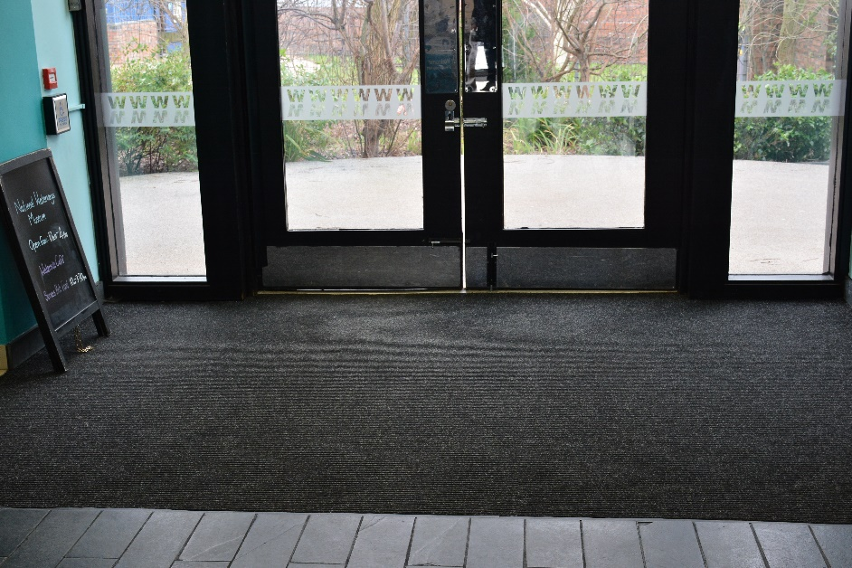

Toilets by reception

Inside the main doorway is an atrium with an accessible toilet facility on the left-hand side. To the right-hand side is a toilet facility with a pull-down changing station at a height of 86 cms.

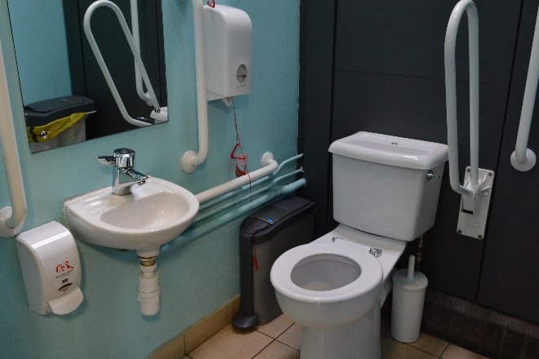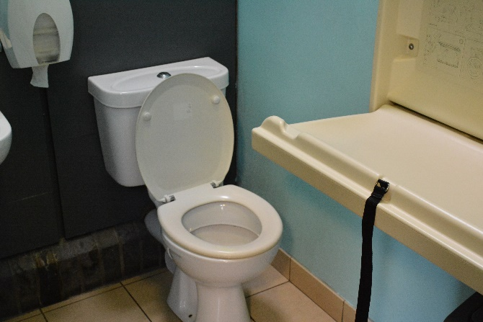

Disabled toilet facility Baby changing facility

There are also conventional toilets for men and for women.

Reception Desk

From the atrium you follow the slate flooring towards the reception desk.

The reception desk is 90 cms from the floor with a lower easy access section to the right which has a clearance of 72 cms. There is a TV screen above the reception desk which has a rolling programme of images.

There are black pillars in the reception, café and shop areas.

For those visitors who require a carer, the museum provides the carer with free admission.

A map is provided to each visitor – this map details the more friendly push-chair/wheelchair friendly route around the site.

The museum generally has two manual wheelchairs available to use – please ask at reception. If it is essential to your visit that you have one of these wheelchairs, please ring ahead to check availability and, if available, book it for your visit. If not booked, the wheelchairs are allocated on a first come first served basis.

Waterside Café

To the left of the reception desk, there is the Waterside Café where the flooring changes from slate to a wood effect vinyl. The room is spacious, light and airy and has canal views through the large windows. The counter is 92 cms from the floor. The table heights provide a clear space of 73 cms from the floor. The chairs are easy to move if required. The tables are well spaced apart and there are clear walkways with good wheelchair access.

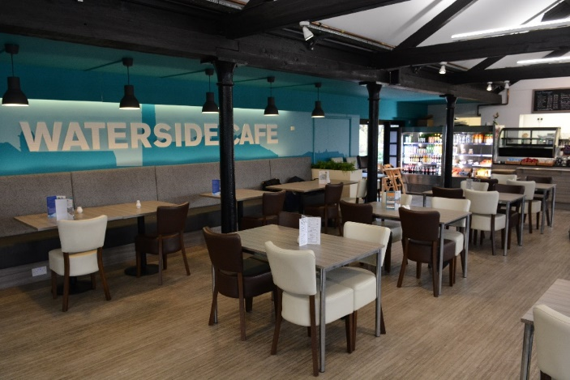
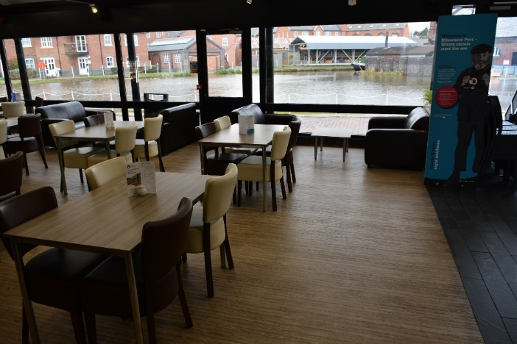

External seating and tables are provided. The flooring is of engineering brick. The table heights provide a clear space of 70 cms and the chairs are light and easy to move if required.

The cafe generally provides gluten free and lactose free products. If you have special dietary requirements, please speak with the staff or ring ahead and we will make every effort to meet your requirements.

Shop

To the right of the reception desk, the flooring changes to wood effect vinyl and is a shop which has clear aisles for easy circulation and has good accessibility with low level cabinets and easy to reach goods.

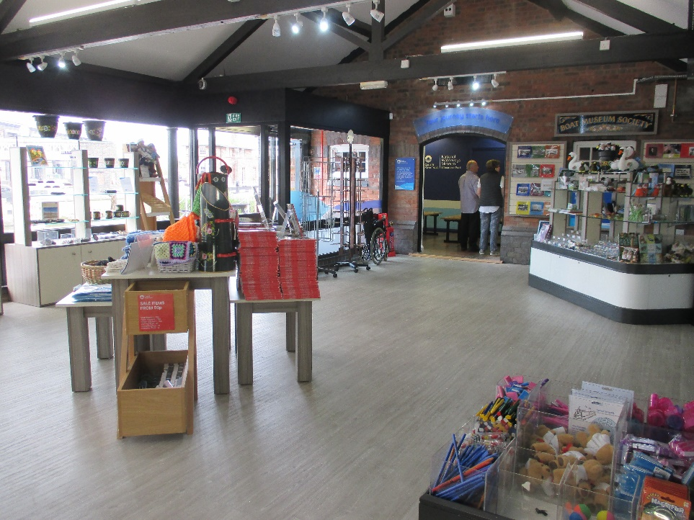

There are black pillars in the reception area. The atrium, shop and café are well lit.

Introductory Video Room

At the far end of the shop is an introductory video room which houses an 85 inch screen television. This has a red tiled floor with four benches for sitting to view the video. There is room for wheelchair users to watch the video.

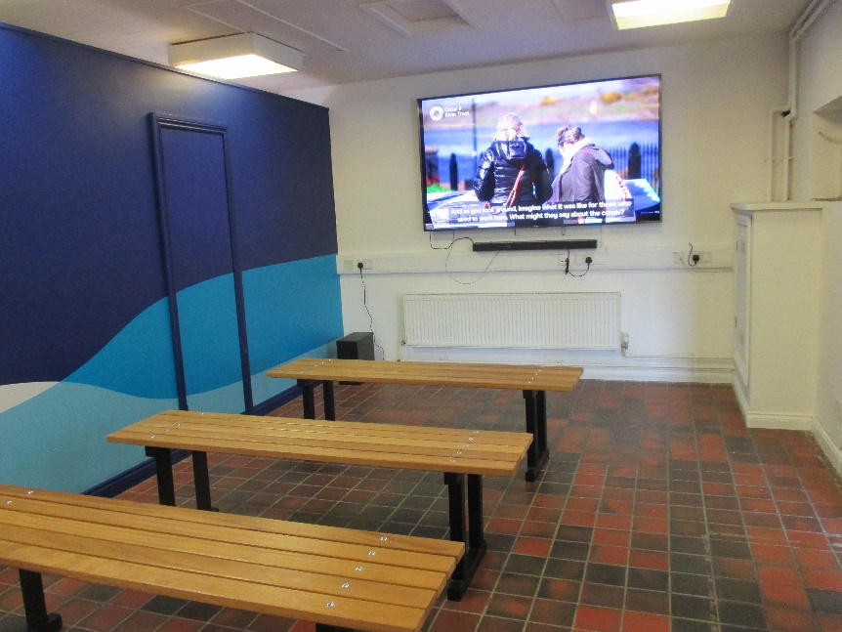

Access into the Museum

Access can be made through the doors at the rear of the video room which has a 7 inch step down to the ground outside. Alternatively, return to the shop area and access into the museum through a large door which can be opened through the electronic push pad which is on the right-hand side of the door at a height of approximately one metre.

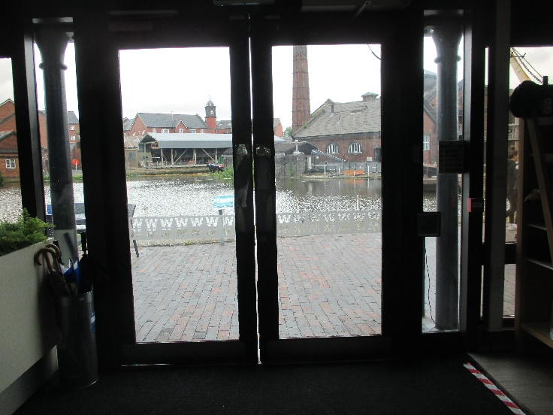

The Slipway

Visitors are encouraged to visit the slipway as their starting point. The route is down the side of the building you have just come out of and is constructed of engineering brick. The route has an initial gradient of 1:12 (8%). The path is edged by a wall either side. A short distance then of 1:20 (5%) towards the boat horse sculpture positioned on grass.

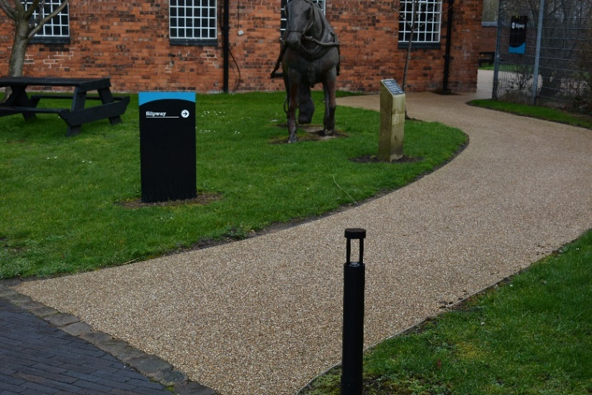

The ground towards the slipway is a composite resin flooring and reasonably level.

The Winch House

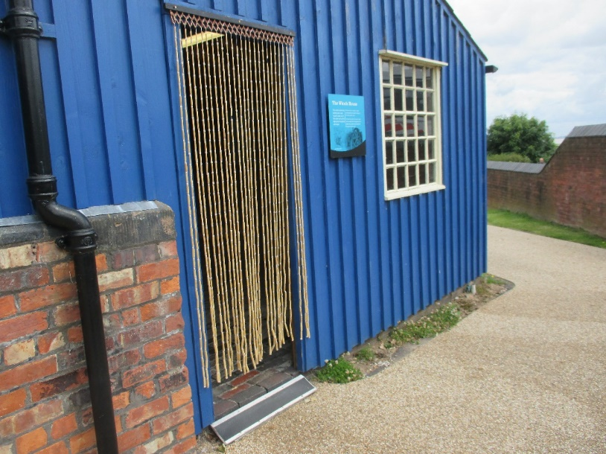

Access into the Winch House is via a ramp which fills a 9 cms lip. The flooring is engineering brick. The winch house has windows and strip lighting. There is a history video showing on a 66inch screen and there are three benches. There is also wheelchair space.

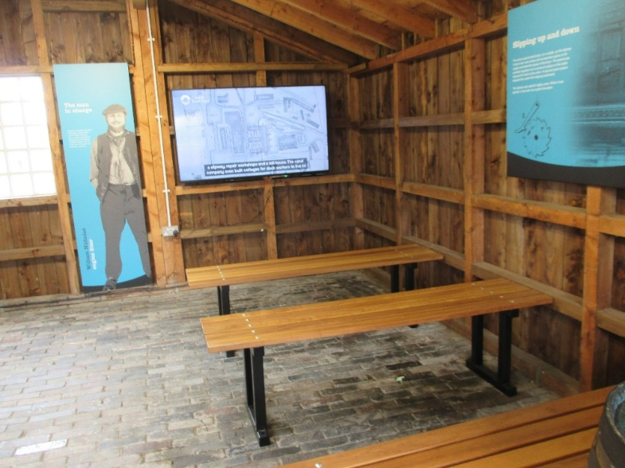

Window on the World

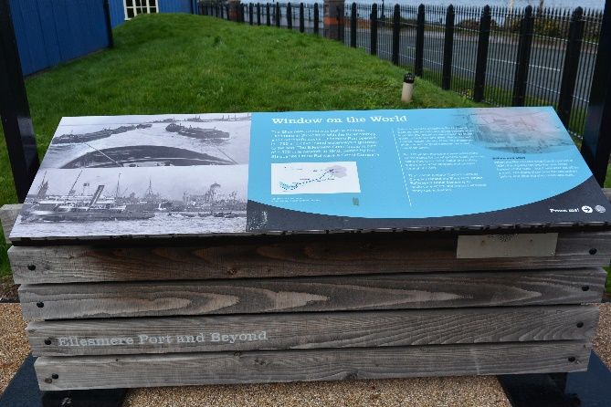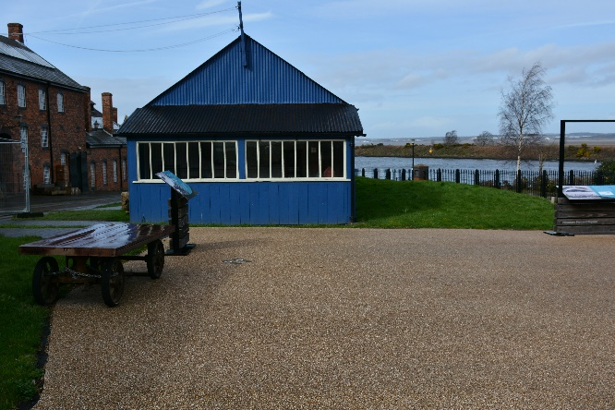
Window on the World exhibition panel

From the Winch House, the flooring is made of composite resin and is fairly level. The height of the button on the Window on the World feature to hear the narrative is at 83cms.

Slipway

The slipway has a slope of 1:15 and is made of engineering brick with large slabs which are slightly uneven with a 2 cms dip in places.

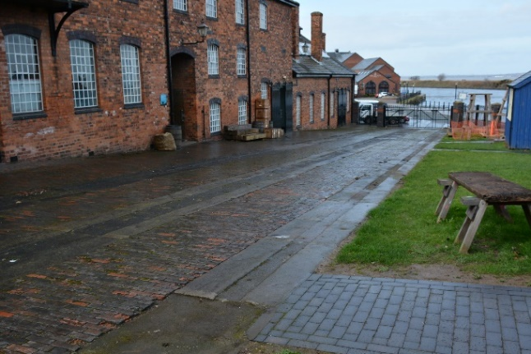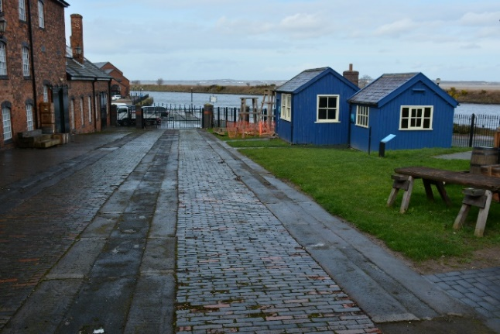
View looking down the slipway Mess room and Lindop’s office on the right
Carpenter’s Shed

There is level access across engineering brick onto the concrete floor within the carpenter’s shed. The open-door width is 70cm but the second door can be opened providing for a 140cms entrance.

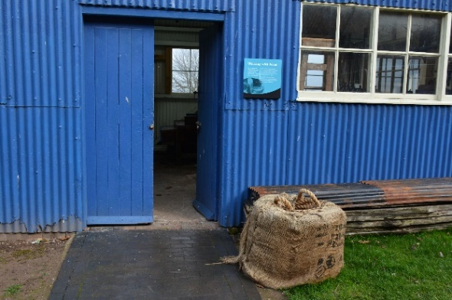

Mess Room

The access path to the Mess Room is one metre wide and made of level engineering brick. Viewing of the Mess Room takes place from the door for all visitors.

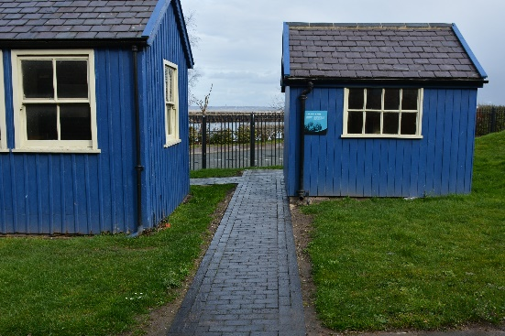
Access to the Mess Room

Superintendent’s Office

Access to the Superintendent’s office is by two steps – 10cms rise onto engineering brick and 14cms rise onto the wooden flooring. The door width is 70cms and there is little turning space inside.

Leaving the Slipway

Visitors may return the way they came and turn right after the boat horse sculpture. Alternatively, visitors can pass through the glass doors. The single door width is 85cms.

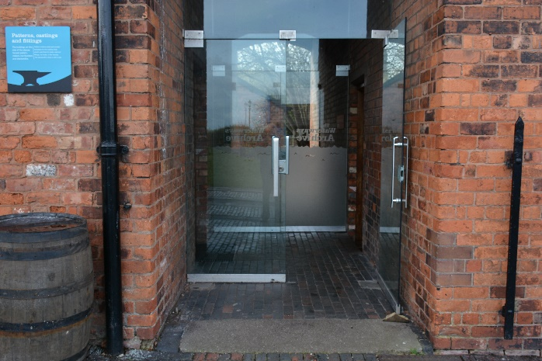

Archives and Reading Room

After passing through the glass doors, the door to the Archives and Reading Room is on the left-hand side. Access to the main area of the room is via 4 steps with a rise of 16cms with a handrail. Level access to the main area of the room can be obtained via the Fire Escape Door which has a width of 110cms. The Fire Escape Door can be accessed from the Slipway. Archives staff will be happy to help should you require level access.

Conference Centre

Rolt Conference Centre Toilets

After passing through the glass doors, there are 4 steps to the right-hand side which lead down to a set of ladies’ toilets and a set of men’s toilets. The steps have a rise of 16cms.

The conference centre is accessed by a path of more than 3 metres wide, which is composed of raised setts. A 1.2 metre paved path to the right-hand edge of the main path, has a better surface. It has a white edge to one side of the ramp. The path is approximately 10m long at a gradient of 1:8 (12.5%). The ramp culminates at a 4cm step into doorway of the conference centre. The doorway is one metre wide. Alternatively, there are four steps, edged in white, with a hand rail on both sides from the top level down to the door.

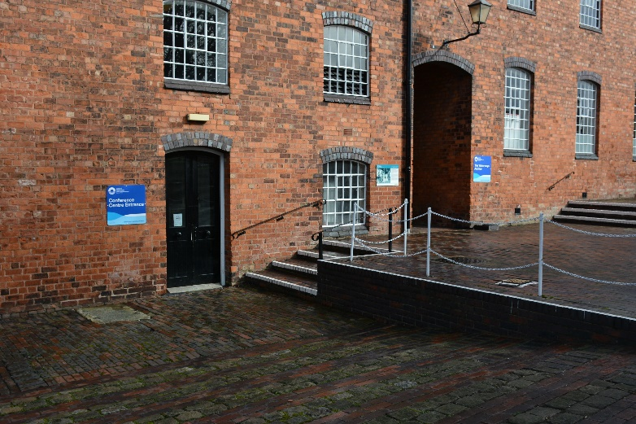

Once inside the conference centre there is a wheelchair accessible lift to the upper floor. The lift has side adjacent opening doors.

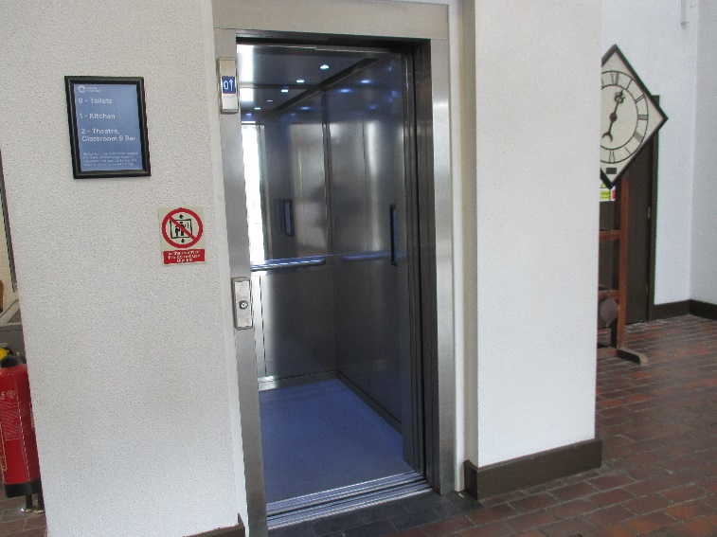

There are also stairs to the upper floors. The flooring on the stairs is carpeted.
Coffee lounge

The coffee lounge is accessed from the stairs and from the lift. It is a brightly naturally lighted room although there is supplementary lighting too. Flooring is carpet.

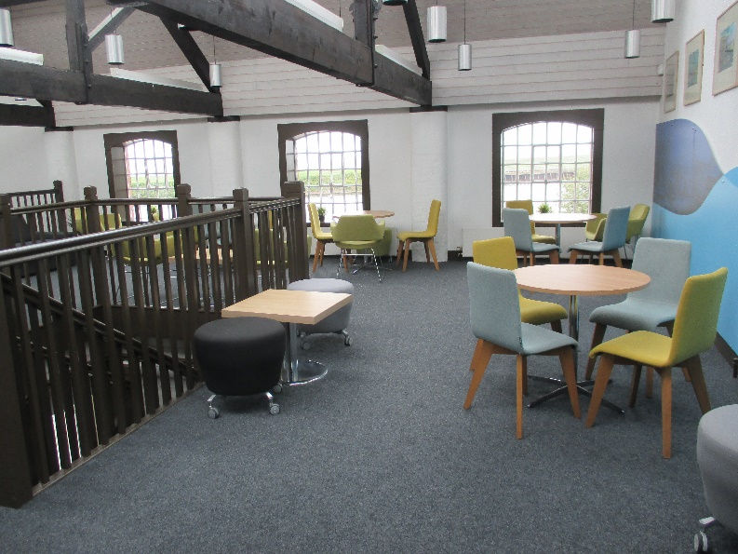

Classroom

The classroom is lit through natural light with supplementary lighting available. The flooring is wooden.

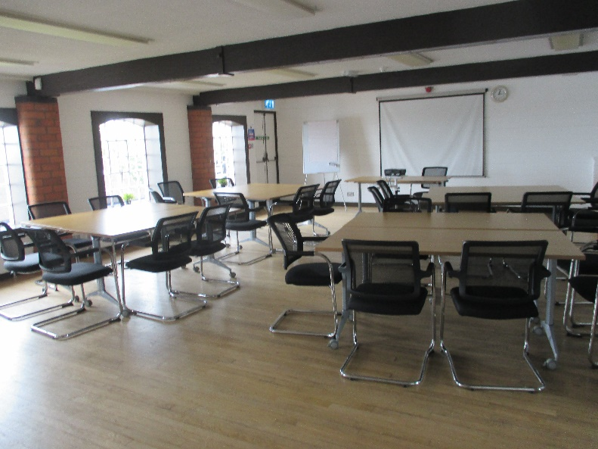

Theatre

The theatre is accessed by a series of seven steps which converts into a stair lift. The theatre has no natural lighting and has a wooden floor.

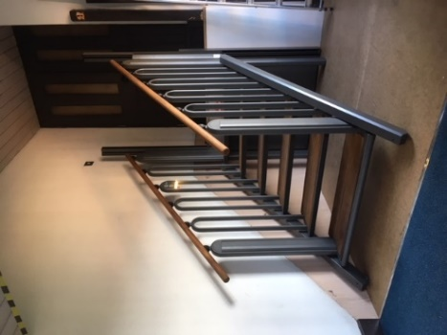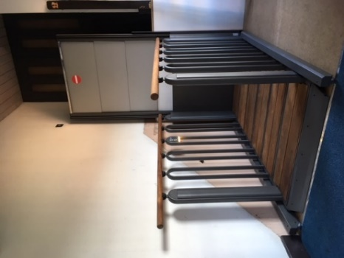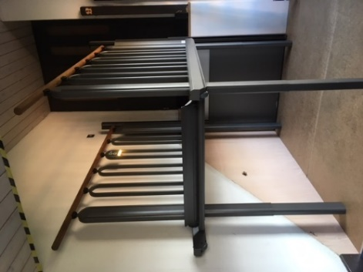

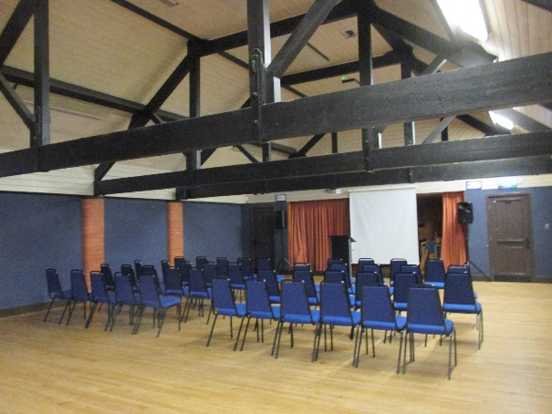

Blacksmith’s Forge

The slope down to the blacksmith’s forge is of engineering brick edged with path walls which are painted white.

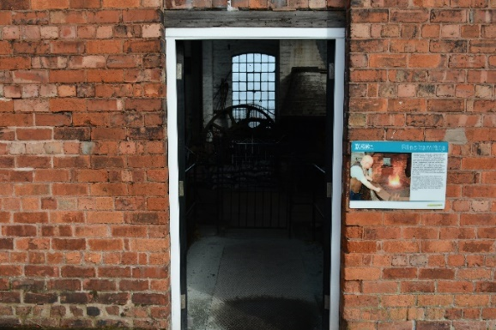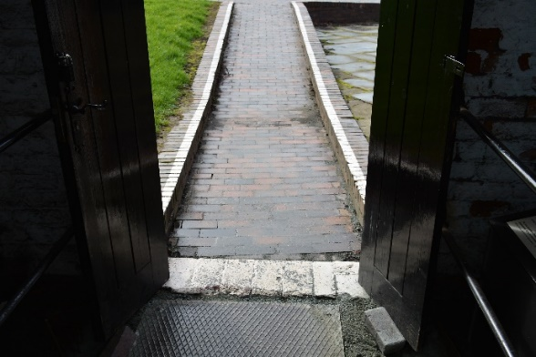

The working blacksmith’s forge has a small public viewing area at the entrance. There is a 2cm lip with white edging at the doorway into the Forge. The flooring is sheet steel on an earthern area. There are railings between the viewing and the working areas which are one metre in height.

Education Centre

The Education Centre is available for schools to use and is often open on Events Days for craft activities. There is a lip at the doorway but there are ramps in place.

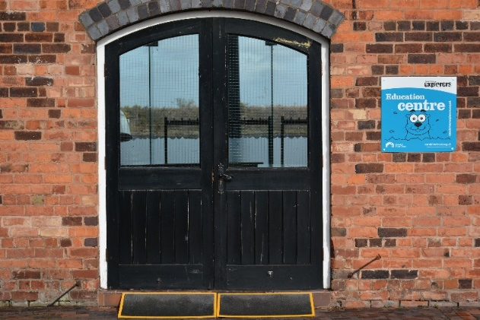

Power Hall

The route to the Power Hall is by a slope not steeper than 1:15 (6%) that is well constructed in traditional engineering brick. There is level access to the double doors, with a useable gap of 1.5 metres. There is a concrete ramp over the lip of 2cm into the Power Hall.

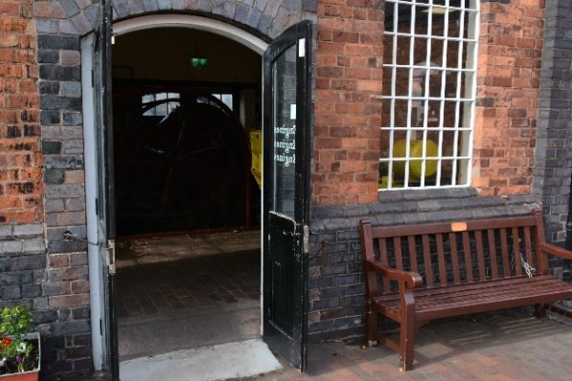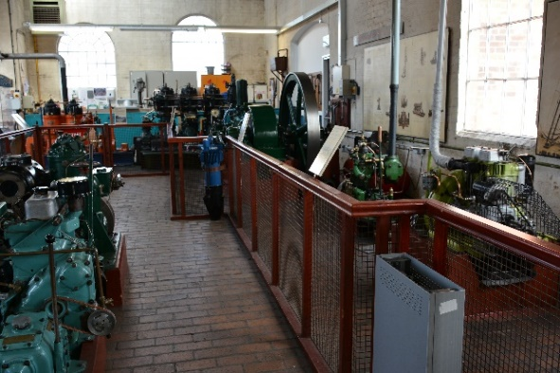

The hall is a warm, light and spacious place, with level access throughout provided by a red brick floor. Engines may be running and therefore may be a noisy area and have an oily aroma. Access to buttons to start the engines are at a height of one metre.

Footprint of the Old Gas Works

The footprint of the old gas works is made of engineering brick. Access to the area is across grass or via stepping stones inset into the grass.
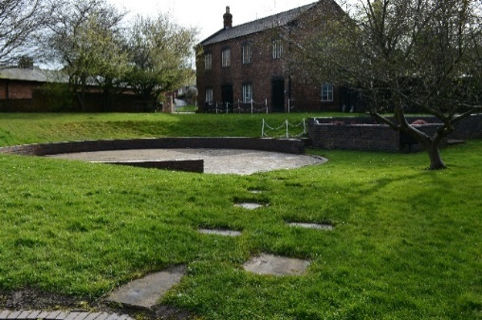

Stables

The Stables and attached heritage buildings are reached by retracing the outward route and turning right in front of the stable block. Access to the stables exhibition is along engineering brick and reasonably level.

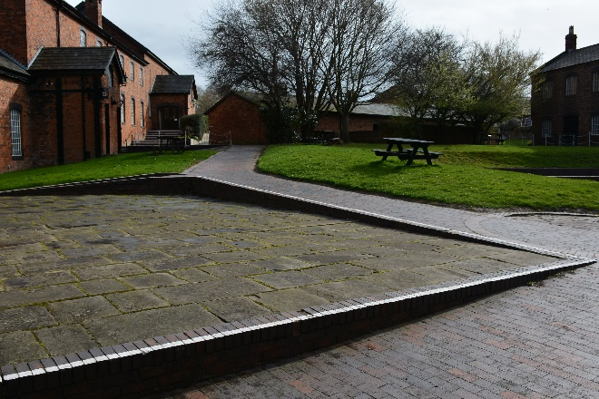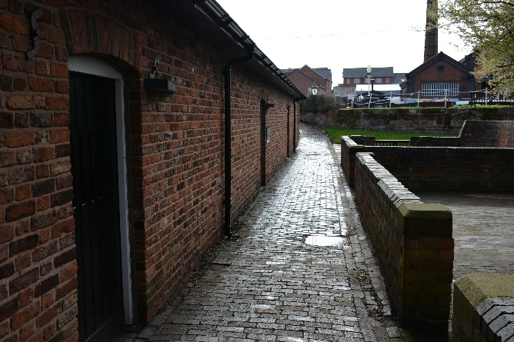
Path from Power Hall and Education Centre towards Stables and the path in front of the Stables.

There is level access into the stables through an open doorway with a portal width of 1.2m. Due to the former use of the building the floor is undulating half cobbled and half stone set floor which is well-constructed.

After leaving the stables, the wheelchair and pushchair friendly route is to retrace one’s steps back to the boat horse sculpture and towards the canal. The alternative routes have steps and cobbled and half stone set floors as shown below:

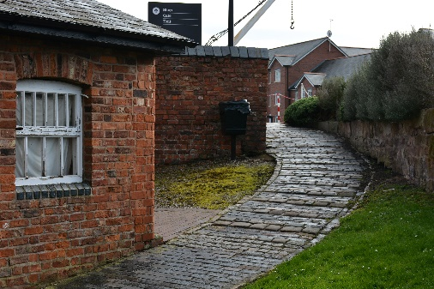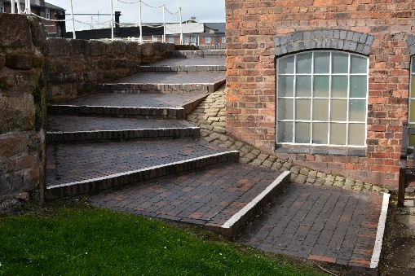

Pattern Shop

Access to the Pattern shop which houses the “40 Years on…the making of our museum” exhibition is accessed by 2 steps edged white, with a maximum tread of 22cms. A portable ramp is available. The door width is 75cms.

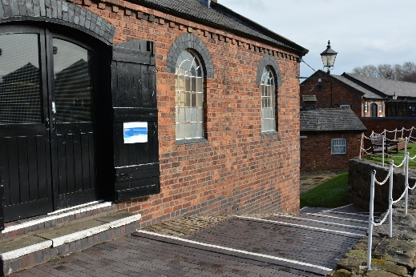

Locks

Looking down the Locks

There is a very steep slow down by the locks as shown in the photograph below.

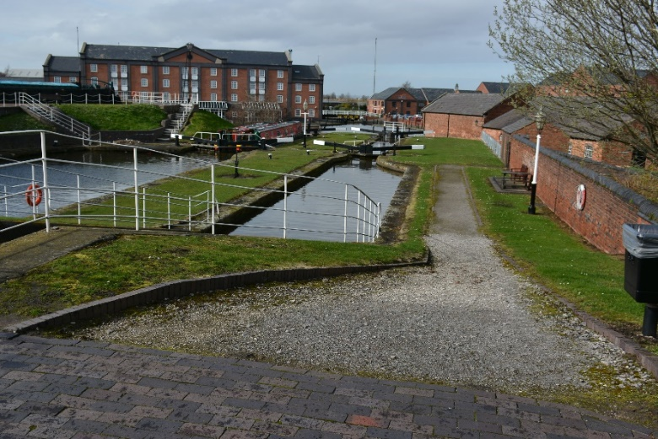

Across the Locks towards the Island Warehouse

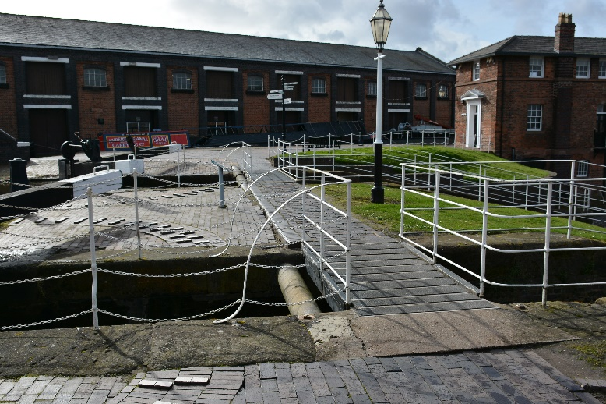

The width of the bridge across the canal at the end of the top lock is 120cms. The flooring is asphalt on wooden slats and there are white handrails on each side. The path then changes to engineering brick before it changes back to asphalt on wooden slats across the wide lock. There are white hand rails each side over the lock.

Toll House

The Toll House is used as an office therefore there is only staff access to these areas.

Island Warehouse

The main access to the Island Warehouse is across a level, wide, iron slab bridge which is 170cms wide and leads to a double door (single width 96cms) operated by an electronic keypad which is at a height of one metre on the left-hand side.

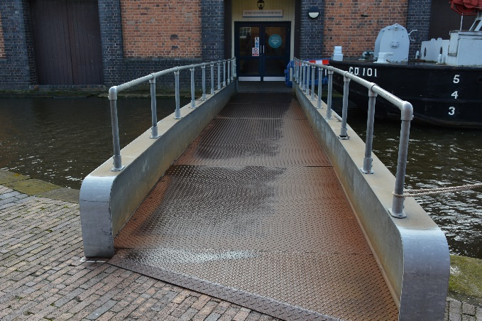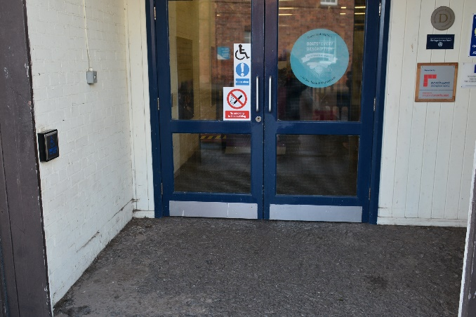

On entering the building there are the sounds and smell of an “oily” industrial environment. The ground floor is a level concrete screed surface.

To the right there is a 1.5 metre square raised exhibit, approximately 4cms from the floor with black and white edges to identify its position as a trip hazard.

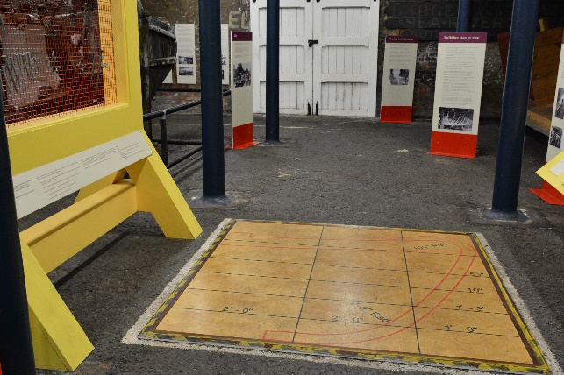

There are dark blue pillars in the building on both the ground and the first floor.

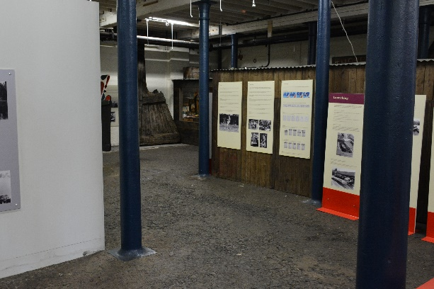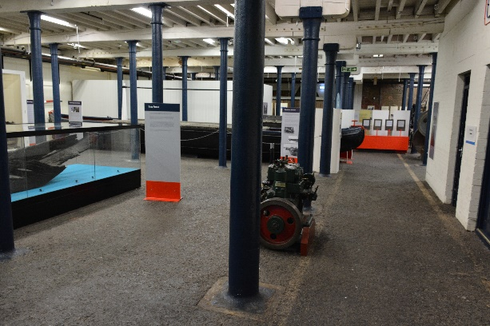

On the ground floor there is a carpenter’s workshop which has audio interpretation and is triggered by passing a sensor.

Interactive Activities on the Ground Floor

Ice breaker – turning a handle makes the model ice breaker move – the handle is at a height of one metre.

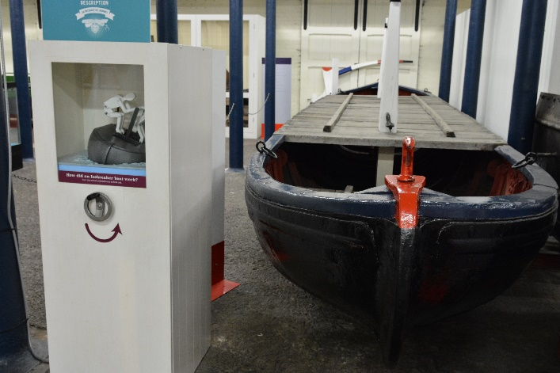

The Ellesmere Port Exhibition has chairs, play areas and dressing up clothes which are accessible for children.

Upstairs in the Island Warehouse

Access to the upper floor exhibition is by either a staircase or the visitor lift.

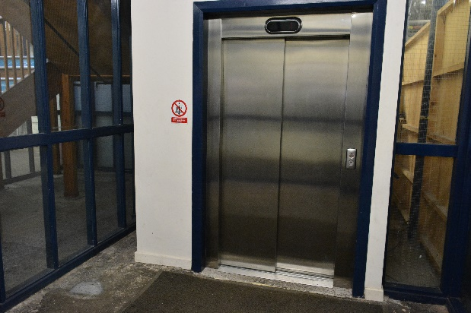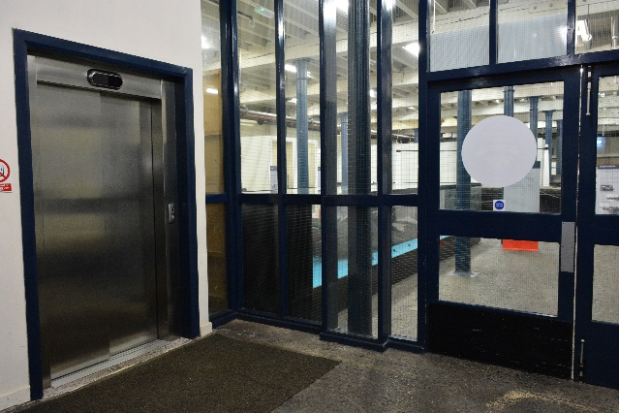

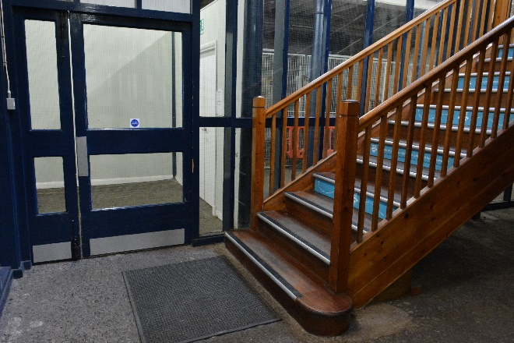

The wide staircase (width 122cms) has hand rails on both sides and clear delineation to distinguish the edges of the stairs together with safety strips on the treads of stairs. There are 12 steps on the first staircase and 10 steps on the second part with a rise of 18cms. The staircase is bright and spacious. There is a well illuminated large visitor lift with an opening of 120cm and control buttons at a maximum height of 1.1 metres. There is a safety rail. At the back of the lift is a full mirror which enables a wheelchair or mobility scooter user to be aware when the door opens behind them and to be able to view the interior of the museum and leave the lift conveniently.

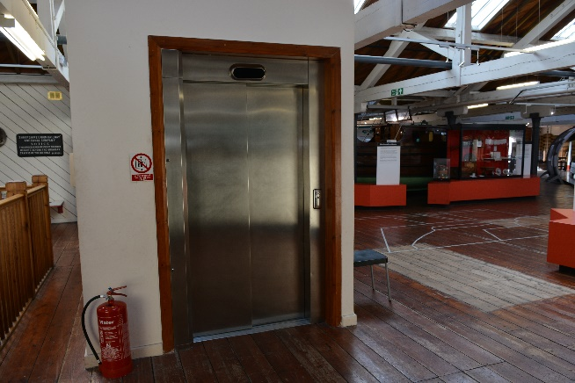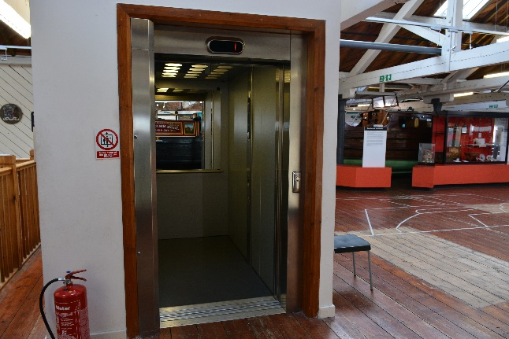

The lighting is good in the first floor, including ambient light through the roof windows and supported by electric lighting. The flooring has a traditional wooden planked floor and is quite a spacious and uncluttered environment. There is less background noise than that downstairs.

Toilets in the Island Warehouse

On this floor there is a separate baby changing facility which is 1.5 x 2m in size. The baby changing unit is situated at 85cms from the floor.

Opposite this is an accessible toilet facility which has hand rails.

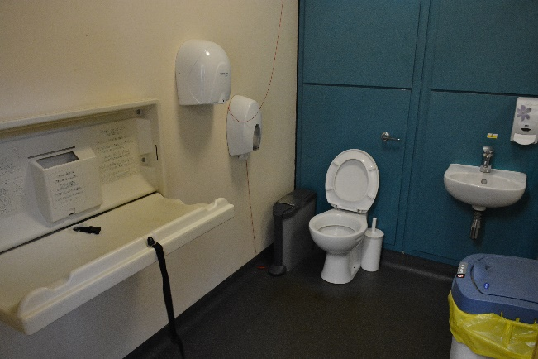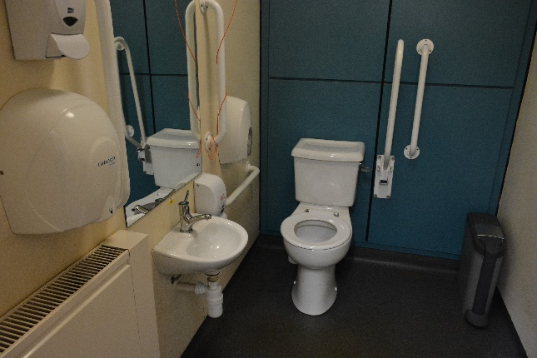

Interactive Activities

There is the opportunity to make brass rubbings on one of three tables which are at a height of 43cms, 63cms and 83cms cms.

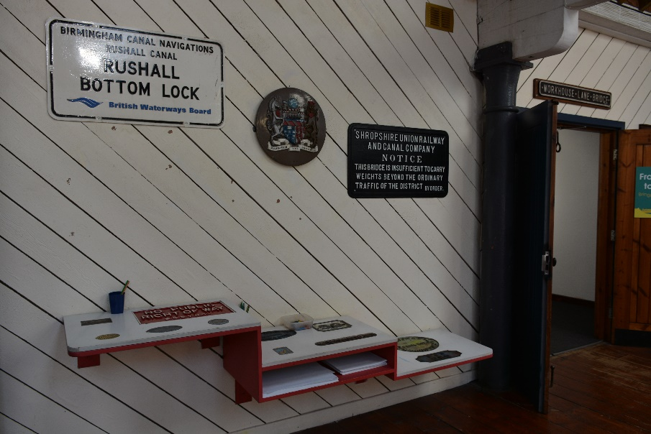

“What Is It?” – a range of cabinets with knobs at 70cms, 1 metre and 130cms above the floor.

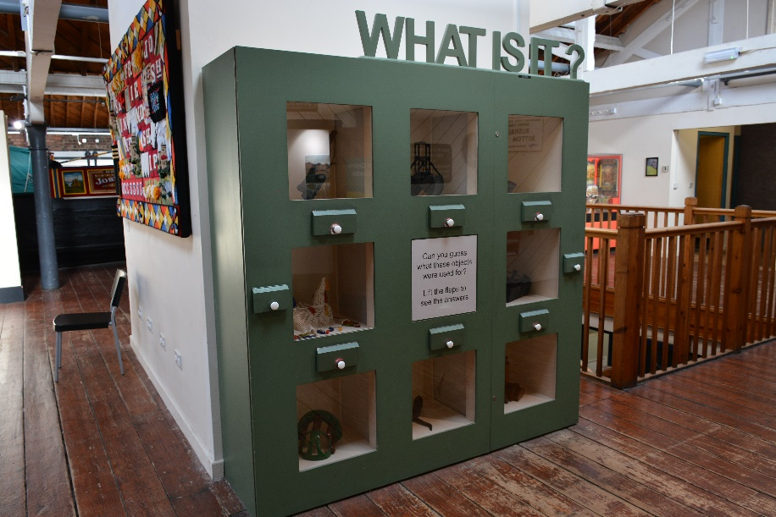

Archimedes Screw – has a handle at a height of one metre.

Manchester Ship Canal Video

In the corner of the first floor of the Island Warehouse there is a screening of the Manchester Ship Canal video which has moving images and sound.

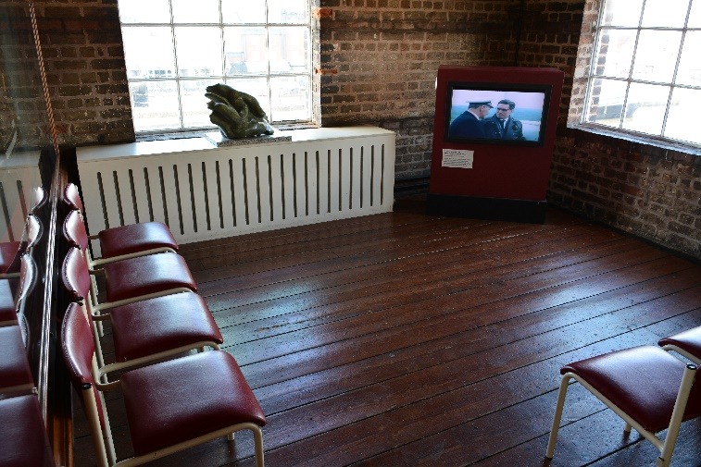

Friendship

The central area of the upper Island Warehouse is dominated by an iconic full length (approx. 20m x 3m) traditional narrow boat, Friendship. There is a short wooden ramp (width 83cms) to get to see into the boat and see its full open interior and the small area reserved for living and sleeping.

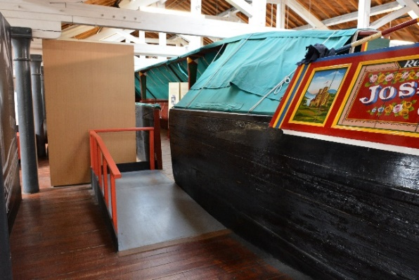
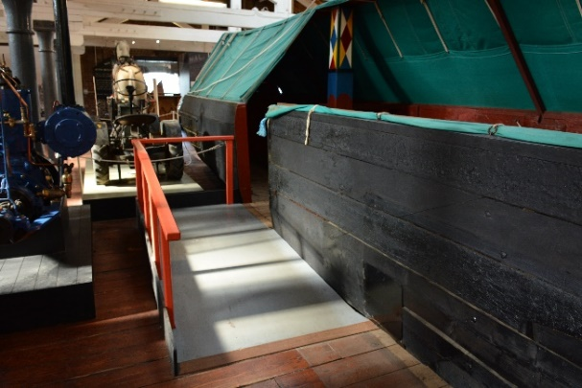

Interactive Display

The huge interactive wall has computer generated images, both still and moving.

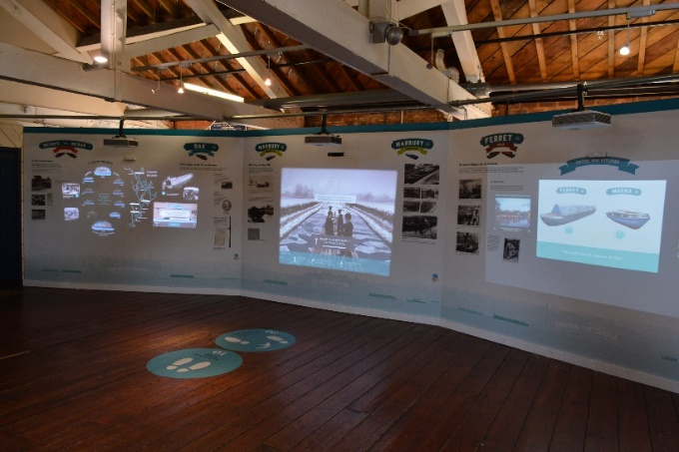

Mossdale

Access from the Island Warehouse to the historic boats dock is through white double doors and then through black warehouse doors (single width 87cms), opened by a conveniently positioned electronic key pad at a height of one metre. The route takes you over a steel plate metal bridge which is more than 1.5 metres wide onto a path made of engineering brick.

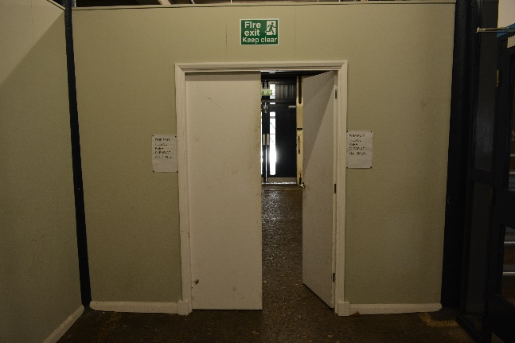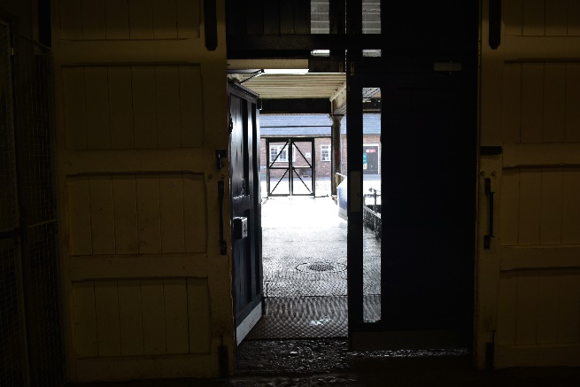

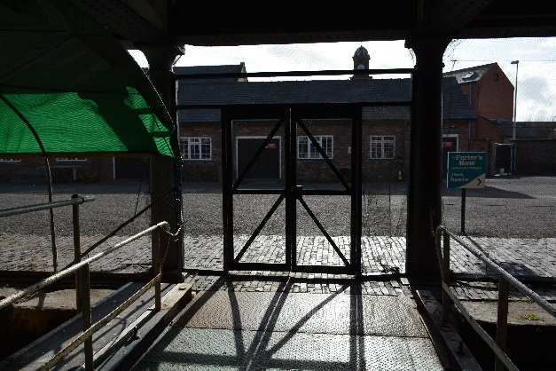

To move over to Mossdale, there is level shale flooring.

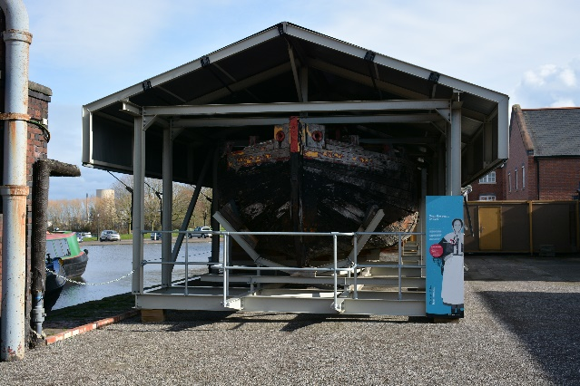

Accessing Porters Row

To go to Porters Row, you can continue over the shale flooring towards the Holiday Inn, moving onto stepping stones on the left-hand side and there are 2 steps down with a maximum height of 20cms. There is no hand rail here. The steps take you onto a shale surface which then changes to a cobbled surface.

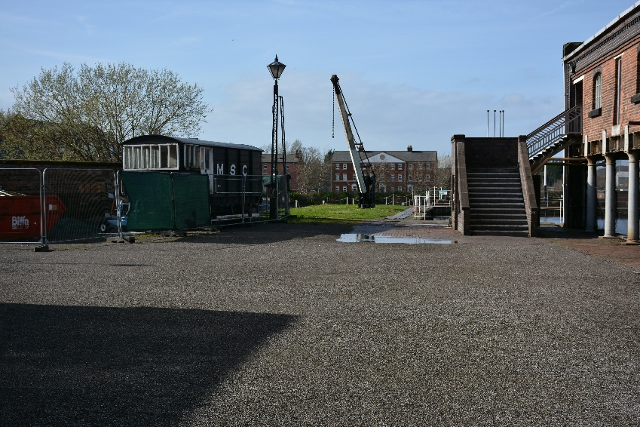

Alternatively, you can follow the red engineering brick path alongside the Island Warehouse which also has pillars on the side closest to the water. The path then follows the edge of the top basin and changes to metal sheeting.

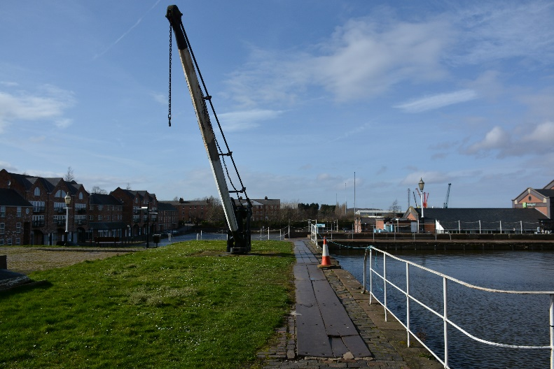

This path joins the route which runs between the Upper and Lower Basin path.

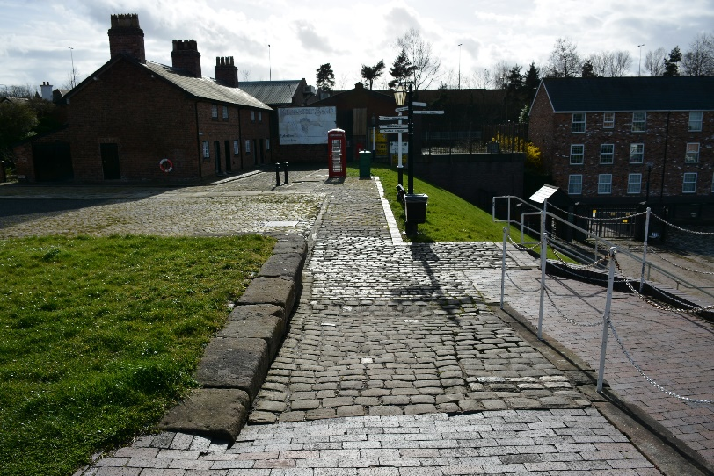

Porters Row Cottages

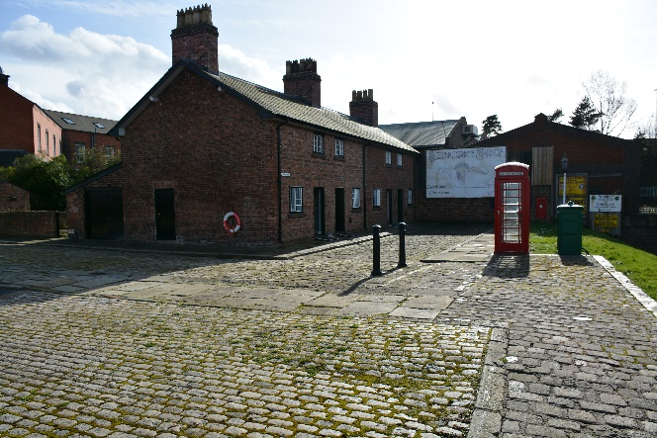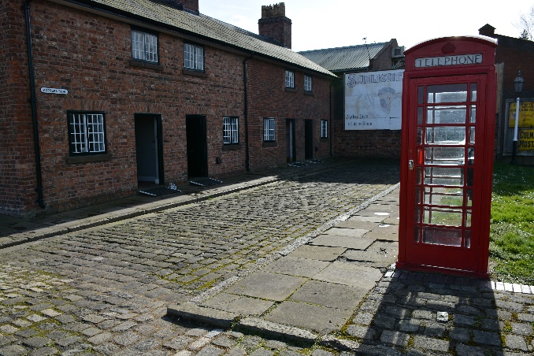

The path to Porters Row cottages takes you to an uneven ramp of stone setts and the ground outside Porters Row Cottages is a traditional street design with kerbs and stone setts. The cobbled nature of the path provides an uneven surface.

The four cottages all have lips at the front doors but these have been addressed by the placing of ramps.

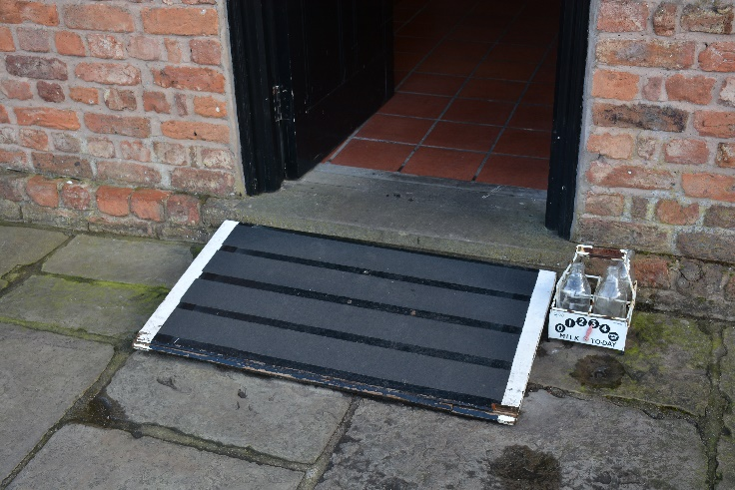

The furthest cottage (1800’s) has a 12cms drop to the back yard. The narrowest door is 70cms.

The 1900’s cottage has access to the kitchen but the route to the garden is blocked by a mangle. Access to the garden can be obtained by entering through the garden gate which is accessed at the side of the end cottage. See below.

The “Garage”, at the rear entrance to the cottages has large double doors with a slight lip from York-stone flags and then a large flat area providing access to the cottages. Access to the 1950’s house has a 6cm lip and the access to the 1930’s house has a 2cm lip.

The bottom of the windows are at a height of 120cms and can be looked through.

There is access to communal garden, with paths of stone setts forming a good level surface. There is a seat with handrails set on solid ground, which overlooks the garden. The gate width is 76cm and there is a protruding gas tap close to gate post. The garden has some low level beds and others are raised, to approximately 30cm from the ground.

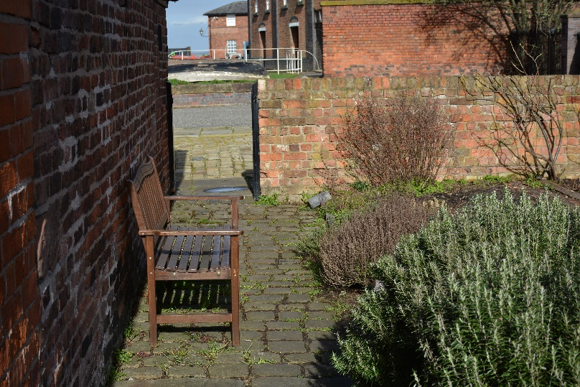

Within the cottages, the flooring is of quarry tiles and is level to the front and back rooms.

Returning to Reception

Visitors can return to Reception by the path between the Upper and Lower basin which is of red engineering brick and fairly level.

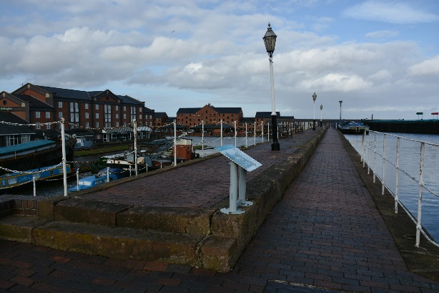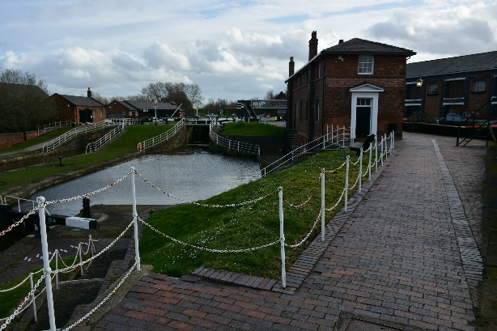

We hope this document has been helpful. If you have any questions or any comments on the document please contact our museum team on 0151 355 5017 or email at nationalwaterwaysmuseum@canalrivertrust.org.uk.

Thank you.

Last updated 07/08/2019

