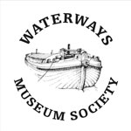
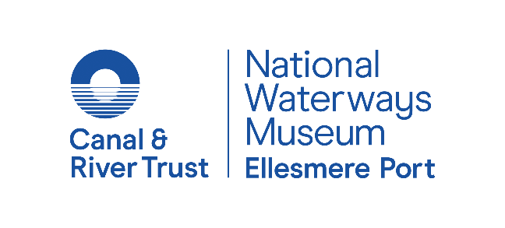

Easter Boat Gathering Boat Entry Form
19 – 22 April 2019
Please use Block Capitals
NAME:
ADDRESS:

POSTCODE:
EMAIL: |  |  |  |  |  |  |  | PHONE: |  | I am happy for the museum team to contact me on the day.
BOAT NAME: |  |  |  |  |  |  |  | BW INDEX:
LENGTH: |  |  |  |  |  |  |  | DRAUGHT:
CREW NUMBERS: |  |  |  |  |  |  |  | GUEST NUMBERS:
PETS (NUMBER & TYPE):
Please tick:
NARROWBOAT |  |  |  | HISTORIC NARROWBOAT |  |  |  |  | HISTORIC WIDEBEAM
STEEL |  |  |  | COMPOSITE |  |  |  |  | WOOD
ANTICIPATED ARRIVAL
DATE: |  |  |  |  |  | TIME:
VIA SHROPSHIRE UNION |  |  |  |  |  | VIA MANCHESTER SHIP CANAL
ANTICIPATED DEPARTURE
DATE: |  |  |  |  |  | TIME:
VIA SHROPSHIRE UNION |  |  |  |  |  | VIA MANCHESTER SHIP CANAL
HISTORIC CRAFT ONLY:
Are you willing to open your boat to the visiting public or take part in any boating demonstrations?
YES |  |  |  |  |  | NO
NOTES:
Would you like to attend Saturday Night with Greg Russell & Ciaran Algar?
2 free tickets per boat available per boat. Limited places. Pre-sale available until 21 February.

YES |  |  |  |  |  | NO

PLEASE RETURN YOUR COMPLETED FORM TO: nationalwaterwaysmuseum@canalrivertrust.org.uk
Please note, we are unable to reserve moorings – if you are delayed in arriving, you may not be guaranteed a space within the museum. If you would like to stay longer after the event, please let the museum know.
Your details will only be used in connection with the event.

