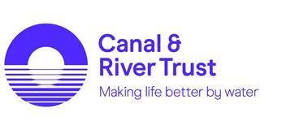
Freight Enquiry Form
Our canals were originally built to transport goods and although this is no longer the main purpose of our waterways we believe that today we have an important role to play in reducing road congestion and improving air quality. We also believe our waterways can provide a competitive alternative to road transport.
If you are interested in using our inland waterway system for transporting goods, please download and complete this form and email to stuart.mckenzie@canalrivertrust.org.uk. We will be in touch as soon as we can to discuss your proposals with you.
Key Details
Date of Enquiry
Contact Name
Company Name
Company Address
Contact Telephone Number & Name
Contact email
Have you any experience of inland water freight. If so, please provide details

Location of Proposed Operation
From
To
Waterways involved if known

Details of Goods to be Carried
Estimated Annual Tonnage or duration if known
Estimated start date if know
Goods to be carried
Are you a freight carrier or customer or other? If other, please provide details.

Please provide brief details of your proposal plus any other information you feel may be relevant

For Internal Use Only
National Ref No. | FE
Region

