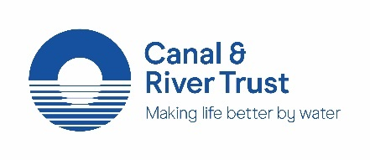
Our new brand giveaways
We’re publicly committed to eradicating plastic in our canals and rivers through our #PlasticsChallenge campaign and, internally, our environmental and ethical code of practice is there to guide our work. It states that to be environmentally sustainable our marketing principles must “reflect our commitment to protecting the wider environment in the same way as we care for our waterways.”
Our ethical merchandise policy contains a list of approved brand giveaway to be used across the Trust. The giveaways are in line with our environmental and ethical code of practice and are, where possible, endorsed by the most appropriate ethical trademark (Fairtrade, the Ethical Trading Initiative and the FSC etc.) All giveaways are either recyclable or reusable.
Product | Credential | Minimum order & cost | Where to order
Pen | 100% biodegradable as they are made from sugar cane and made using hydro-electricity power. | 250 units  @ 71p per unit | Mojo Promotions  tom@mojopromotions.co.uk
Well-B stickers  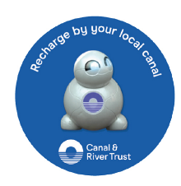 | Made in the UK and are recyclable | Order in packs of 175 stickers @ 3p each  (5 sheets) | Via the Brand Centre.
Dog poop bag holder  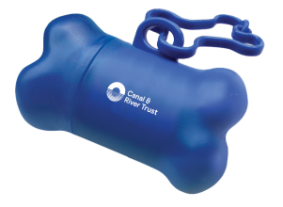 | Reusable item and fully recyclable at the end of its life. Currently supplied without bags as these do not meet our requirements. | 1000 units  @ £1.03 per unit. | Mojo Promotions  tom@mojopromotions.co.uk
Window stickers | All waste created during production is sent to the Netherlands and starts a new life as a bench. | 250 units  @ 89p per unit | Mojo promotions  tom@mojopromotions.co.uk
Seedsticks | Compostable and recyclable. Certified FSC and PEFC approved. | 1000 units  @ 99p per unit | Buddy Burst  jamie@buddyburst.com
Seedpaper wrist bands  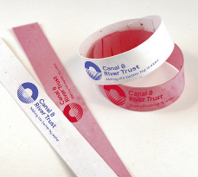 | Plant the entire item and wait for it to grow. | 1000 units  @ 99p per unit | Buddy Burst  jamie@buddyburst.com
Duck food envelopes | Vegetable based inks and fully recyclable | 1000 units  @ 25p per unit | Media Design Wales  lauren@mediadesign-wales.co.uk

While we have included the minimum order, the more you order the better price you will get. If you are interested in ordering items, this will need to be signed of by your task manager who will then order the product. Further information on the items can be found on ‘My Trust’.

