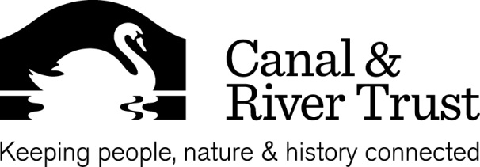
Minutes
Title | North East Waterway Partnership
Date | 2nd May 2013
Venue | Fearn’s Wharf Leeds
Attendees | Mark Penny Chair (MP), Chris Hawkesworth (CH), Eric Bootland (EB), Peter Scott (PS), David Lowe (DL), Geraint Coles (GC), Dianne Hurst (DH)  CRT: Jon Horsfall (JH), Heather Clarke (HC), Jane Thomson, (JT), Stephen Hardy (SH)
Apologies | Ken Taylor (KT), Mel Taylor (MT), Hilary Brooke (HB), Jon Kendall (JK), Michael Osborne (MO)

1 |  | ACTION
 | CH presented a Watersports Participation 2012 Survey Executive Summary UK for over 16’s only.  This survey was based on 12,000 people interviewed over the whole year.  CH suggested that this message should be extended nationally.  HC will feed back to Simon Salem.  BCU contributed £30,000 to survey.  CH to email presentation to the members | HC  CH
2
 | JT gave an Enterprise update April- May 2013.  Strategic Activity  The Trust has been offered a position on South Yorkshire Nature Partnership Board. Waterway related projects are in included within the SYGI Strategy.  South Yorkshire Forest has made an offer of office space and IT in their Sheffield offices.  The Trust has been working with Champollion and is helping them to shape an MP briefing note.  GC suggested approaching Kevin Baron MP for Rotherham. JT to follow up  Funding  A revised bid for the Pocklington Canal has been submitted.  An enquiry form has been submitted to the Big Lottery Community Spaces for the North Tower building at the Tees.  Mirfield – towpath enhancement  Major fish pass scheme at Sprotbrough Weir in Doncaster. | JT
3
 | GC spoke about Rother Valley Link and future educational projects.  A water industry apprentice school was suggested also live site projects.  It was suggested that a meeting should be arranged with The Trust’s engineers to find out where the problems are.  GC to liaise with JH to involve the Trust’s engineering manager.  GC would like this meeting to be held before the Waterway Conference.  DL attended The Regional Passenger Transport Exec Group Meeting. The Region has a billion pounds in transport funds.  Towpath improvements from Armley Mills into Leeds City Centre have been funded by the West Yorkshire Transport Plan.  JT to speak the council regarding transport around the region.  GC attended a meeting with members of HS2.  GC to forward his notes to the partnership members  General discussion in meeting on HS2 scheme.  Tees White Water Course has been shortlisted for the Waterway Renaissance Awards.  DL gave an update from the latest FRAG meeting. | GC & JH  JT  GC
4
 | A discussion was held regarding the Waterway Conference.  A date and venue to be confirmed next week  Draft list of invites to go out.  CH to help with the organisation of the conference. | MP  CH
5
 | SWP Workshop No3 Outputs - second draft.  A discussion was held.  HC to update document in preparation for the next meeting. | HC
6
 | East Riding Waterway Partnership meeting is on the 9th May.  LW to email instructions to the Partnership to enable to access the Extranet site. | LW

