

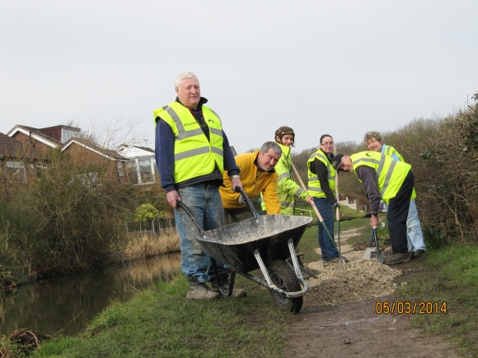

Telling the story of Waterway Community Adoptions

Group Name

Disley Towpath Action Group

Where is your adoption?

1 mile stretch on Peak Forest Canal from Bridge 24 to 27.

Why did your group adopt?

Following a residents’ survey for a local parish plan, the   
state of the local towpath emerged as a concern – a valued but poorly maintained resource. Several of us involved in the local footpaths society together with parish plan organisers and the parish council held a meeting with (then) British Waterways to put together a grant application to Cheshire East for funds to improve the towpath. This was followed by a meeting in the community centre to gauge support for organising an adoption with BW – enthusiastic support was forthcoming and we set up TAG in October 2011.

What’s the biggest achievement by the adoption to date?

Over two years, we have made big strides in re-surfacing much of the towpath, making it better able to withstand rain and pedestrian/cycling traffic and improving access.

Would you recommend groups thinking about adopting?

I would recommend others to consider setting up such groups, yes.

Anything else to share?

We have been well supported by Hazel Mayow and Steve O’Sullivan from CRT, and it’s pleasing that a regular group of between 6-12 volunteers (men & women) turn out on the first Wednesday of every month to get to work – enthusiastically and with good camaraderie. However…. Much of the towpath is in a fragile state, with 2 sections crumbling into the canal. This is well beyond our own resources to deal with. We will continue to be the eyes and ears of the towpath and to keep working with CRT about the bigger jobs to be done.

Please return to Sharon Butler – Sharon.Butler@canalrivertrust.org.uk

**Community Waterway Adoptions**