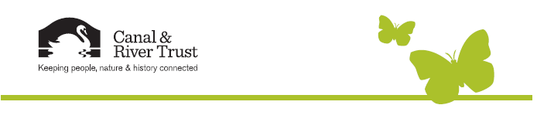

Right click on the picture to change.

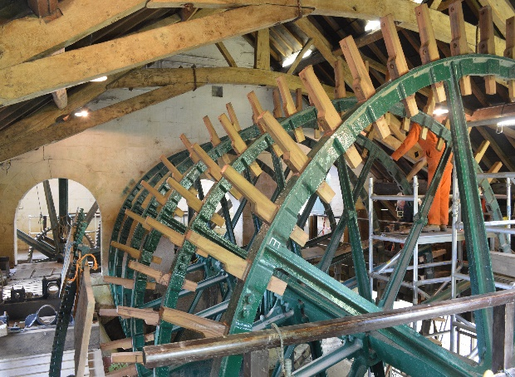

Telling the story of Waterway Community Adoptions

Group Name

The Claverton Pumping Station Group

Where is your adoption?

Claverton Pumping Station

The Kennet & Avon Canal

Why did your group adopt?

We are a group of dedicated volunteers   
who originally restored the Pumping Station   
dating back to 1967. Adoption was the natural thing to do, this cemented our relationship with CRT

What’s the biggest achievement by the adoption to date?

Complete restoration of Claverton Pumping Station. As with all machinery and building this is an ongoing process. We embarked on a full overhaul of the large water wheel on our site in 2011. This has progressed very well and is on schedule to be completed in 2015.

Would you recommend groups thinking about adopting?

Yes it has worked well for us.

Anything else to share?

Our group have been open minded to the changes brought about by the creation of the Canal & River Trust. I would recommend this approach to any other group and would assist them in the process if required.

Please return to Sharon Butler – Sharon.Butler@canalrivertrust.org.uk

**Community Waterway Adoptions**