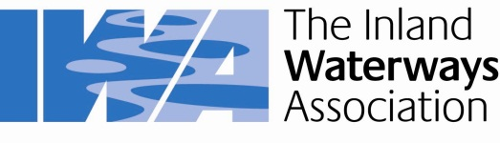
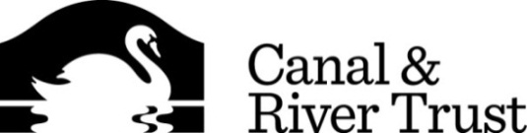

Memorandum of Understanding

between

Canal & River Trust (CRT) and The Inland Waterways Association (IWA)

Basis

This memorandum of understanding (MoU) between Canal & River Trust (CRT) and The Inland Waterways Association (IWA) has been drawn up to:

- Recognise the mutual charitable interests of the two organisations;
- Create a basis for mutual collaboration.
- Establish areas for co-operation as waterway charities;
- Outline specific commitments and responsibilities to avoid unnecessary waste of charitable resources;

Definitions

CRT means Canal & River Trust.

CRT is a company limited by guarantee. Registered in England No. 07807276. Registered Charity No. 1146792. Registered office is at: First Floor North, Station House, 500 Elder Gate, Milton Keynes MK9 1BB.

IWA means The Inland Waterways Association.

IWA is a company limited by guarantee. Registered in England No. 612245. Registered Charity No. 212342. Registered office is at: Island House, Moor Road, Chesham, HP5 1WA.

MOU means this Memorandum of Understanding between CRT and IWA.

Background

Canal & River Trust has been established to manage the waterways previously under the stewardship of British Waterways. The transfer of these waterways out of the public sector into a Trust creates both uncertainty and opportunity within the wider waterway community.
IWA is a leading charity within the inland waterway community and wishes to work with CRT to ensure that its custodianship of its waterways is successful and to assist and facilitate the development of good working relations with other waterways organisations. CRT wishes to work in an open and collaborative partnership with IWA and wishes to give a strong signal of its intent, where there is mutual benefit, to engage more closely with all parties within the wider waterways community in furtherance of those mutual benefits.
IWA and CRT share many common objectives and wish to work together to maximise their collective output for mutual benefit.

declaration of a common objective

CRT and IWA declare their common objective is to help secure the best possible future for the inland waterways of England and Wales.

WORKING TOGETHER

CRT and IWA:

  - Wish to work in a spirit of partnership and co-operation for the benefit of the inland waterways and base that co-operation on open communications and mutual respect.
  - Agree to keep each other informed about public announcements that might impact on the basis of this Memorandum set out at 1 above

Collaboration Projects

CRT and IWA commit themselves to working together on the following initial joint initiatives:

  - Develop ways for local organisations and community groups with an interest in the inland waterways corridor in their area to work in cooperation with both IWA and CRT for mutual benefit.

  - Facilitating, planning and organising work parties for the practical benefit of the waterway environment.

  - Consider supporting or organising boat gatherings and other activities to coincide with local fundraising and awareness events arranged by either party. Such boating events or other activities would be intended to create interest and colour to help bring people to the events.

  - Explore the possibilities of jointly funding work to raise awareness of the waterways and specific issues, particularly amongst opinion formers such as MPs and local Government.

  - Consider opportunities to work in partnership to further the objectives set out above.

  - Convene a meeting of key personnel in our respective organisations at least once a year to review progress in the objective areas to ensure mutual benefit is being gained via agreed actions and priorities.

General Provisions

  - Each party retains the option to progress sole initiatives without the agreement of the other party.
  - This MOU does not constitute or infer any contract or binding agreement on or between CRT and IWA or any of their successors.
  - The effective date for this Memorandum of Understanding between CRT and IWA shall be the date of the later signature below.
  - This MOU shall remain in effect until terminated in writing by either party and may only be modified upon the written agreement by both parties.
  - If any part of this MOU is frustrated, the parties agree to endeavour to develop new provisions that will achieve the common objective set out in 4 above.

Signed for and on behalf of  Canal & River Trust (CRT)  Robin Evans Chief Executive  Date: | Signed for and on behalf of  The Inland Waterways Association (IWA)  Clive Henderson, National Chairman  Date:

