Canal & River Trust
East Wick Mooring Scheme
Invitation to Tender (ITT)
17th August 2015

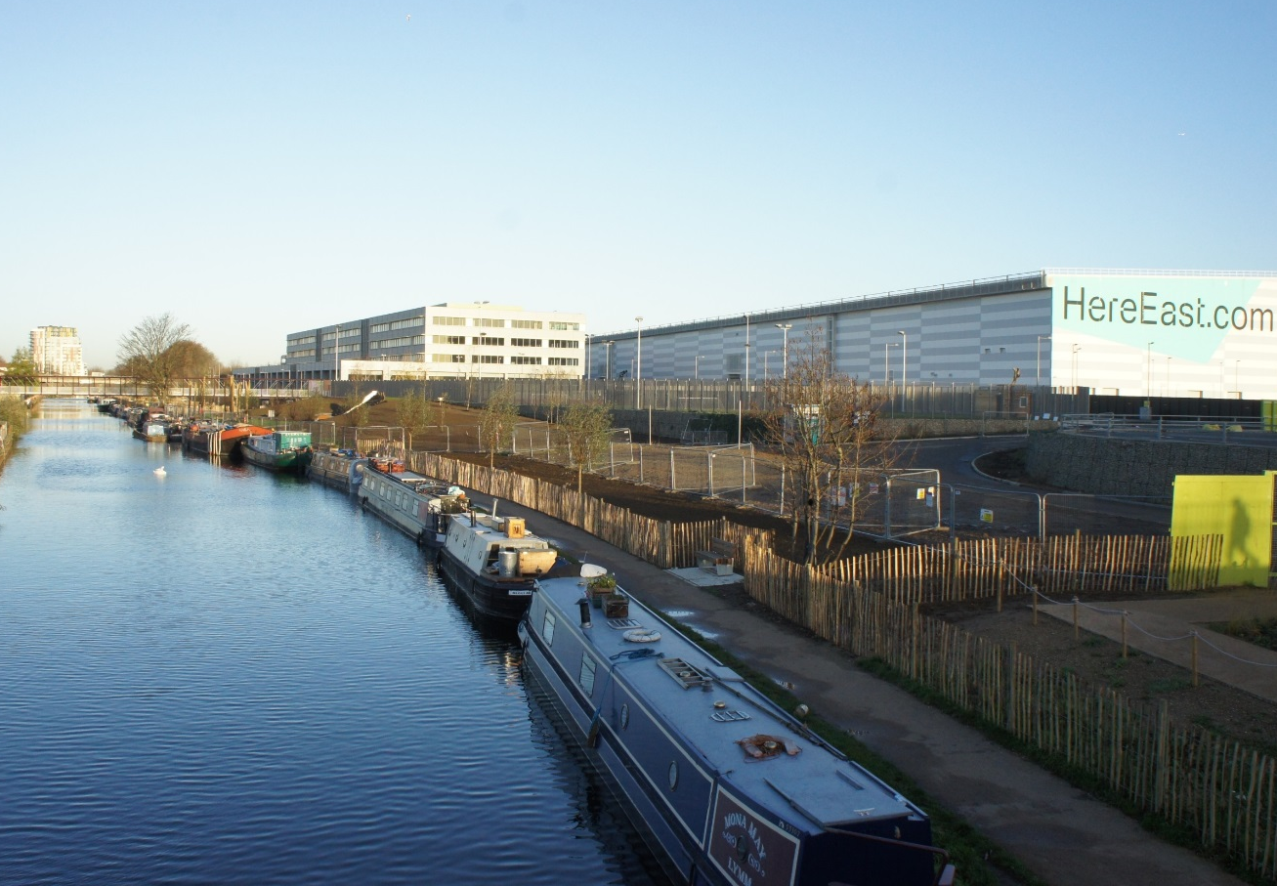

All correspondence relating to this tender should be addressed to:

Sam Anderson-Brown
Business Boating Manager
Canal & River Trust
First Floor (North)
Station House
500 Elder Gate
Milton Keynes
MK9 1BB

E-mail: Sam.Anderson-Brown@canalrivertrust.org.uk

Contents
Section 1 Introduction
section 2 INSTRUCTIONS to Organisations
section 3 about Canal & River Trust
section 4 SITE OVERVIEW AND THE OPPORTUNITY
SECTION 5 the Tender process
SECTION 6 DATA FOR THE PREPARATION OF TENDERS
sECTION 7 EVALUATION
SECTION 8 ORGANISATION DECLARATION
SECTION 9 QUESTIONNAIRE
APPENDIX 1 Site Map

SECTION 1 INTRODUCTION

This Invitation to Tender (“ITT”) dated 17th August 2015 is issued to Organisations that wish to express an interest in providing mooring management services to the Canal & River Trust (C&RT) & London Legacy Development Corporation(LLDC).

Following an assessment of responses to this ITT by a joint panel of C&RT and LLDC representatives, a maximum of three top scoring Organisations will be invited to participate in the second stage of this process – presentations.

.

SECTION 2 INSTRUCTIONS TO ORGANISATIONS

2.1 General

This Invitation to Tender (“ITT”) dated 17th August 2015 is issued to Organisations that wish to express an interest in providing mooring management services to the Canal & River Trust (C&RT) & London Legacy Development Corporation(LLDC). If there is a need for any changes to this ITT, Organisations will be informed of the changes and given adequate time to respond.

This ITT (and the information contained in it) does not form the basis of any contract nor does it constitute an invitation or offer to participate in the Contract.

C&RT reserves the right to terminate the tender (or part of it), to change the tender basis or procedures, to procure the project by other means, or to do any combination of these.

C&RT also reserves the right to procure any of the services referred to in this ITT separately.

2.2 Conflicts of Interest

Organisations are required to notify C&RT immediately of any actual or potential conflicts of interest in relation to this tender process that it becomes aware of. C&RT requires all actual or potential conflicts of interest to be resolved to C&RT’s satisfaction prior to the delivery of the Organisation’s response to this ITT. Failure to declare any such conflicts and/or failure to address such conflicts to the reasonable satisfaction of C&RT could result in an organisation being disqualified.

2.3 Canvassing

C&RT reserves the right to disqualify (without prejudice to any other civil remedies available to C&RT and without prejudice to any criminal liability which such conduct by an Organisation may attract) any Organisation who, in connection with this ITT:

Offers any inducement, fee or reward to any member or officer of C&RT or any person acting as an adviser for C&RT in connection with this ITT;

Does anything which would constitute a breach of the Bribery Act 2010; or

Contacts any officer of C&RT prior to financial close about any aspect of the ITT in a manner not permitted by this ITT, unless advised otherwise during the course of the tender.

2.4 Non-Collusion

C&RT reserves the right to disqualify (without prejudice to any other civil remedies available to C&RT and without prejudice to any criminal liability which such conduct by an Organisation may attract) any Organisation who, in connection with this ITT:

Fixes or adjusts their tender by or in accordance with any agreement or arrangement with any other Organisation;

Enters into any agreement or arrangement with any other Organisation to the effect that they shall refrain from making a tender or as to the amount of any tender to be submitted;

Causes or induces any person to enter such agreement as is mentioned in either bullet point above; or

Communicates to any person other than C&RT the amount or approximate amount of their proposed tender (except where such disclosure is made in confidence in order to obtain quotations necessary for the preparation of a tender).

2.5 Intellectual Property

The copyright in this ITT is vested in C&RT and may not be reproduced, copied or stored in any medium without the prior written consent of C&RT except in relation to the preparation of a tender. All documentation supplied by C&RT in relation to this ITT is and shall remain the property of C&RT and must be returned on demand, without any copies being retained.

2.6 Publicity

Organisations shall not undertake (or permit to be undertaken) at any time, whether at this stage or after financial close, any publicity activity with any section of the media in relation to the Contract other than with the prior written agreement of C&RT. Such agreement shall extend to the content of any publicity. In this paragraph the word "media" includes (without limitation) radio, television, newspapers, trade and specialist press, social media, internet and email accessible by the public at large and the representatives of such media.

2.7 C&RT’s Right to Reject Tenders

C&RT reserves the right to reject or disqualify an Organisation where:

A tender is submitted late, is completed incorrectly, is materially incomplete or fails to meet C&RT’s submission requirements;

The Organisation is guilty of material misrepresentation in relation to its application and/or the process;

The Organisation contravenes any of the terms and conditions of this ITT; or

There is a change in identity, control, financial standing or any other factor impacting on the selection and/or evaluation process affecting the Organisation.

The disqualification of an Organisation will not prejudice any other civil remedy available to C&RT and will not prejudice any criminal liability that such conduct by an Organisation may attract.

2.8 Confidentiality

The information in this ITT is confidential and is made available to each Organisation on this basis. .

2.9 No Liability for Information Provided

None of C&RT, its advisers or any of their respective directors, officers, employees and agents owes any duty of care to any Organisation either in relation to this ITT or any other information that they are provided with at any time, other than as may arise out of a written agreement between the relevant parties at some future date. Organisations must undertake such investigations as they see fit before entering into any contract.

None of C&RT, its advisers or any of their respective directors, officers or employees or any other person makes any express or implied representation or warranty and no responsibility or liability (except in the case of fraud) is accepted by any of them with respect to the adequacy, accuracy, reasonableness or completeness of the contents of this ITT or the facts, opinions, estimates, forecasts, projections or other information included within this ITT or of any other information (written or oral) supplied at any time in connection with the tender procedure.

2.10 Costs

Organisations will be solely responsible for all costs incurred in developing, preparing and submitting any response to the ITT. C&RT will not in any circumstances accept responsibility for any costs incurred by Organisations.

2.11 Submission of the completed ITT

A complete ITT document should be emailed to Sam.Anderson-Brown@canalrivertrust.org.uk. All tender submissions should be submitted before the tender deadline of 12:00 on 28th September 2015. (6 weeks)

- Any queries in relation to this tender process should be directed in writing (email) & not telephone to the C&RT Contact. This a matter of transparency and equal fairness to all Organisations
- Please try to keep you tender proposal in the minimum amount of documents. One would be preferable. .
- All questions should be asked as soon as possible but at the latest before 12:00 on 14 September 2015 (4 weeks) otherwise a reply cannot be guaranteed.
- All questions and subsequent answers will be published for all parties to view.

  - C&RT Contact

All correspondence relating to this tender should be addressed to:

Sam Anderson-Brown
Business Boating Manager
Canal & River Trust
First Floor (North)
Station House
500 Elder Gate
Milton Keynes
MK9 1BB

E-mail: Sam.Anderson-Brown@canalrivertrust.org.uk

SECTION 3

ABOUT CANAL & RIVER TRUST

The Canal & River Trust is the new charity set up to care for England and Wales’ wonderful legacy of 200-year-old waterways, holding them in trust for the nation forever. The Canal & River Trust is among the UK’s biggest charities, with responsibility for 2,000 miles of canals, rivers, docks and reservoirs, along with museums, archives and the country’s third largest collection of protected historic buildings. The Canal & River Trust formally took over the responsibilities of British Waterways in England and Wales on 2nd July 2012.

We help transform places and enrich lives by creating, caring for and giving everyone access to living waterways, today and tomorrow. We aim to:
- Breathe new life into our canals and rivers
- Ensure our canals and rivers are cherished by and make a difference to the communities they serve
- Help more people discover and enjoy the magic of the waterways
- Increase access to our canals and rivers for current and future generations

Our work

Our canals and rivers are today used by more people and for a wider variety of purposes than ever before, with over 35,000 boats and 10 million towpath visitors using them as an escape from the hurly burly of modern life. Once Britain’s most important transport system, our waterways are now a focus for economic renewal in the towns and cities they helped to create.

The Canal & River Trust is the guardian of a 200-year old working heritage, a remarkable legacy of the Industrial Revolution, and a nationally important wildlife corridor. It is responsible for an enormous network of bridges, locks, embankments and reservoirs and for maintaining them for the benefit and safety of our millions of visitors and neighbours.

SECTION 4 SITE OVERVIEW AND THE OPPORTUNITY

4.0 INTRODUCTION
The increasing number of vessels using the waterways, particularly in the London area, has led to an ever increasing need for mooring space for the Trust’s boating customers. We are responding by creating and facilitating new moorings to help serve this demand, both for private and commercial use. At the same time we are encouraging third parties to develop and manage sites across our network so that there is an increasing supply together with a wider choice of mooring offers for customers.

In East London, the Trust owns the majority of the waterways which flow through and alongside the new Queen Elizabeth Olympic Park. Since 2005, these waterways have been cleaned, repaired and painstakingly rejuvenated to create an extraordinary legacy from the 2012 Olympic and Paralympic Games. Working in collaboration, the Trust and the London Legacy Development Corporation (as custodian of the Park), are establishing new opportunities which seek to maximise the potential of these waterways for future generations.

An opportunity has arisen for a third party to manage a newly established section of moorings situated adjacent to the QEOP Park on the River Lee Navigation in Hackney Wick. The mooring location is indicated by the black line on the plan overleaf.

Overview

4.1.1 The Mooring site
The site has potential for both commercial operators and leisure customers the Trust has sought to ensure that adequate facilities are provided for all boaters. The site comprises 14 towpath moorings spread over 280 linear metres creating ample room for 12 leisure and 2 trade moorings each with their own metered 32 amp electricity supply and telecommunications links. It should be noted that the two suggested trade berths situated at the northern end of the site are serviced by a 32amp 3 phase power supply whilst the 12 suggested leisure berths are serviced by a 32amp single phase supply.

Other currently installed facilities include:
Water supply direct to each berth
Pump out facility at northern end of site – Please note this facility is available to all boaters and as such will be continued to be managed by the Trust.
Fixed mooring rings at 5m spacing’s
There is a dredged depth of around 1.3m across the length of the site. The maximum height of vessels (which is dictated by bridges located to the north and south of the site4) is 2.6m

The following are not provided:
Waste/refuse - disposal arrangements will need to be made by the incoming operator.
Storage space - There is currently no storage provision in place. The incoming operator will need to make their own enquiries with adjacent land owners and building occupiers should they require storage. As the site forms part of the River Lee Navigation towpath, there is no permission for individual berth occupiers to place or store any items on the towpath at any time.

The nearest vehicular access is via Waterden Road and off the Eastway (A106). Although this is a public highway loading and unloading arrangements will still need to be made with adjacent landowners and the local authority.

It should be noted that there are works underway in the immediate vicinity of the site, on the Here East site as well as the wider Park. There will be further construction works coming forward as the Park continues to develop in line with the long term plans for this area.

The location

London’s newest visitor destination, Queen Elizabeth Olympic Park, is a place unlike any other. Visitors to the Park are able to enjoy beautiful parklands and waterways, world-famous sporting venues, arts and events and spectacular views from the ArcelorMittal Orbit. As a new heart for East London, the Park will also provide new homes and jobs. The Park will also become a host location for major cultural and sporting events such as this year’s Rugby World Cup.

The new mooring scheme is located next to ‘Here East’ – the new digital quarter for east London which is being created within the former Press and Broadcast Centres for the London 2012 Olympic and Paralympic Games. This major new development builds on the creative and entrepreneurial heritage of Hackney Wick. It will create a thriving commercial space providing more than 7,500 jobs and a vibrant focal point for the local community, with a pedestrianized square, cafés, restaurants and bars.

Nearby on the Waterworks River, is the emerging cultural and education quarter called ‘Olympicpolis’ which will include a new Victoria & Albert museum, University College London, University of the Arts London (UAL), Sadler’s Wells and potentially a new London base for the world-renowned Smithsonian Institution.

The River Lee Navigation and specifically the areas of East Wick and Sweet Water will provide an extremely attractive proposition for boating customers looking to find a mooring, as well as unique opportunity for canal based businesses to thrive.

Further information on the East Wick & Sweet Water, two of the neighbourhoods within the park can be found here.

In total, including East Wick and Sweetwater five new neighbourhoods will be created with future phases of development aiming to accommodate up to 6800 homes on the Park, these new communities will be supported by local retail, business space, leisure opportunities, hotels, two new primary schools and one new secondary school with additional health services and community infrastructure.

Across the park proposals for a wealth of new attractions are being considered from rides to museums, water and light shows to ice skating rinks. The East Wick moorings will provide a completely unique opportunity for commercial and leisure boating customers that cannot be found anywhere else on the waterway network.

To find out more about the many opportunities currently being put forward at the Park follow this link http://QueenElizabethOlympicPark.co.uk/our-story/publications/documents.

Site Consents

There is currently no formal planning use for the site. Whilst planning permission will not be required for the use of the site for leisure moorings, tenants wishing to trade will have to apply for the relevant planning permission.

The Planning Policy Decisions Team at LLDC are the planning authority for the site and bidders can make their own enquiries on 020 3288 8820 or planningenquiries@londonlegacy.co.uk.

Berth holders will not be able to use the mooring as their residence and any operator will be expected to strictly enforce the relevant restrictions on berth holders not to exceed the stipulated number of nights on board.

C&RT and LLDC prior consent is required before any formal planning application is submitted.

4.2 Lease out Arrangements

The winning party will be granted a lease from the Trust of the site giving full control of the moorings. The terms of the lease will include responsibilities for:
- Site maintenance, including, servicing of water and electricity bollards, refuse services etc.
- Marketing and promotion of berths and selecting business and leisure customers.
- Insurance and indemnities
- The safe operation of the site
- Compliance with relevant legislation, bye-laws and to follow any lawful directions given by the Trust.
- Be responsible for the dredging of the moorings.
- Repairing any damage caused to the waterway wall as a result of mooring activity.
- Any relevant licences for the proposed use.

4.3 Terms of Lease

The terms of the agreement are subject to negotiation and will depend on the nature of the operation.

A term of up to 10 years will be offered with a review of the trading fee at 3 yearly intervals.

The agreement will be for a fixed term and there will be no automatic rights to review at the end of the lease term, the lease will be contracted out of the Landlord and Tenant Act 1954. All moorings granted by the successful bidder should also be contracted out of the Landlord and Tenant Act 1954.

4.4 Annual Rent and Fees

The successful tenderer/operator will pay C&RT a yearly fee to operate the moorings. The operator is responsible for all outgoings associated with the opportunity including any liability to rates, utilities, waste, etc.

The electricity service bollards are currently configured to allow customers to pay for the electricity they use via an online payment system. This system known as meter-MACS and is used successfully by the Trust across our directly managed mooring sites. The system is currently set up so that payments made by customers will be received by C&RT, this will have to be changed to allow the new operator to collect payment for electricity from their customers. The system is designed in such a way that the operator pays the service provider then collects the appropriate fees from their tenants using the meter-MACS system.

The cost to the operator will be approximately £3200.00 to implement this system in first year of operation. The fee includes an initial start-up cost and then a monthly charge from meter-MACS for the service. A draft meter-MACS contract is available to view on request.

It should be noted LLDC reserve the right to charge an estate charge in line with LLDC’s estate charge policy.

4.5 Bidder Qualifications
Bidders must clearly state the annual fee exclusive of Value Added Tax that they are willing to pay for the lease of the East Wick moorings.

Potential bidders must present a business plan that aims to attract a diverse mix of use from future trade/commercial craft which will provide an interesting offer for the existing community, attract additional visitors to the area and complement adjacent land uses. Plans should also demonstrate how the operation of the moorings can contribute to the wider stewardship of the Lower Lea Valley waterways.

The Trust is seeking a bidder who can manage the East Wick moorings in a highly professional manner and in a way that reflects the Trust’s corporate objectives summarised below.

Prospective bidders should ensure that their business plan consistently addresses the Trust’s key objectives in regard to:

The Waterways – To protect and improve the accessibility, usability and resilience of our assets and their heritage, for people to use and enjoy, now and in the future
Resources – To secure sufficient resources, and manage them efficiently, for the long term sustainability of the waterways within the Trust’s care
Influence - To be a widely respected partner and trusted guardian with growing influence and responsibility
People – To enrich people’s lives
Prosperity – To yield economic benefits for local communities and the nation
Places – To provide special places that people value, sustainable environments and routes.
These six strategic goals operate interactively to deliver, together, our strategic vision – of Living Waterways that transform places and enrich lives.

In addition those submitting a business plan should also demonstrate:
- An ability to deliver excellent levels of customer service to boaters utilising the East Wick site.
- Clearly show that they have the expertise and resources / contacts to enable them to manage the maintenance and administration of the mooring site.
- Show through a proven track record that they have successfully taken on the management of a site and generated an adequate income.
- Prove they have adequate resources to advertise and select appropriate vessels to moor on site in a fair and transparent way.

SECTION 5 THE TENDER PROCESS

This section of the ITT explains the process that will be followed by C&RT during this phase of the procurement process.
ITT This ITT forms the second stage of the procurement process, with a presentation forming the third stage.
Following the deadline for return of your tender proposal, C&RT will review as follows:
Element 1 - Compliance Check
This will involve checking that Organisations have returned their ITT responses by the stated deadline, that their ITT responses have been completed in line with the instructions contained in the ITT and that their ITT responses contain all the required information. C&RT reserves the right to exclude from further participation in this competition any Organisation that fails to satisfy this compliance check.
Element 2 - Eligibility Check
This stage will involve a review of Organisations’ responses to Sections 8 & 9 of this ITT, which should be incorporated within your tender proposal.
Element 3 - Assessment of ITT responses
If an Organisations’ tender proposal passes Elements 1 and 2, it will be assessed under Element 3 (Evaluation Criteria). The evaluation criteria for element 3 is split on a 50/50 ratio, see section 7.1 for criteria headings.

This stage is your free text tender proposal and in order to give some structure, it should satisfy the requirements of “Section 4.5” & evaluation criteria in section 7 (The latter can be implied within your tender proposal). You should incorporate signed section 8 and completed section 9 within your tender proposal.. This whole ITT document does not need to be copied into your tender proposal.

C&RT may seek clarification from Organisations at any stage in its review of your tender proposal.
A maximum of three top scoring Organisations from the ITT phase will be invited to make a presentation

SECTION 6 DATA FOR THE PREPARATION OF TENDERS

6.1 Evaluation

Organisations are encouraged to bear in mind that their tenders must contain all elements necessary to meet the requirements set out and will be evaluated against the criteria set out in section 7.1 and Section 4 Bidder requirements .

Organisations can book a visit to the site for either a morning (10.00 – 12.00) or afternoon (13.00 – 15.00) tour with the project manager (please contact Sam Anderson- Brown to arrange) on Monday 7th September. These tours are open to all and therefore multiple organisations will be present. It will be an opportunity to seek answers to questions to support your tender proposal.

6.2 Post-Tender Clarifications

A maximum of three top scoring Organisations will be invited to conduct a 15 minute presentation followed by a 45 minute question and answer session. This will be held on 12th October 2015 between 09:00 – 17:00 at C&RT’s Milton Keynes Office.

Milestone | Timing
ITT submission deadline | 12:00 28th September 2015 ( 6 weeks)
Presentations – each shortlisted Organisation will be given a 60 minute slot for a 15 minute presentation to summarise their proposals as submitted in their tenders and 45 minutes for Q&As. This will be held at the Canal & River Trust’s Milton Keynes office between 09:00 – 17:00. | 12th October 2015 (No alternative date can be offered) (two weeks)
Award of Contract | 19th October 2015 (1 week)

SECTION 7 EVALUATION

7.1 Evaluation Criteria

The following evaluation criteria (with their respective weightings) will be used to evaluate tenders: The award of this contract will be on the basis of most economically advantageous tender with 50% Price (Criteria 1) and 50% Quality (Criteria 2 – 4).

- Criteria 1 Fee proposal 50%} 50%
_______________________________________________________________
- Criteria 2 Track record in Managing other Mooring sites 20%} 50%
- Criteria 3 Ability of scheme to meet trusts charitable objectives 10%}
- Criteria 4 Ability of applicant to effectively manage site 20%}

Each “criteria” element should have its own individual heading within your tender proposal and have sufficient supporting information to undertake a comprehensive evaluation. A minimum of three top scoring Organisations will be taken forward to presentations.

7.2 Fee Proposal

Organisations should clearly indicate an annual fee exclusive of Value Added Tax that they are willing to pay in return for the lease of the site.

7.3 Experience & Track record

Organisations should demonstrate their experience in managing similar sites and provide evidence of a proven track record in mooring management.

7.4 Ability to meet trusts charitable objectives.

Organisations should possess the necessary skills internally to meet the trust charitable objectives set out in Section 4. Organisations will need to detail how they plan to meet each of the five objectives.

7.5 Ability to effectively manage site

Prospective bidders should be able to demonstrate that they have the resources to manage the site effectively in accordance with the management criteria set out in section 4.

SECTION 8 ORGANISATION DECLARATION

I, the undersigned, confirm that the information contained in this ITT response is correct at the time of completion. Any changes relevant to this requirement will be notified to the C&RT Contact without undue delay.

Signed |  | Date
Print name |  | Position
On behalf of |  | Company Name

SECTION 9 QUESTIONNAIRE

9.1 Organisation Details

Please provide the following details:

Full company name
Previous company name
(and date of name change)
Please list the locations of your contact centres (town and country)

Registered address
Street/building/PO box
Town/city
Postal code
County/region
Country
Telephone
Facsimile
web address
Name of contact for this response
Mobile Telephone

Contact address

(if different from above)
Street/building/PO box
Town/city
Postal code
County/region
Country
Position
Direct Telephone
Direct Facsimile
E-Mail address

Organisation type (e.g. PLC, LP, Partnership, etc.)
Country of registration
Registration number
Registration year

9.2 Organisation Structure
If the Organisation is part of a group, please explain the group structure, including:
- organisation chart;
- The ultimate holding company and its controlling shareholders.

9.3 Financial information
Please provide the following information:
Financial year ending | (day/month)

Accounts (as registered) for last 3 years | Latest accounting  Year | Previous accounting year | Previous accounting  year
Accounting year
Annual turnover
Pre-tax profit
Total assets
Current assets
Total short term liabilities
Borrowings (excluding overdrafts)
Total net assets
Issued share capital (if applicable)

Further Details
Please provide details of any events since the date that the latest set of accounts was signed that have materially changed the Organisation’s financial position.
Please provide copies of any company announcements made to the authorities of any stock exchange or market on which the stocks or shares of the company are publicly traded, since the date of publication of the latest set of accounts.
Please provide details of Parent Guarantees or equivalent to be offered by the Organisation
Name, Contact and
Address of Bankers
Name, Contact and
Address of Auditors

9.4 Insurance
Standards / insurance | Public liability | Employer’s liability | Professional indemnity
Year
Value per incident
Total cumulative value

Please provide details of any claims within the last three years under professional indemnity insurance

9.5 Litigation
Please provide details of any pending, threatened or determined litigation or other legal proceedings within the last three years that may affect the Organisation’s ability to deliver this contract.
Please provide details of any site management contracts that have been terminated or not renewed within the last three years due to breach of contract or non-performance by the Organisation.

9.6 Credentials – Existing Contracts
Each Organisation should provide details of contracts that share similar characteristics to the subject contract. Please provide contact information to enable C&RT to take up references if required.

Name of Client Organisation
Address (inclusive of post code)
Client Contact Name & position held
Direct Dial Telephone
E-mail
Description of Contract (include contract period and value, scope of services

Name of Client Organisation
Address (inclusive of post code)
Client Contact Name & position held
Direct Dial Telephone
E-mail
Description of Contract
(include contract period and value, scope of services

Name of Client Organisation
Address (inclusive of post code)
Client Contact Name & position held
Direct Dial Telephone
E-mail
Description of Contract (include contract period & value, scope of services

9.7 Good Standing

The Organisation must disclose full details (including any sentence/penalties incurred) in the space provided below if the Organisation has:

- Been in a state of bankruptcy, insolvency, compulsory winding up, administration, receivership, composition with creditors or any analogous state, or subject to relevant proceedings;
- Been convicted of a criminal offence relating to business or professional conduct including but not limited to any offences of dishonesty, bribery and/or corruption;
- Been committed an act of grave misconduct in the course of its business or profession;
- Failed to fulfil its obligations relating to the payment of social security contributions;
- Failed to fulfil obligations relating to the payment of taxes; or
- Been guilty of serious misrepresentation in providing information required as set out in the preceding requirements and/or information required to be provided in response to the ITT.

Directors of the company should disclose any criminal convictions other than motoring or convictions that are “spent”. This should include Director’s name, penalty incurred and details of the conviction(s).

The Organisation should also confirm below that, where applicable:
- Where licensing and/or membership of a specified organisation is required in order to provide the Services, the it holds all relevant licences and/or is a member of the relevant organisation; and
- It is registered on any relevant trade or professional register.

If the Organisation cannot confirm the above then it should give a full explanation as to why not.

APPENDIX 1 – SITE MAP East Wick Mooring Site - Queen Elizabeth Olympic Park, North Park, Waterden Road, London E20 3HV

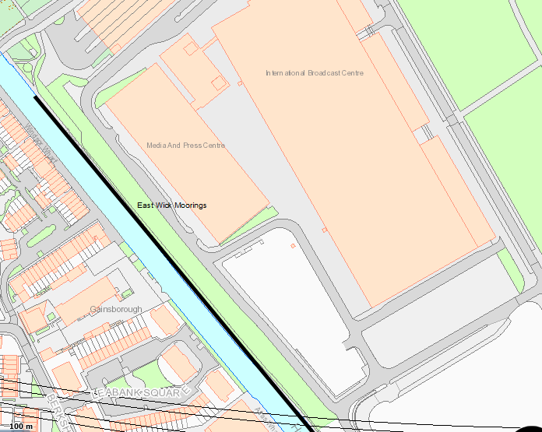

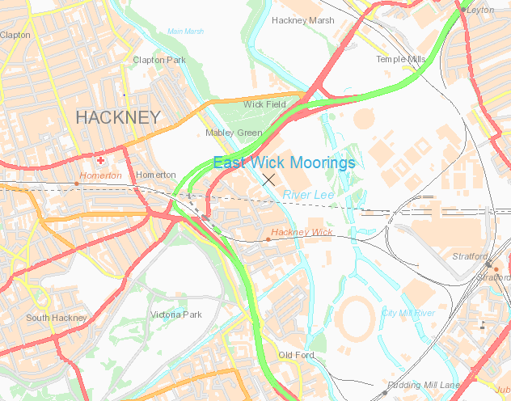
Appendix 1 Cont – Site location within Park

