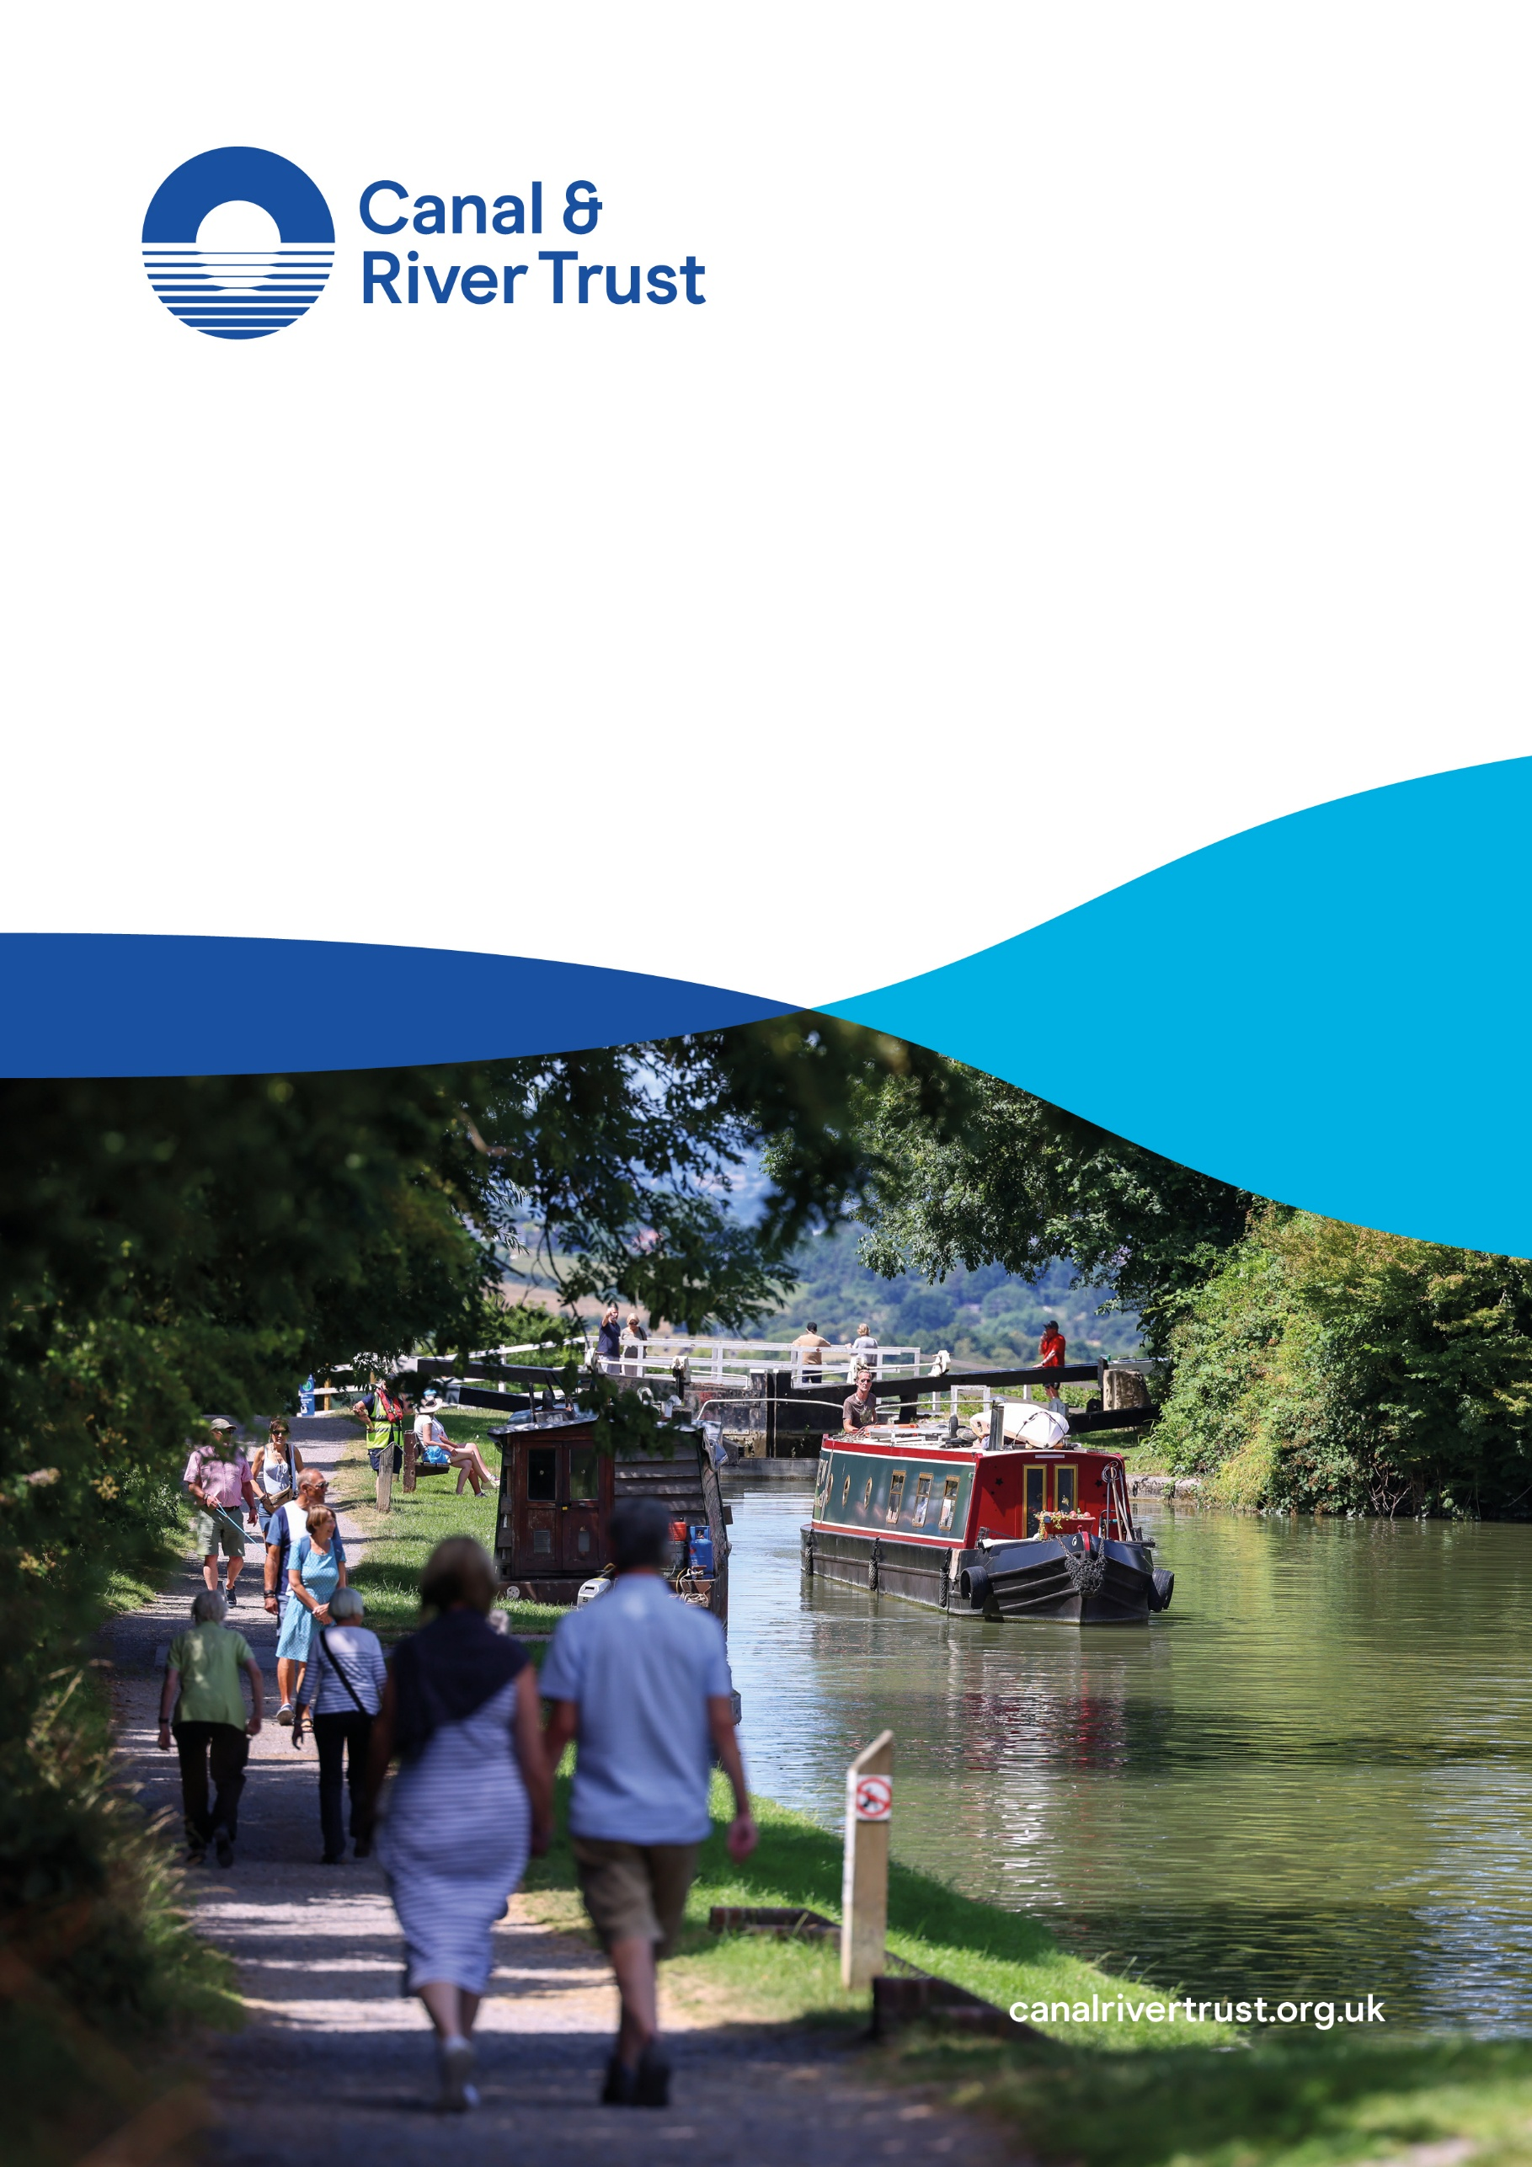

Natural Capital Baseline
Technical Report
June 2026

Contents
Introduction 3
Methodology 4
Key National Findings 5
Key Regional Findings 11
References 16
Appendix: Summary of methodology by ecosystem service 18

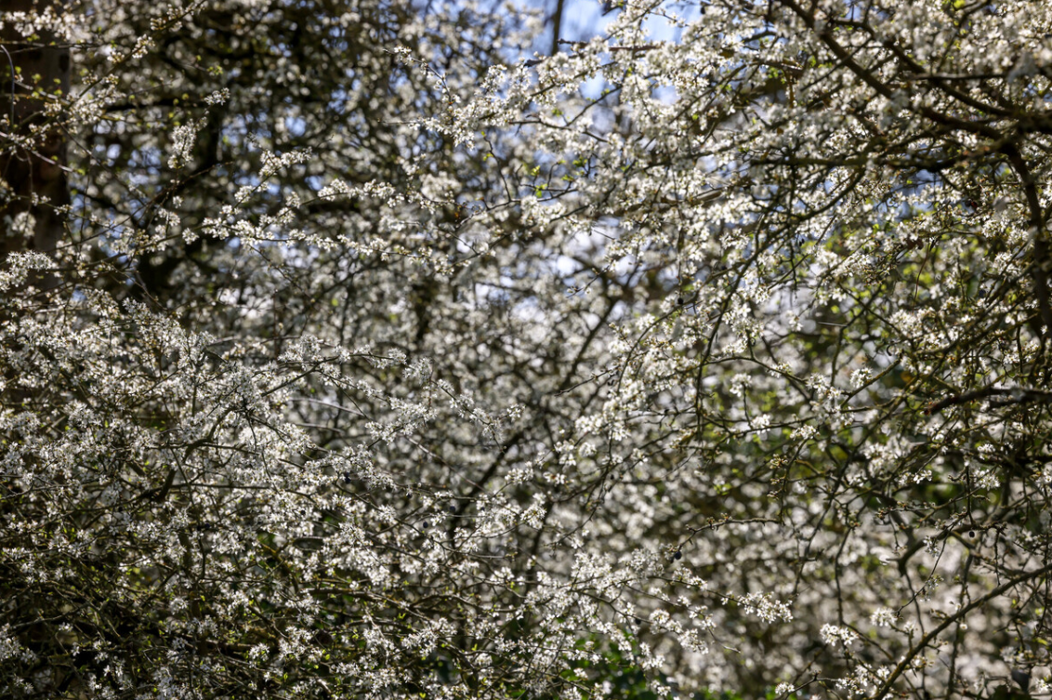

Introduction
The Canal & River Trust cares for a national network of canals and towpaths, river navigations, docks and reservoirs, stretching for 2,000 miles (3,220 kms) across England & Wales. It manages and maintains historic assets, including aqueducts, embankments, bridges and tunnels, and provides green blue spaces and routes for people to use and to enjoy. The canal network plays a vital role in supporting water security, generating renewable energy, regulating urban temperatures, sequestering carbon and enhancing air quality. It also provides accessible spaces for recreation, contributes to physical and mental health and wellbeing, and creates opportunities for education, volunteering and community engagement. Together, these services demonstrate the key role of the canal network as nationally important infrastructure.
This report provides a systematic and consistent framework to measure the value of the natural assets that the Trust manages and is responsible for through a natural capital account baseline for the year 2023. This publication presents an initial application of that framework. Future updates will incorporate additional components (such as a natural capital balance sheet), consistent with Defra’s Enabling a Natural Capital Approach (ENCA) guidance on a staged approach. Iteration will also enable the Trust to track changes and respond to emerging sustainability challenges.
The Trust’s natural capital accounts follow Corporate Natural Capital Accounting (CNCA) guidance and include the following core components:
- Natural capital asset register: An inventory of the stocks of the relevant natural capital assets (called habitats) and information regarding the condition of these assets.
- Physical flow account: A record of the estimated flow of the goods and services (called ecosystem services) produced by the habitats specified in the asset register, measured in physical units.
- Monetary flow account: A record of the value of the estimated flow of the goods and services (called ecosystem services) set out in the physical flow account. Value is measured with respect to both the private benefits of the organisation as well as the wider societal benefits. This is complemented with the value of the whole life of the Trust’s natural capital.
The Trust’s habitats deliver an annual value of £3.3 billion. Over a 100-year period, the estimated asset value is £99.2billion.
Recreation, tourism and health benefits account for around 90% of the total value of the Trust’s natural assets. This is because the network is an important free and accessible blue-green space, with 9 million people living within a 10–15-minute walk of one of the Trust’s canals.
From a regional perspective, London & South East’s natural assets have the highest total value at £28.1billion due to the location of water transfer projects, a high urban cooling effect in a region that experiences the highest temperatures, high property prices that lead to higher amenity values, and the higher overall number of visits.
The natural capital monetary estimates presented in the report should be viewed as a partial value of the services provided by the Trust’s natural assets, given that some services are less easy to fully quantify and value. Although biodiversity benefits are captured through the valuation of ecosystem services, the migration enabled through the connectivity dimension of the canal network may not be completely captured and it requires further research to be included. We are also aware that there are limitations in any natural capital valuation exercise. For example, we cannot capture relational, collective or intrinsic values.
The report delves into the natural dimension of waterways. However, the Canal & River Trust is aiming to develop an inclusive wealth framework that measures the holistic long-term social value delivered by the Trust’s waterways. This means valuing the economic, environmental, social and cultural footprint of the canal network. The capital accounting approach will help to systematically show how waterways contribute to society wellbeing through the services they provide for people, communities and the nation.
It will also aid in identifying pressures and gaps in the funding required to maintain these assets in good condition so that their benefits are protected and future generations can also enjoy them.
Due to the overlap between different dimensions of value provided by waterways, the value attributed to the natural capital account may change in future iterations. For example, the overlap between the natural and culture & heritage dimensions of waterways mean that it is likely that part of the recreation value included in the natural capital account will be reattributed to the culture and heritage account. This is one of the emerging results of collaborative work we are developing with academics at the Economic Statistics Centre for Excellence and at University of Exeter.
We would like to thank AECOM for their support in the production of this report.

Methodology
Natural capital accounts (NCA) have been in development at the national level in the UK by the Office for National Statistics (ONS) since 2011. At the organisation level, the Natural Capital Committee developed guidance for Corporate Natural Capital Accounting (CNCA) in 2015. The Trust’s natural capital account baseline adopts the CNCA approach. This natural capital account baseline initially focuses on the development of the asset register, the physical flow account and the monetary flow account. In further iterations, we plan to include the cost of maintenance to obtain a balance sheet with the net natural capital value.
The geographic boundary for the natural capital account follows the areas included in the Trust’s Ecological Baseline. This includes:
- Land owned by the Trust.
- Land leased to others (owned by the Trust).
- Land leased by the Trust (under leasehold).
- Joint ventures if the Trust owns or leases land as part of this arrangement.
The Trust may contribute to the overall impact on habitats outside of this boundary. However, this is not measured in the baseline account.
A biodiversity footprint mapping and survey of the Trust’s network was undertaken in 2023 to establish a comprehensive Ecological Baseline aligned with the Defra Biodiversity Metric. This combined high-resolution spatial mapping of habitats across all Trust landholdings - drawing on national datasets - with a programme of stratified random ground-truthing surveys to verify habitat type, location, and condition. Field survey data were then used to calibrate statistical models to predict habitat condition across the full estate, producing a consistent, network-wide baseline of habitat extent and quality. The Ecological Baseline has provided a foundation for the development of the natural capital accounts baseline asset register.
The findings are reported at a national and regional level. The Trust’s regional boundaries are applied for the latter.
The reporting timeline is the financial year April 2023 – March 2024. The accounts include the annual value of the ecosystem service flows in 2023. In line with natural capital accounting guidance, a 100-year period is applied to quantify the present value of the flow of ecosystem services. Future values are discounted according to recommended discount rates from the HM Treasury Green Book.

The price year is the year to which all monetary values are standardised when calculating the value of natural capital (so that all values are reported in real terms). The price year is chosen to be 2023 to align with the 2023 Ecological Baseline. All prices are adjusted using the GDP deflator index to reflect their equivalent in 2023.
The ONS Principles of Natural Capital Accounting (2017a) paper recommends the use of exchange values to be consistent with national accounts (such as the ONS natural capital accounts). However, Defra ENCA (2023) guidance highlights that the use of exchange values is less essential for natural capital accounting at a corporate or local level and welfare values are typically used where this is the appropriate method. Welfare values are more suitable to capture social benefits and public good components of canals.
In cases where we could choose between valuation methods, we followed the hierarchy of economic valuation techniques for ecosystem services as defined by the UN’s System of Environmental Economic Accounting – Ecosystem Accounting (SEEA EA) (UN et al., 2025; Ferrini et al., 2025). This meant that we applied the following prioritisation of methodology types:
- Where the price is directly observable.
- Where the price can be obtained from similar goods or services.
- Where the price is embedded in an economic transaction (for example resource rent techniques or hedonic methods).
- Based on costs for related goods or services (for example travel cost methods or cost-based approaches to meet an outcome).
- That depend on expected expenditures (for instance avoided costs or replacements costs).
- Other types of valuation methods.
An overview of valuation methods that are applied in the Trust’s natural capital account is provided below. Please see Table 5 in the Appendix for the methodology used for each ecosystem service.
- Market prices/ resource rents: applies to goods and services that are traded, such as the market value of timber. In natural capital accounting, market prices can inform the calculation of resource rent which reflects the proportion of value attributable to the natural asset. The resource rent approach has been applied to value water provisioning and to renewable energy provisioning services.
- Hedonic pricing: environmental characteristics (such as a pleasant view) are reflected in property prices. The value of the environmental component can be revealed by isolating the contribution of the environmental characteristic on the price of the property. This method has been applied to value the aesthetic and recreation service.
- Travel cost method: uses the costs incurred by individuals taking a trip to a recreation site (transport costs, entry fees, opportunity cost of time) as a proxy for the recreational value of that site. This method has been applied to value the recreation (enjoyment benefits), tourism and education services.
- Cost-based approaches: use the costs of providing the environmental service as proxy values for the benefits. This method is applied to value the greenhouse gas regulating service.
- Avoided costs: prices are estimated in terms of the value of the damages that would arise if the service were reduced or did not exist. This technique has been applied to value the air pollution regulating, urban heat regulating and recreation (health cost savings) services.
- Replacement costs: prices reflect the estimated cost of replacing a service. This method has been applied to value the volunteering service.
We have undertaken a materiality assessment to identify the priority ecosystem services to include in the accounts. This has considered evidence (e.g. from internal Trust information and research) on what ecosystem services provided are present and significant for waterways and whether the service provision is widespread across the Trust’s network or more localised.

Key National Findings
The annual value of ecosystem services delivered by the natural capital assets under Trust management responsibility is £3.3billion. The total asset value is £99.2billion. See Table 1 for the estimated physical flow, monetary flow and asset value for each ecosystem service.
The large majority of the natural capital value comes from the recreational visits to the Trust’s waterways and towpaths (£44.6 billion), domestic tourism visits (£8.3billion) and the health benefits from active visits (£35.8billion), accounting for 89% of the total value (see Figure 1).
Figure 1: Summary of breakdown of total natural capital asset value by ecosystem service in 2023.
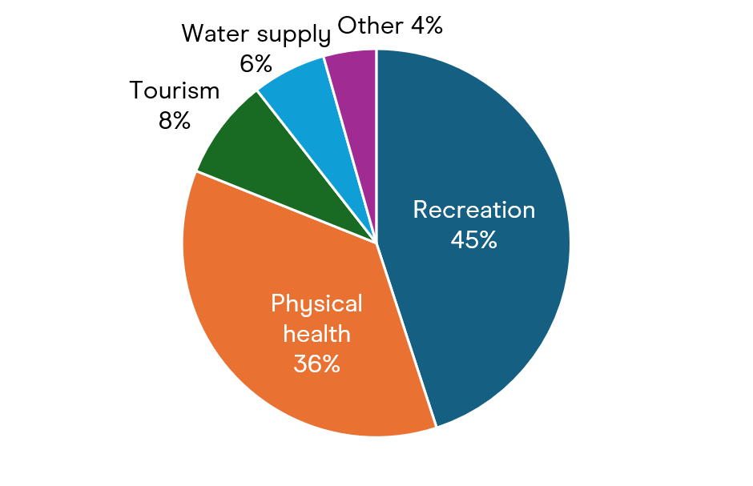
The remaining 11% of asset value is delivered from a range of other ecosystem services. Water provided through transfer agreements with water companies is valued at £6.1billion, aesthetic and recreation (house prices) benefits are valued at £2.5billion, urban heat regulating benefits are valued at £1.1billion, volunteering benefits are valued at £0.34billion, greenhouse gas regulating benefits valued at £0.28billion, air pollution regulating benefits valued at £0.07billion, and education valued at £0.01billion.
The relatively high £1.1billion urban heat regulating asset value reflects the benefit that the canals in urban areas will deliver with increasing temperatures as a result of climate change. The cooling effect of the Trust’s canals will become increasingly more valuable each year as temperatures rise over time.

Table 1: Summary results for 2023 – Total organisational (England & Wales) (£millions, 2023 price year, annual and asset value over 100-year period)
Ecosystem service | Physical Flow (annual) | Units | Monetary Flow (annual)  Millions (m) | Asset Value  Millions (m)
Provisioning services
Renewable energy provisioning | 92,845 | MWh | £1.76m | £52.46m
Water provisioning | 276,488,000 | m³ | £204.60m | £6,110.08m
Regulating services
Air pollution regulating | 9.96 (PM2.5), 8.16 (SO₂),  3.36 (NO₂), 213.66 (O₃) | Tonnes | £1.21m | £65.92m
Greenhouse gas regulating | 20,396 | Tonnes | £5.79m | £279.00m
Urban heat regulating | N/A | N/A | £14.41m | £1,077.07m
Cultural services
Recreation (enjoyment benefits) | 389,100,082 | visits (<3 hours, non-active, non-volunteer living >100m away) | £1,494.14m | £44,620.17m
Recreation (health cost savings) | 323,095,712 | active visits | £1,198.69m | £35,796.77m
Tourism | 72,489,119 | visits (3+ hours, non-active, non-volunteer living >100m away) | £278.36m | £8,312.71m
Aesthetic and recreation (house prices) | 271,739 | households living within 100 metres | £95.56m | £2,534.14m
Volunteering | 715,198 | volunteer hours | £11.33m | £338.31m
Education | 93,399 | hours of education | £0.45m | £13.50m
Total Value |  |  | £3,306.3m | £99,200.1m

Biodiversity
Biodiversity underpins the functioning of the Trust’s natural assets and the services they provide. It refers to ‘the variability among living organisms from all sources including terrestrial, marine and other aquatic ecosystems and the ecological complexes of which they are part’ (Convention on Biological Diversity). In line with Corporate Natural Capital Accounting (CNCA) guidance, biodiversity is understood as a supporting function, enabling key ecological processes such as pollination, nutrient cycling, soil formation and disease regulation. These processes sit behind the delivery of provisioning, regulating and cultural services captured elsewhere in the accounts. To avoid double counting, biodiversity is therefore not typically assigned a standalone monetary value within natural capital accounts.
While not directly valued, biodiversity remains a critical component of the Trust’s overall natural capital. Quantitative measures of habitat extent and condition - such as those derived from the Defra Biodiversity Metric - are incorporated within the asset register, providing an important indicator of the underlying ecological health of the network. Evidence from the Trust’s baseline work and the Vital Connector report highlights the role of the canal network in supporting diverse habitats and species, particularly within landscapes that are otherwise fragmented or nature depleted.

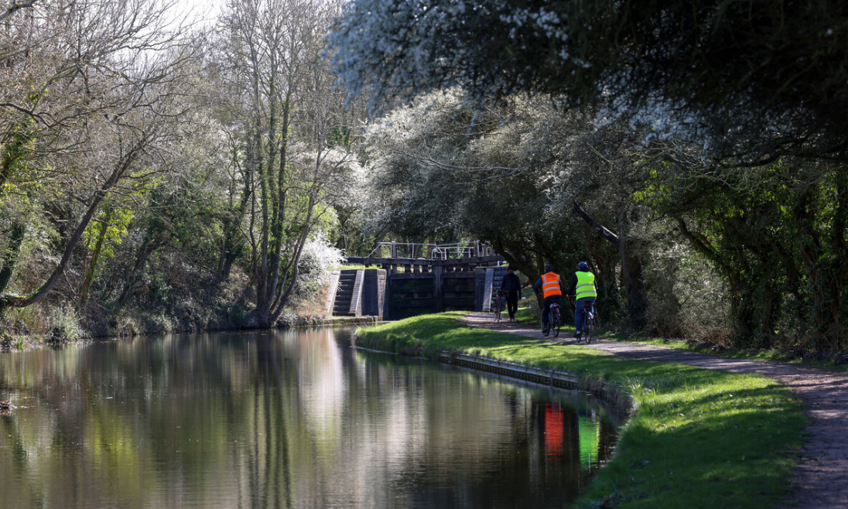

As such, biodiversity should be understood as the foundation that enables and increases the productivity of many of the benefits reported in the accounts, rather than a separate value stream. Recognising and maintaining this underlying ecological function is essential to sustaining the long-term flow of ecosystem services provided by the network.

Natural asset connectivity
The Trust’s canal network is one of the UK’s most extensive systems of connected blue-green infrastructure, acting as a continuous biodiversity corridor through both urban and rural landscapes. As highlighted in the Vital Connector report, these waterways function as “living arteries” that reconnect fragmented habitats - supporting species movement, dispersal and genetic exchange. In doing so, they help underpin ecosystem resilience, particularly in parts of the country where natural habitats are otherwise isolated. Current guidance doesn’t recommend including these system-level benefits within natural capital accounts due to the overlap with biodiversity benefits (which are not monetised because they are embedded across different ecosystem services) but they represent an important component of the value of the Trust’s natural assets. This is an area of potential future research.

Asset Register
The Trust manages 2,977km of watercourses and 11,079 hectares of total land area across England and Wales. The watercourse footprint accounts for just under half of the total land area. Of the non-watercourse land area, this is mainly comprised of woodland and forest (14%), urban (13%) and reservoirs and pond (lakes) (11%) habitats (see Figure 2).
Figure 2: Summary of extent of habitats managed by the Trust in 2023.
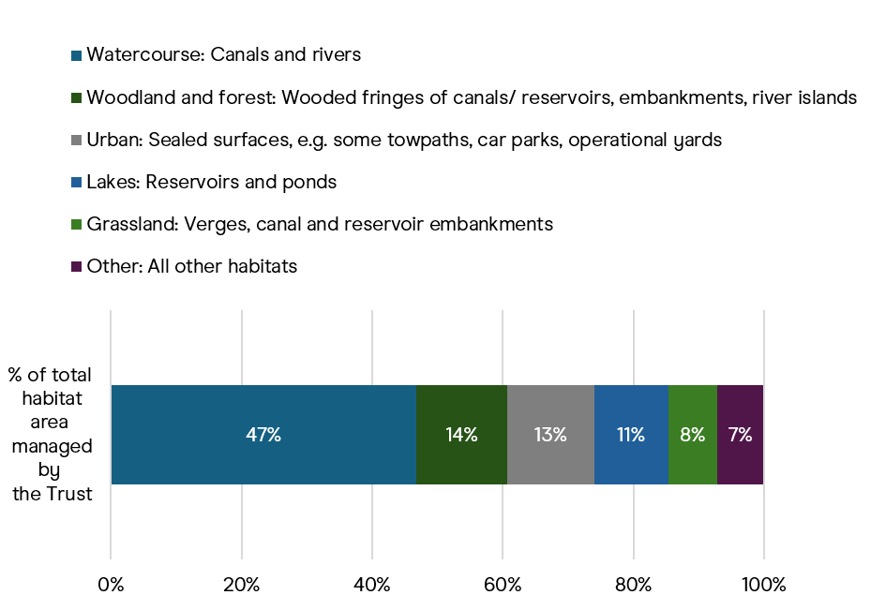
Total area: 11,079 hectares
Total watercourse length: 2,977km

Within the 2023 ecological baseline, each parcel of land is given a condition score using the Defra Biodiversity Metric. For the non-watercourse land area, 0.3% of habitat area under Trust management responsibility are classified as being in ‘Good’ condition, with 28.3% and 37.1% of the natural assets in ‘Moderate’ and ‘Poor’ condition respectively; the remaining 34.2% of assets do not have a condition assessment (see Figure 3).
For the watercourse habitats, condition is assigned based on Water Framework Directive (WFD) Ecological Class. 38.8% of Trust-managed watercourses are classified as being in ‘Good’ condition, 54.9% as being in ‘Moderate’ condition, 2.4% being in ‘Poor’ condition, 0.4% being in ‘Bad’ condition, and the remaining 3.5% not having any WFD Ecological Class (see Figure 3).

Figure 3: Summary of condition of natural assets managed by the Trust in 2023. For Habitats this is measured using the Defra Biodiversity metric. For Watercourses this is measured using Water Framework Directive (WFD) Ecological Class.
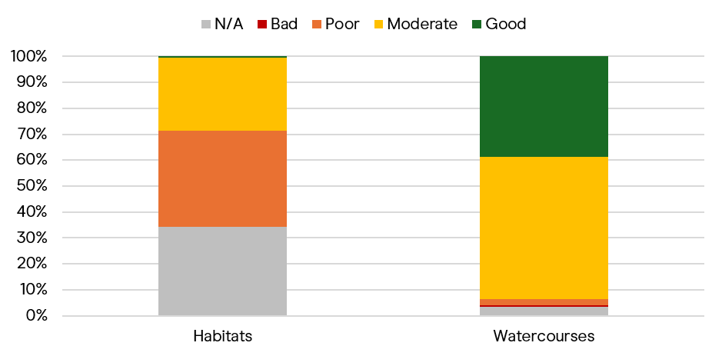

Key Regional Findings
The Canal & River Trust operates within six self-defined regional boundaries: London & South East, Yorkshire & North East, East Midlands, North West, West Midlands, and Wales & South West.
There are large differences in the annual monetary flow and asset value between Trust regions in the baseline accounts. Table 2 shows that the natural capital value of the London & South East region (£28.1billion) is far larger than that of the other regions, driven primarily by recreation-related benefits and water provisioning. £4.8billion of the £28.1billion London & South East natural capital value is driven by water provisioning. This reflects the current pattern of existing water transfer arrangements, which may change over time.
London & South East also delivers the majority of urban heat regulating benefits (£0.7billion of the total £1.1billion) across all regions, accounting for almost 65% of it. This service reduces the temperature of adjacent urban areas which in turn reduces the losses in labour productivity caused by hot days. This is due to the significant cooling effect generated by the London canal network and the large number of workers in London that may benefit from this cooling effect.
The Education benefits delivered by the North West and West Midlands regions are proportionally larger than for other regions. The Aesthetic and recreation (house prices) value delivered by the London & South East region are relatively higher than for other regions due to the large number of households in close proximity to a waterway and higher than average house prices in London. See Figure 4 for the relative contribution of region to the total monetary flow of each ecosystem service.

Table 2: Summary of breakdown of total natural capital asset value by Trust region in 2023 (£millions (m), 2023 price year, 100-year period).
Ecosystem service |  |  | Asset value
Ecosystem service | London & South East | Yorkshire & North East |  | East Midlands | North West | West Midlands |  | Wales & South West
Provisioning services
Renewable energy provisioning | £26.27m | £7.30m |  | £16.75m | £0.08m | £1.03m |  | £1.03m
Water provisioning | £4,839.66m | £0.00m |  | £0.00m | £0.00m | £399.28m |  | £871.14m
Regulating services
Air pollution regulating | £5.85m | £10.04m |  | £6.89m | £13.41m | £21.05m |  | £8.69m
Greenhouse gas regulating | £35.87m | £32.49m |  | £32.73m | £65.82m | £86.69m |  | £25.40m
Urban heat regulating | £695.03m | £68.97m |  | £0.00m | £147.85m | £155.38m |  | £9.83m
Cultural services
Recreation (enjoyment benefits) | £10,537.59m | £5,992.93m |  | £8,122.08m | £8,354.54m | £9,006.00m |  | £2,731.57m
Recreation (health cost savings) | £8,309.06m | £4,919.19m | £6,084.89m | £7,041.05m | £6,959.08m | £2,474.62m
Tourism | £2,440.08m | £1,103.61m | £1,306.10m | £1,427.60m | £1,437.72m | £445.49m
Aesthetic and recreation (house prices) | £1,153.69m | £183.03m | £144.13m | £360.97m | £546.77m | £145.55m
Volunteering | £33.96m | £49.52m | £76.71m | £46.54m | £85.69m | £45.89m
Education | £1.99m | £0.89m | £1.16m | £4.65m | £4.01m | £0.80m
Total Asset Value | £28,079.1m | £12,368.0m | £15,791.4m | £17,462.5m | £18,702.7m | £6,760.0m
Total Monetary Flow (annual) | £932.0m | £412.5m | £528.9m | £581.5m | £623.9m | £226.3m

Figure 4: Relative contribution of each region to the total annual monetary flow of each ecosystem service (%)
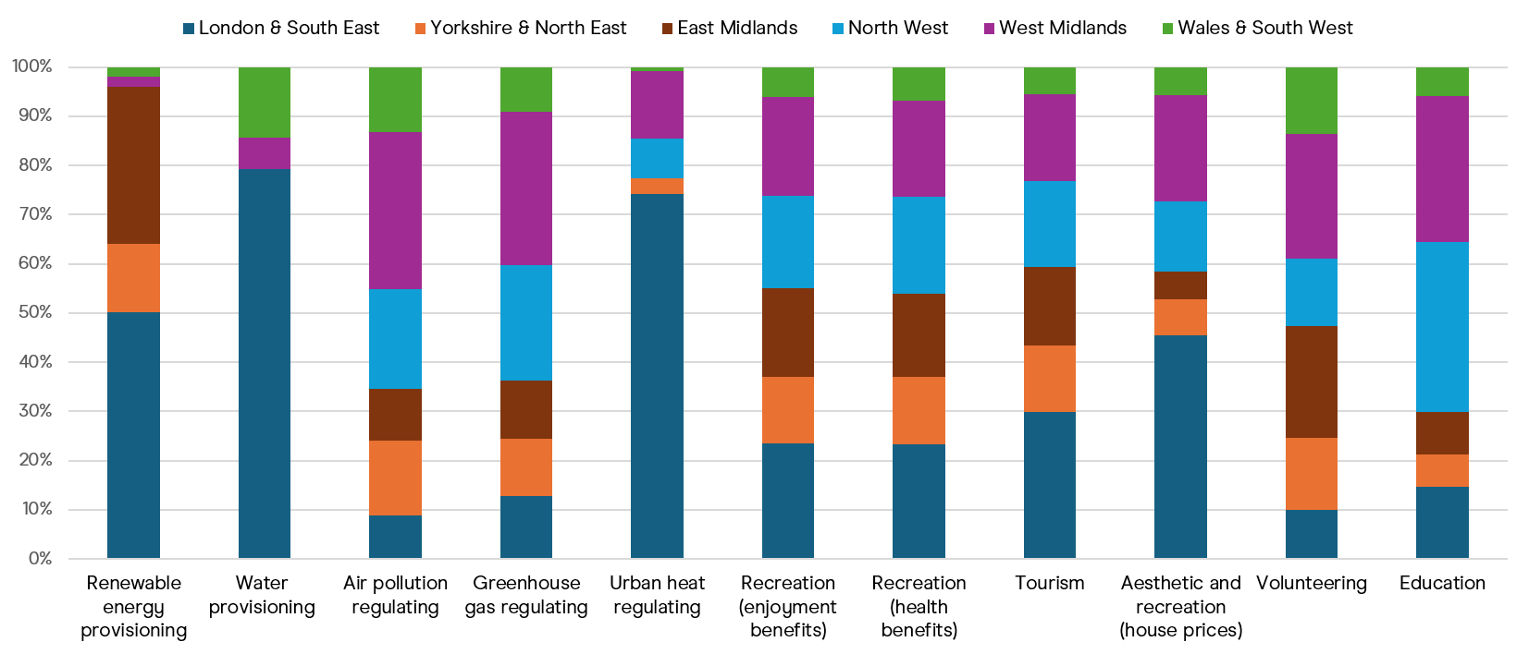

Asset Register
The West Midlands region contains the largest amount of natural capital assets (both by canal length and habitat area). The North West, East Midlands, and Yorkshire & North East regions contain the next largest amounts of natural capital assets, whilst the London & South East and Wales & South West regions contain the smallest quantities of natural capital assets.
The extent of broad habitat type varies across regions, as evidenced by London & South East containing a large proportion of lake (reservoirs and ponds) habitats (20%) compared with Wales & South West (3%). As different habitat types contribute to different ecosystem services, this results in some regions providing proportionately more or less of an ecosystem service relative to their overall size. Please see Figure 5.
Figure 5: Total habitat area (ha), total watercourse length (km) and proportion (%) of each habitat type by region
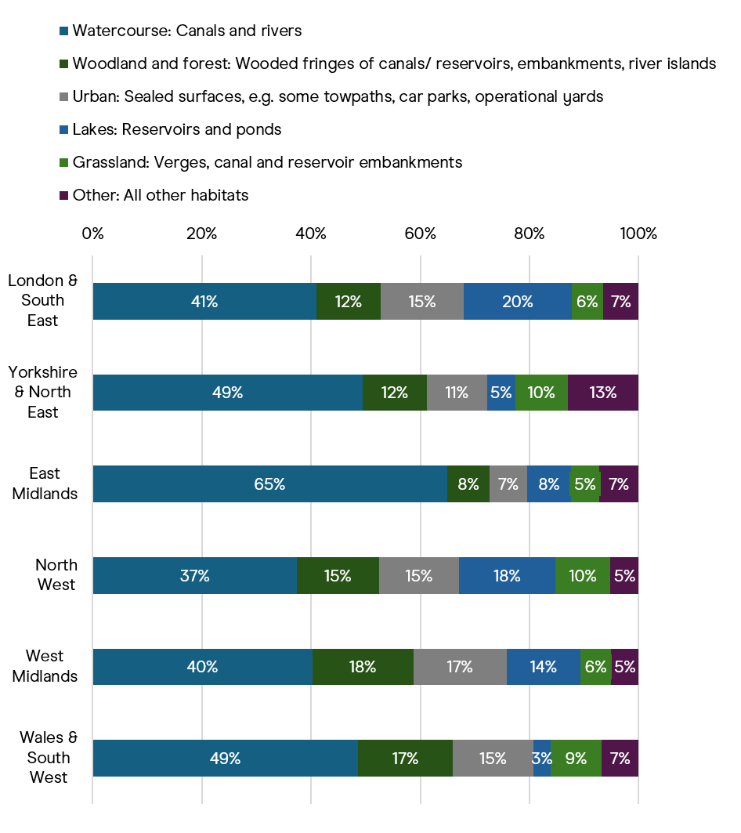
Watercourse length: 338km
Watercourse length: 834km
Watercourse length: 578km
Watercourse length: 479km
Watercourse length: 431km
Watercourse length: 318km
Total area: 1,198 hectares
Total area: 2,726 hectares
Total area: 2,056 hectares
Total area: 1,992 hectares
Total area: 1,973 hectares
Total area: 1,135 hectares

The condition of habitats varies significantly between Trust regions. In Yorkshire & North East, around 6% of land habitats are in ‘Good’ or ‘Moderate’ condition, whereas in the North West region, 40% are in ‘Good’ or ‘Moderate’ condition (see Figure 6).
The WFD ecological classification of canals shows that the average condition of waterbodies also differs significantly by region. The ecological condition of waterbodies is significantly higher in the West Midlands region and in the Yorkshire & North East region where 79% and 55% are in ‘Good’ ecological condition respectively. In contrast, only 6% of canals in the North West region and only 5% in the Wales & South West region are in ‘Good’ ecological condition (see Figure 7). Note, data for ecological condition is only available for England, Welsh waterbodies were not assessed for ecological condition.
Figure 6: Summary of condition of land habitats managed by the Trust in 2023, measured using the Defra Biodiversity metric
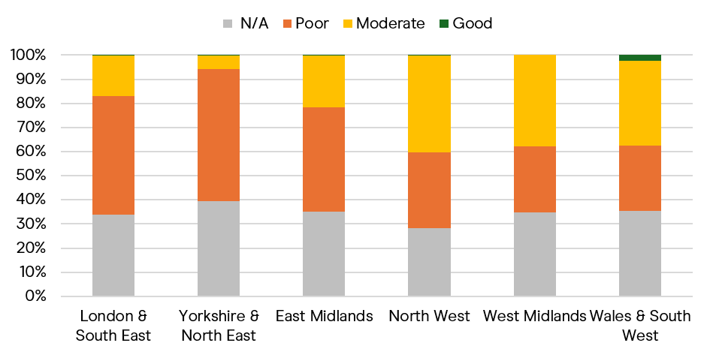
Figure 7: Summary of condition of watercourses managed by the Trust in 2023, measured using Water Framework Directive (WFD) Ecological Class.
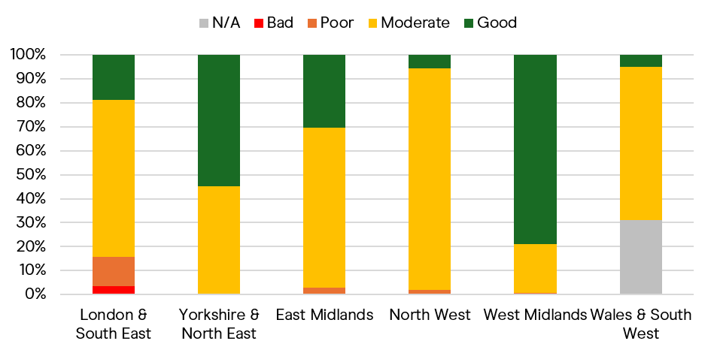

References
Canal & River Trust (2025). The Vital Connector for Nature and People: The Role of our Canal Network in UK Nature Recovery and Connectedness. Available at: https://canalrivertrust.org.uk/our-cause/the-vital-connector-for-nature-and-people-report
CEFAS (2021). Carbon stocks and accumulation analysis for Secretary of State (SoS) region: Cefas Project Report for Defra, 42 pp. Available at: https://randd.defra.gov.uk/ProjectDetails?ProjectId=20754
Costa, H., Floater, G., Hooyberghs, H., Verbeke, S. and De Ridder, K., (2016). Climate change, heat stress and labour productivity: A cost methodology for city economies. Centre for Climate Change Economics and Policy Working Paper No. 278. Grantham Research Institute on Climate Change and the Environment Working Paper No. 248. Available at: https://www.cccep.ac.uk/wp-content/uploads/2016/07/Working-Paper-248-Costa-et-al.pdf
Defra (2023). Enabling a Natural Capital Approach (ENCA). Available at: https://www.gov.uk/guidance/enabling-a-natural-capital-approach-enca
DESNZ and BEIS (2024). Traded carbon values used for modelling purposes, 2023. Available at: https://www.gov.uk/government/publications/traded-carbon-values-used-for-modelling-purposes-2023/traded-carbon-values-used-for-modelling-purposes-2023
Eftec (2018). Scoping UK urban natural capital account - local climate regulation extension. Available at: https://randd.defra.gov.uk/ProjectDetails?ProjectID=20065&FromSearch=Y&Publisher=1&SearchText=urban
Ferrini, S., Reas, V., Bartolini, A., Ekins, P., and Grice, J. (2025). Economic Methods for Water Ecosystem Services for SEEA EA. ESCoE Discussion Paper No. 2025-06.
Gibbons, S., Peng, C. & Tang, C.K. (2021). Valuing the environmental benefits of canals and canal restoration using house prices. Land Economics, 97(4), 858- 874. Available at: https://researchonline.lse.ac.uk/id/eprint/107931/1/Gibbons_Valuing_environmental_benefits_canals_2021.pdf
Jones, L., Vieno, M., Morton, D., Hall, J., Carnell, E., Nemitz, E., Beck, R., Reis, S., Pritchard, N., Hayes, F., Mills, G., Cryle, P., Dickie, I., Koshy, A., Holland, M., (2017) Developing estimates for the valuation of air pollution removal in ecosystem accounts. Final report for Office of National Statistics. Wallingford, NERC/Centre for Ecology & Hydrology, 75pp. (CEH Project no. C06156) Available at: https://nora.nerc.ac.uk/id/eprint/524081/
Lawton, R.N., Gramatki, I., Watt, W. et al. (2021). Does Volunteering Make Us Happier, or Are Happier People More Likely to Volunteer? Addressing the Problem of Reverse Causality When Estimating the Wellbeing Impacts of Volunteering. J Happiness Stud 22, 599–624.
Mourato, S., Atkinson, G., Collins, M., Gibbons, S., MacKerron, G., and Resende, G. (2010). Economic Analysis of Cultural Services. Available at: https://www.cbd.int/financial/values/unitedkingdom-culturalvalues.pdf
Murphy, J.M., Sexton, D.M.H., Jenkins, G.J., Boorman, P.M., Booth, B.B.B., Brown, C.C., Clark, R.T., Collins, M., Harris, G.R., Kendon, E.J., Betts, R.A., Brown, S.J., Howard, T. P., Humphrey, K. A., McCarthy, M. P., McDonald, R. E., Stephens, A., Wallace, C., Warren, R., Wilby, R., Wood, R. A. (2009), UK Climate Projections Science Report: Climate change projections. Met Office Hadley Centre, Exeter.
Natural Capital Committee (2015). Developing Corporate Natural Capital Accounts: Final Report. Available at: https://www.gov.uk/government/publications/natural-capital-committee-research-corporate-natural-capital-accounting
Natural England (2021). Carbon storage and sequestration by habitat: a review of the evidence (second edition). Natural England Research Report NERR094. Natural England, York. Available at: https://publications.naturalengland.org.uk/publication/5419124441481216#:~:text=This%20Natural%20England%20Research%20Report,their%20condition%20and%2For%20management
Office for National Statistics (ONS) (2017a). Principles of Natural Capital Accounting. Available at: https://www.ons.gov.uk/economy/environmentalaccounts/methodologies/principlesofnaturalcapitalaccounting
Office for National Statistics (ONS) (2017b). Changes in the value and division of unpaid volunteering in the UK: 2000 to 2015. Available at: https://www.ons.gov.uk/economy/nationalaccounts/satelliteaccounts/articles/changesinthevalueanddivisionofunpaidcareworkintheuk/2015#time-and-participation-in-formal-volunteering-in-the-uk-between-2000-and-2015
Office for National Statistics (ONS) (2023). Urban natural capital accounts, UK: 2023. Available at: https://www.ons.gov.uk/economy/environmentalaccounts/bulletins/urbannaturalcapitalaccountsuk/2023
Office for National Statistics (ONS) (2024). UK natural capital accounts: 2024. Available at: https://www.ons.gov.uk/economy/environmentalaccounts/bulletins/uknaturalcapitalaccounts/2024
ORVal (2018). Outdoor Recreation Valuation (ORVal) User Guide: Version 2.0. Land, Environment, Economics and Policy (LEEP) Institute, Business School, University of Exeter. Available at: https://www.leep.exeter.ac.uk/orval/
United Nations (UN), European Commission, International Monetary Fund, Organisation for Economic Co-operation and Development, & World Bank. (2025). System of National Accounts 2025: Pre-edit version. Available at: https://unstats.un.org/unsd/nationalaccount/sna25.asp
University of Manchester (2019). Canals, Cooling and Replicable Models - Summary Report to the Canal and River Trust. Available at: https://documents.manchester.ac.uk/display.aspx?DocID=57300
White, M.P., Elliott, L.R., Taylor, T., Wheeler, B.W., Spencer, A., Bone, A., Depledge, M.H., Fleming, L.E. (2016). Recreational physical activity in natural environments and implications for health: A population-based cross-sectional study in England. Preventive Medicine 91, 383–388.

Appendix: Summary of methodology by ecosystem service
Table 3: Summary of methodology by ecosystem service
Ecosystem Service | Physical Flow | Confidence (Physical) | Valuation Method | Confidence (Monetary) | Evidence Source | Discount Rate | Asset Value Assumptions
Provisioning Services
Renewable energy provisioning | Average annual MWh energy provided | M | Resource rent, £/kWh | M | ONS (2024) resource rent, Trust data | Standard: 3.5%, declining after 30 years | Renewable energy provision remains constant over 100-year period
Water provisioning | Volume of water transfer, m3 per year | M | Resource rent, £/m3 | M | ONS (2024) resource rent, Trust data | Standard: 3.5%, declining after 30 years | Water transfer agreements remain constant over 100-year period
Regulating Services
Air pollution regulating | Tonnes air pollutant emissions removed per hectare by habitat type | M | Avoided health damage cost, £ per tonne by pollutant | M | Jones et al. (2017) (re-published 2019), ONS (2024) | Health: 1.5%, declining after 30 years | Constant real value of pollutant removed per hectare over time
Greenhouse gas regulating | Net carbon sequestration by habitat type, tCO2e/ha | M | Cost-based approach, marginal abatement cost to meet the UK net zero target by 2050, £/tCO2e | H | Evidence from ENCA 3.1 (2024): Natural England (2021), CEFAS (2021), ONS (2023), DESNZ and BEIS (2024) | Standard: 3.5%, declining after 30 years | Increasing non-traded cost of carbon over time
Urban heat regulating | N/A | M | Avoided loss in labour productivity, £ saving due to urban cooling effect of canals | L | Eftec (2018), ONS (2024), University of Manchester (2019), Costa et al., (2016), Murphy et al., (2009) | Standard: 3.5%, declining after 30 years | Increasing temperatures in line with UKCP09, GVA uplift of 2% annually, decreasing to 1.5% for years 31 – 75, and 1% for years 76 – 100
Cultural Ecosystem Services
Recreation (enjoyment benefits) | Number of unique visits per year | M | Travel costs (ORVal) | M | ORVal (2018) | Standard: 3.5%, declining after 30 years | Visits remain constant over time
Recreation (health cost savings) | Number of active visits per year | M | Avoided NHS health costs, £ per active visit | M | White et al., (2016) | Standard: 3.5%, declining after 30 years | Active visits remain constant over the 100-year period
Tourism | Domestic visits per year that are 3+ hours long | M | Travel costs (ORVal) | M | ORVal (2018) | Standard: 3.5%, declining after 30 years | Domestic tourism visits remain constant over the 100-year period
Aesthetic and recreation (house prices) | Number of households living within 100m of a canal | H | Hedonic pricing, house price premium, £ per household | M | Gibbons et al. (2021) | Standard: 3.5%, declining after 30 years | Number of houses within 100m of a canal remains constant. Aggregate price premiums are annualised over a 60-year period to estimate equivalent annual flows.
Volunteering | Number of volunteer hours | H | Replacement wage approach | H | ONS (2017b), Lawton et al. (2021) | Standard: 3.5%, declining after 30 years | Volunteer hours / number of volunteers remain constant over the 100-year period
Education | Number of participant hours per year | M | Travel cost method, £ per pupil hour | M | Mourato (2010) | Standard: 3.5%, declining after 30 years | Education programme continues at current scale over the 100-year period

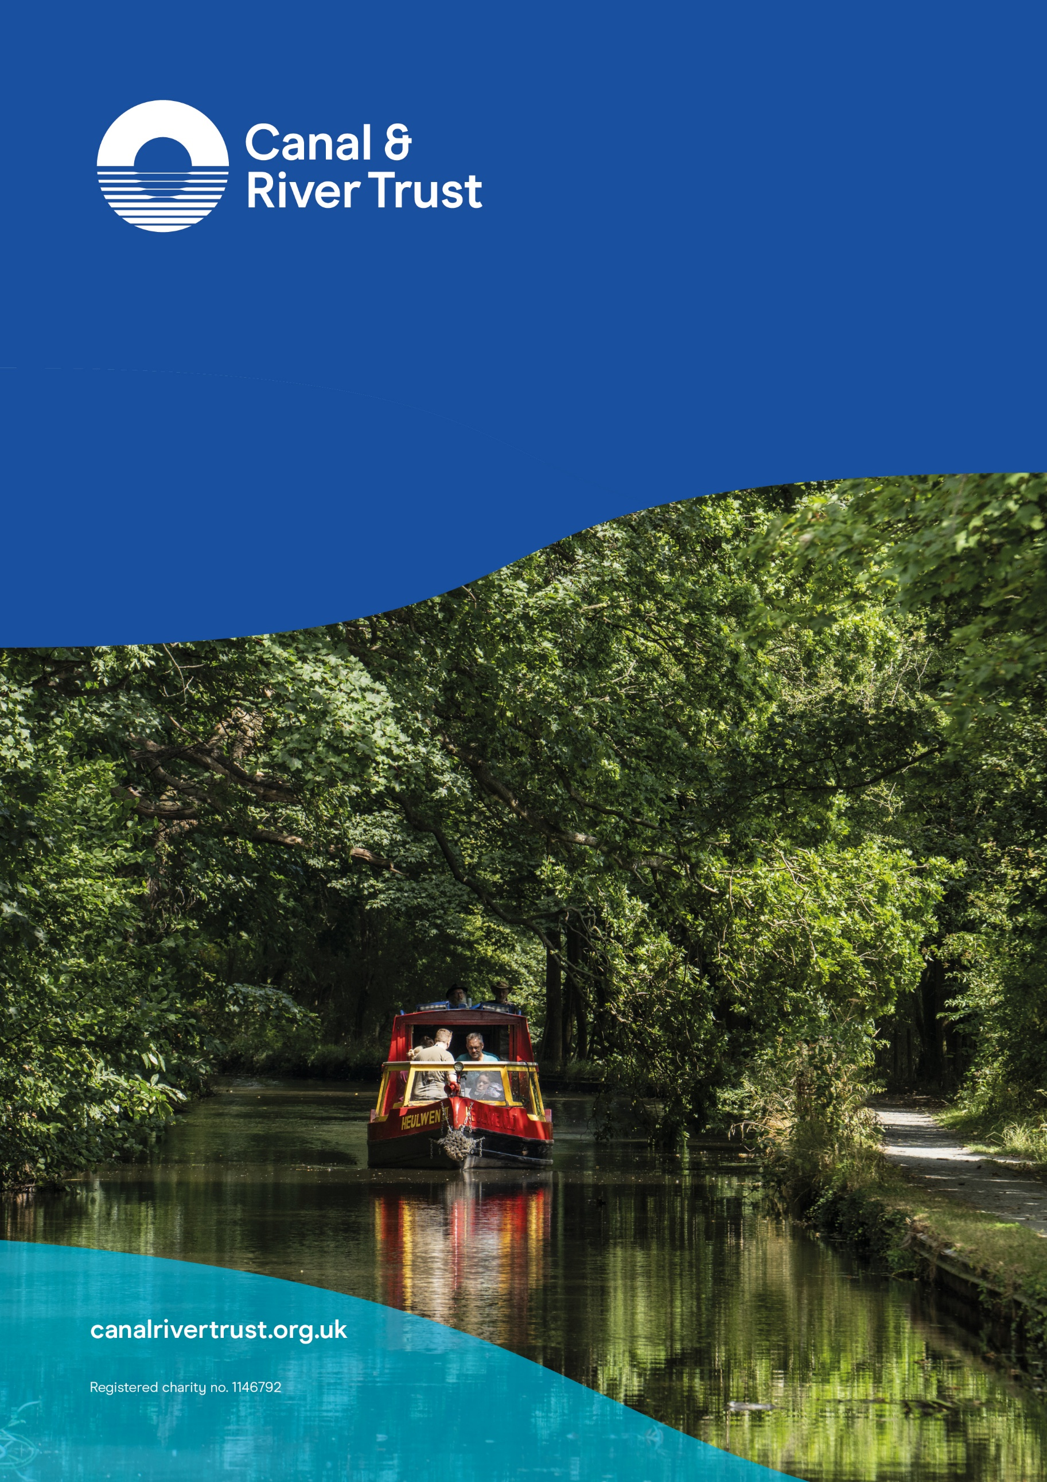
For any queries, please contact Brenda Dorpalen (Insights and Economics Team Manager) at
Brenda.Dorpalen@canalrivertrust.org.uk

HM Treasury (2022): The Green Book – Central Government Guidance on Appraisal and Evaluation; The Green Book (publishing.service.gov.uk)
This doesn’t include the Grand Union Canal Water Transfer Project. It will be included in the next iteration.
This category predominantly includes Urban, Cropland, and Other habitat types.
Excludes active visits, visits >3 hours, visits from volunteers, and visits from those living within 100m to ensure there is no double counting between cultural ecosystem services
Excludes visits from volunteers, and visits from those living within 100m to ensure there is no double counting between cultural ecosystem services.
Excludes active visits, visits from volunteers, and visits from those living within 100m to ensure there is no double counting between cultural ecosystem services.

