Construction Environmental Management Plan (CEMP)

for

Construction of an open water reserve, Coppice Lane, Pool Quay, Powys

April, 2024

Contents

|  |  |
| --- | --- |
| Section | Topic |
| 1.0 | Introduction |
| 2.0 | Regulatory Framework and Planning Conditions |
| 3.0 | Site Location & Project Description |
| 4.0 | Construction Programme |
| 5.0 | Roles and Responsibilities |
| 6.0 | Information for Contractors and Visitors |
| 7.0 | Environmental Assessment |
| 8.0 | Ecology |
| 8.1 | Plants & Habitats |
| 8.2 | Fish |
| 8.3 | Bats |
| 8.4 | Badgers |
| 8.5 | Reptiles |
| 8.6 | Amphibians |
| 8.7 | Birds |
| 8.8 | Otters |
| 8.9 | Water voles |
| 8.10 | Trees & woodland |
| 8.11 | Invasive & Injurious Plant Species |
| 9 | Air Quality |
| 10 | Waste |
| 11 | Heritage |
| 12 | Water use |
| 13 | Pollution Prevention & Hazardous Materials Storage |
| 14 | Soil & Geology |
| 15 | Construction Lighting |
| 16 | Noise and Vibration |
| 17 | Housekeeping and Security |
| 18 | Incident Response |
| 19 | Internal Communications |
| 20 | External Communications |

1.0 Introduction

**1.1** The aim of the Construction Environmental Management Plan (CEMP) is to set out the responsibilities with regards to compliance with legislation and to implement any mitigation measures.

**1.2**  This CEMP details management measures to minimise environmental and community related impacts from the construction phase of the development.

**1.3**  It also provides a framework within which the measures will be implemented throughout the project.

**1.4**  The CEMP provides project-specific management measures and is a dynamic document, which is to be reviewed if activities or conditions onsite change that may influence management measures.

**1.5** This document has been developed to avoid, minimise and mitigate against any construction effects on the environment and surrounding community. It should be considered a living document with reviews being undertaken at regular intervals and new information added as appropriate.

**1.6** For the purposes of this document, the working area is defined as any area where there will be a requirement for temporary or permanent works to facilitate the construction of the development. This includes areas required for access, temporary construction and temporary storage areas.

2.0 Regulatory Framework & Planning Conditions

2.1 The proposed scheme is to construct an open water reserve which sits next to the Montgomery canal and will be connected to the canal by an inlet/outlet structure, which will provide the water for the reserve.

**2.2** The CEMP provides the framework for which commitments made in the Canal & River Trust’s (the Trust) Environmental Appraisal (EApp) can be realised. The CEMP outlines the construction phases with the primary aim of reducing any adverse impacts from construction on local sensitive receptors.

**2.3** This CEMP forms part of the pre application/planning package of documents.

**2.4** For the purposes of this planning, Development does not refer to any of the following enabling works:

- site investigations

- ecological management measures

- archaeological investigations

- tree/vegetation management

**2.5** If work on site is related to clearing of the site, it would not be considered as commencement or development.

**3.0 Site Location & Project Description**

**3.1** The CEMP has been produced to support a pre application and planning application. The work involves the excavation of a pond/reserve (Figure 2) which will be connected to the Montgomery canal by an inlet/outlet structure and will be naturally filled with water from the canal. The NGR for the site is SJ 25592 13107).

**3.2** The red line boundary and blue line (land purchase) boundary for the proposed scheme (Figure 1) is shown below. The land for the reserve is currently being purchased by the Canal & River Trust.

Figure 1 Wern reserve – red and blue line boundary

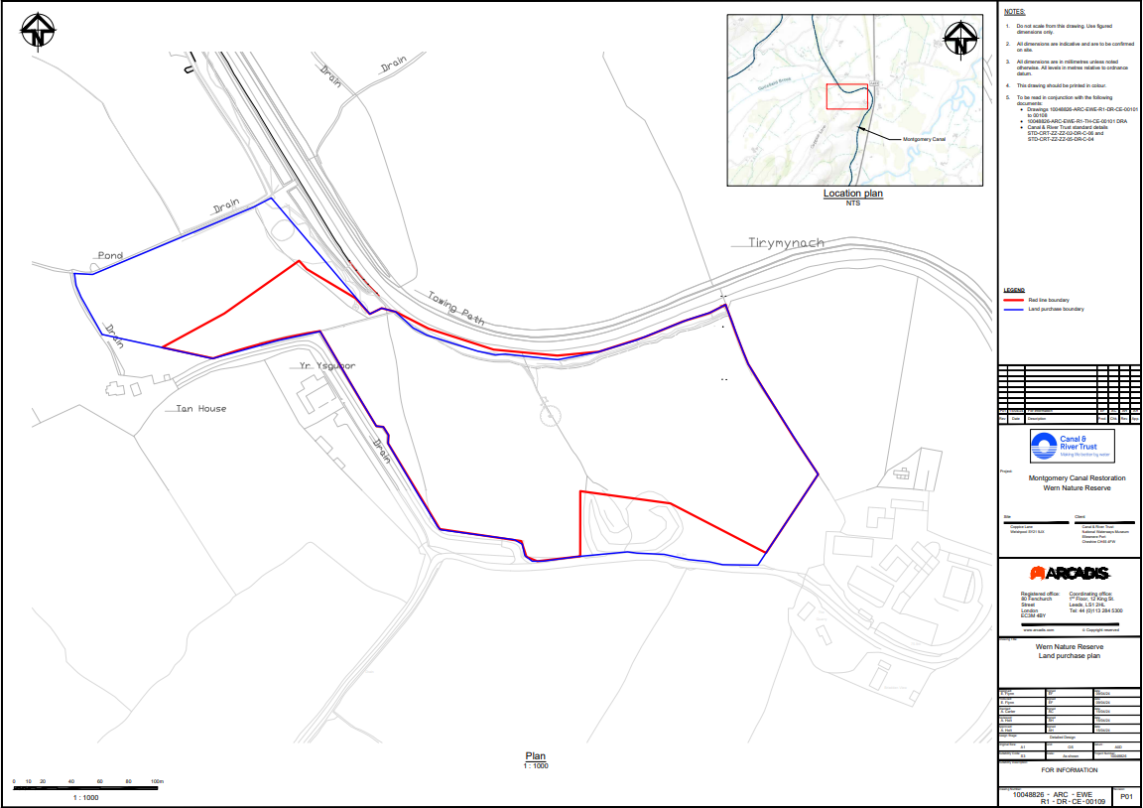

Figure 2 Wern reserve – general arrangement

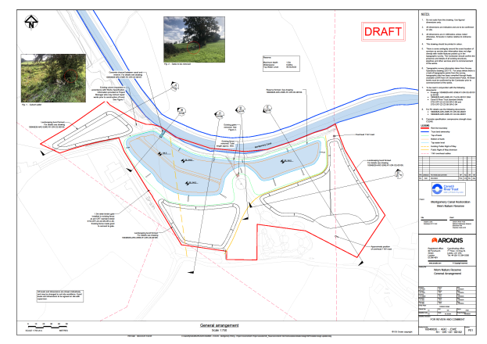

**3.3**  The site is approximately 6km north of Welshpool.

3.4 The site is comprised of 3 irregular parcels of improved grassland, which has been used for grazing. It is bounded by the Montgomery canal, Coppice Lane and 3 residential properties.

The site is almost entirely bound by mature hedgerow and trees along the southern, western and eastern boundaries. Vegetation along the northern boundary with the canal includes belts of scrub and grassland. A mature outgrown hedgerow and several mature trees extend through the centre of the site.

**3.5** There are no hospitals, care homes or schools in the immediate vicinity.

**3.6** The construction work will take place within the development site. A small amount of hedgerow will need to be removed. The reserve design has been altered to avoid the notable oak tree. Some of the excavated soil will be reused on site as part of landscaping surrounding the reserve and there is scope to create more complex habitat on the site.

**3.7**  A PRoW which currently crosses the site, will be diverted within the site boundary.

**3.8** The reserve has been designed to provide additional aquatic habitat and will enhance biodiversity.

**3.9** The works include:

- Establishing a temporary site access and causeway over the canal (single vehicle crossing) for construction vehicles.

- Establishing a site compound and welfare facilities.

- Excavation of existing ground to form a new reserve profile (the reserve will provide approx 1 ha of open water, to a depth of 1.5m).

- Approx 43,000 m3 of soil will be excavated, it is expected that 60% of soil arisings will be reused on site in landscaped areas. The remaining soil will need to be removed from site and either reused locally (in agreed schemes) or taken to a landfill site for disposal.

- The landscaping will be designed to enhance the biodiversity of the area.

- Installation of pumps to temporarily pump canal water over the causeway. Pipes to be installed in the causeway to maintain some water flow.

- Decommissioning of existing water supply lines that cross the site and laying new water supply lines and connecting to the existing (work currently being confirmed with Severn Trent Water).

- Constructing 1 reinforced concrete weir to connect the reserve to the canal, part of which will require localized dewatering of the canal.

- Public Right of Way (PRoW) diversion – this will require very little work (as current PRoW is grassed and a like for like diversion is required).

**4.0 Construction Programme**

To be supplied once a contractor has been appointed.

**5.0 Roles and Responsibilities**

These will be supplied once a contractor is appointed.

**5.1**  The contractor will be responsible for ensuring that the CEMP is developed held on site and updated throughout the project. They will ensure that all contractors and visitors are aware of and comply with it.

**5.2**  The contractor will ensure that the site and all stored materials and chemicals are safe and secure and site will be kept in a tidy and orderly manner.

The contractor will ensure that emergency egress arrangements are in place, first aid facilities and appropriately trained first aid staff, spill kits and appropriately trained staff.

**5.3** The contractor will ensure that all activities are carried out in accordance with associated RAMS and records will be kept of any incidents/near misses.

**6.0 Information for Contractors and Visitors**

**6.1** All contractors and visitors will be made aware of Health and Safety and Environmental appraisal/CEMP.

**6.2**  The onsite project manager will be responsible for monitoring communications between all relevant parties to the project ensuring that all environmental matters to the project are discussed and managed. All communications will be documented in the fortnightly site meetings and sent to all relevant parties.

**6.3** The relevant site layout and locations plans/CDM drawing detailing the location and construction of the site compound, storage locations and car parking are to be displayed on information boards in the main site cabin.

**7.0 Environmental Assessment**

**7.1** The works will comply with the Canal & River Trust’s Environmental appraisal (Eapp) and environmental policy requirements. The Eapp is a works specific document that ensures the key environment, heritage and community impacts of each specific activity are considered, detailed, addressed and mitigated accordingly where necessary. The appraisal is validated by the Trust’s inhouse specialists and under which works could proceed in terms of internal approval. The Eapp remains a live document that is also revised as necessary, in the event of any changes encountered on site.

**7.2** The environmental appraisal considers each work activity to be undertaken and the potential for them to have an impact and includes consideration of and actionable measures where necessary under the following headings:

- Planning

- Built Heritage

- Biodiversity/Ecology

- Water

- Waste

- Hazardous Materials Use and Storage

- Contamination

- Resource use and procurement

- Nuisance

- Landscape

- Customers and access

- Environmental enhancement

**7.3** A scoping Eapp (2210-3111-0055-9955) was produced for the works in October 2022, which indicated that additional survey work was needed. A full Eapp is due to be produced which will include details/actions from ecological, arboricultural and archaeological surveys and the HRA.

**8.0 Ecology**

**8.0.1** Desktop and field surveys of the site have been undertaken by qualified and experienced ecologists from Arcadis Consulting. All habitats within the proposed works area, and adjacent, were noted and potential for protected or notable species was assessed. A summary of the key finds and especially actions for the construction phase are listed below.

**8.0.2** As a standard, an Ecological Clerk of Works (ECoW) will be working closely with this development. This will include during the planning of the construction works and will cover ecological risks, mitigation and awareness. Mitigation will be planned with contractors before and throughout the scheme to protect noted habitat, plant and animals, and remove risks.

**8.0.3** As a general rule, best practice measure should be put in place to prevent animals from getting trapped in excavations. Placing ramps, covering holes or excavating such that a gentle slope is retained on one side of the excavation, must be put in throughout the works.

**8.1 Protected Sites and Protected Plants**

**8.1.1** The canal is designated as a Site of Special Scientific Interest (SSSI) and Special Area of Conservation (SAC). A major reason is for the presence of Floating water plantain (*Luronium natans*), which is a protected species. A Habitats Regulations Assessment (HRA) has been undertaken and concluded the development will not result in an adverse effect on the integrity of the site. However, this requires mitigation measures to be put in place.

**8.1.2** The ECoW will undertake surveys of the canal before works starts to ensure the protected plant is not present. The specific design, location and reinstatement of the temporary canal crossing is to be finalised through detailed design with the Contractor and agreed with the ECoW.

**8.1.3** The ECoW will ensure the Contractor and their staff are aware of the designated site and protected plant. Toolbox talks will be given before works start on site.

**8.1.4** Other mitigation measures were set out in the HRA but are covered elsewhere in this CEMP so will not specifically be detailed. This includes Pollution Prevention and invasives/Biosecurity.

**8.2 Plants and Habitats**

**8.2.1** Only one priority habitat was noted to be present on site and could be impacted by the construction works. These are the species rich hedgerows that are present around the fields. These will not directly be impacted by the works. There is a risk they could be impacted indirectly through root damage. Therefore, the ECoW will plan construction works with the contractors to ensure no works occur within the zone of risk for the hedges. If this is not possible, root protection zones will be needed.

**8.2.2** Veteran and notable trees (trees of considerable age and significant habitat value) are present in the centre of the site. The scheme has been designed to protected these trees so none will be impacted by the works. Root protection zones are required to be set up around the trees, as set out in the Arboriculture report. One tree will have its root protection zone incurred due to the works and a qualified arborist is required to be present for this to ensure the long-term health of the tree.

**8.3 Bats**

**8.3.1** No trees are to be impacted by the works. Root protection zones will ensure they are protected from harm. But bats could be impacted otherwise by lighting. Lighting should be strongly avoided on the site. If lighting is required, this must be directed away from trees and other habitat features and must be agreed with the ECoW before being installed.

**8.4 Badgers, Dormice, Hedgehog and Otter**

**8.4.1** Risks are low for these species and none were noted on or around the site. The ECoW will produce a method statement for all the species. The ECoW will undertake checks of the site before works commence (no more than 2 weeks before) and throughout the construction phase to inform on site works. Toolbox talks are required for those working on site.

**8.4.2** Other measures to protect habitats, plants and other species will also ensure these species are not impacted, if present or passing through. Contractors must ensure all measures are discussed and implemented with ECoW.

**8.5 Reptiles and amphibians**

**8.5.1** The site was deemed to have low suitability for great crested newts. As a precautionary approach the works are required to be undertaken under the supervision by the ECoW.

**8.5.2** The ECoW is required to be present on site before and during the works to undertake reptile checks. A method statement will be produced to detail this.

**8.6 Birds**

8.5.1 All vegetation works, although limited, must be undertaken outside of the bird breeding season (breeding season is March to August inclusive). General best practice for the protection of birds is required and a toolbox talk will be given to those working on site before works commence.

+

**8.7 Invasive Species**

8.7.1 There is a low risk the works could lead to the spread of invasive species, namely Himalayan balsam and Nuttall’s waterweed. These are not present on site, but propagules could be carried down the canal. Therefore, biosecurity measures are required to prevent the spread onto the site, around and offside. Check, Clean, Dry procedures will be put in place by the contractors and agreed by the ECoW.

**9.0 Air Quality**

**9.1** The construction work will involve the excavation of soil, with the some of the soil being reworked on site and the remaining soil being taken off site for disposal, reducing the number of vehicles movements from the site.

**9.2** Mitigation measures for the construction traffic will be implemented as part of the Construction Traffic Management Plan (CTMP). The CTMP will consider the effect of:

- Changes to the existing highway network through regulation/traffic control orders required by the project.

- Vehicular activity generated by the construction process

- Public traffic accessing the site during the construction process

- Designated haul routes and restricted routes for construction traffic.

- Loading, unloading and manoeuvring of plant and materials.

**9.3** The contractor will ensure that all contractors and material suppliers are safely implementing the CTMP during the construction period.

**9.4** All subcontractors, operatives and suppliers will be made aware of the CTMP.

**9.5** The primary access to the works area/compound for all construction will off an unnamed road, which forms a priority junction with the A483. A temporary access road will be constructed across farmland and a small parcel of Mid Wales Road Trunk Agency (NMWRTA) land. A

temporary causeway will be constructed over the canal (Figure 3).

Figure 3 Temporary access route and canal causeway

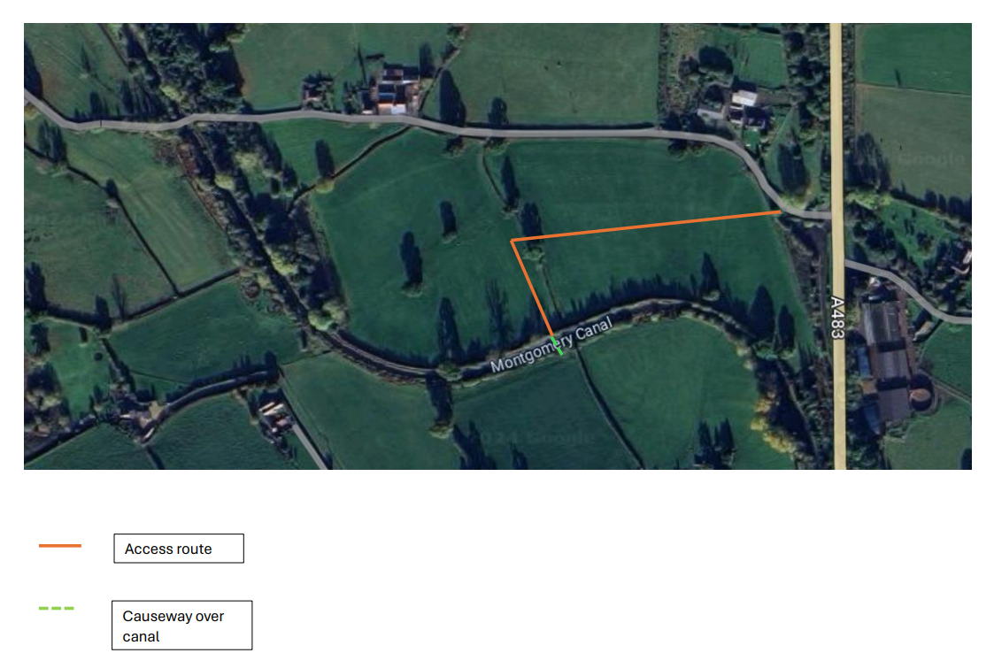

**9.6** The following traffic management principes will be observed:

- Delivery vehicles will supply and remove materials from site using the access track and the contractor’s compound.

- Delivery vehicles whenever practical will avoid peak public traffic hours to reduce traffic congestion and nuisance to the existing road and highway network. No deliveries shall be made on Sundays or statutory banks holidays unless under exceptional circumstances and agreed with local authority.

- To avoid construction traffic congestion and nuisance to the surrounding area all suppliers and contractors will be made aware of traffic routes.

- At certain times of the year, it may be necessary to provide a wheelwash facility during export activities. Road sweepers will be used as required to keep the local access roads clean.

- All materials will be loaded with the site compound/boundary of the working zone to minimise congestion.

- For environmental and road safety all material containers leaving the site will be appropriately covered to avoid soiling of the roads and highway. Engines of all vehicles, mobile and fixed plant on site are not to be left running unnecessarily.

- Plant will be well maintained, with routine servicing of plant and vehicles to be completed in accordance with the manufacturers recommendations and records maintained for the work undertaken.

- All project vehicles will hold current MOT certificates where applicable and where required due to the age of the vehicles and they will comply with exhaust emission regulation for their class.

- Avoid the use of diesel or petrol powered generators as much as possible, using battery powered equipment where practical.

- All commercial road vehicles used in construction must meet the European Emission Standards pursuant to EC Directive 99/69/EC (commonly known as Euro standards) of Euro 3 during any works.

**9.7** Only a limited number of car and HGV construction movements typically occur during the peak hours of 8:30 – 9:15 and 15:00 – 16:00. The working hours of most operatives would not coincide with the network peak and construction processes would be programmed to avoid the more congested periods.

**9.8** Only trained, certified and competent operatives will be allowed to operate the plant machinery. A record of all operative’s certificates should be kept in the site office.

**9.9** All plant should come to site with a current and up to date record of service and annual inspection sheet. An onsite weekly inspection will be carried out by the site agent of all operated plant and recorded. All plant maintenance is to take place in the site compound only. Refuelling of all plant is to take place in the site compound only. Refuelling of all plant is to take place in the compound and drip trays are to be employed during the fuelling process.

Management of dust

**9.10** The application of standard dust control measures included in the British Research Establishment guidance (Building Research Establishment, 2003) will be used. Standard measures will be applied to the construction areas as agreed with the local authority/pollution control office or Environmental Health Officer.

- Staff will receive a Toolbox talk regarding the control of dust and will ensure the site is monitored for levels of surface dust. Should dust build up this will be damped down with hosepipes or removed by a road sweeper as appropriate.

- Record all dust and air quality complaints, identifying causes(s), take appropriate measures to reduce emissions in a timely manner and record the measures taken.

- The access road into and out of the site will be monitored for excessive build up. Should surface dust build up the road will be swept.

- The name and contact details of person accountable for air quality and dust issues will be displayed on site boundary.

**10.0 Construction Site Waste**

10.1 When considering management options for identified waste stream, the Trust, contractors and sub contractors will adhere to the principles outlines in the waste hierarchy below:

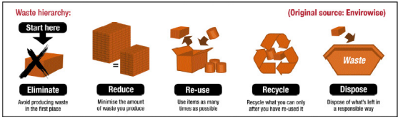

10.2 Waste will be stored away from drains, boreholes, wells and controlled waters. Containers shall be in good condition and where required covered to prevent dust and litter being blown out. If there is any likelihood of any stored waste contaminating the surrounding environs, all necessary steps will be taken to ensure no contamination occurs. This may include the use of containment bunds and/or sealed containers.

**10.3** Before the waste is treated and/or removed from the site, the following legible documents will be provided (if appropriate):

- Environmental permits and/or exemption certificates,

- Waste Carriers Registration Certificates

**10.4** The removal of all inert/non-hazardous waste will be recorded on a waste transfer note. These documents will be kept for a minimum of two years. These documents will be stored on site and made available on request.

The soil analysis has shown that the soil would be classified as ‘non-hazardous’ waste.

**10.5** The removal of hazardous waste will be recorded on hazardous waste consignment notes. These documents will be kept for a minimum of three years. These documents will be stored on site and made available on request.

**10.6** If hazardous waste had to be removed from the site, a premises code will be obtained from Natural Resources Wales.

**10.7** European Waste Catalogue (EWC), most of the codes that will be used are outlined below:

|  |  |
| --- | --- |
| **EWC** | **Waste Description** |
| 13 07 01 | Liquid Fuels |
| 16 02 13/14 | WEEE |
| 16 06 04/01 | Batteries |
| 17 01 07 | Concrete, bricks, tiles and ceramics |
| 17 02 01/02/03 | Wood, glass, plastic |
| 17 04 07 | Metal |
| 17 05 04 | Soil and stones other than those mentioned in 17 05 03 |
| 17 08 02 | Gypsum based construction materials other than those mentioned in 17 08 01 |
| 17 09 04 | Other construction and demolition waste other than those mentioned in 17 09 01, 17 09 02, 17 09 03 |

11.0 Heritage

**11.1** A Heritage Impact Assessment has been carried out by a competent/accredited consultant, who has concluded that there will no impact on significance to any listed building in the vicinity. No formal heritage consents are required.

**11.2** An archaeological desk based assessment of the site has been carried out by an IFA accredited archaeologist, which gives the site an overall Moderate potential of the site in archaeological terms. The report concludes that the archaeological potential of the site does not present an impediment to the proposed development.

**11.3** A WSI has been agreed and approved with Heneb:Clywd Powys Archaeology

An archaeological observation will be undertaken in the area of the hollow way track which will be impacted by the western half of the pond and a vertical section across the hollow way will be cut and recorded).

**11.4** Risk assessments and method statements (RAMS) from contractors will be scrutinised and authorised before work commences to ensure the the above requirements are understood.

**12:0 Water Consumption**

**12.1** Effective construction can deliver major savings in water use and the associated costs of energy, water supply and waste water treatment.

**12.2** Typically, the use of water will take place in the following areas:

- Dust suppression – vehicular dust suppression/stockpiles of soil

- Cleaning – road sweepers/boot wash/high pressure washing

- Domestic and welfare facilities – toilets, food preparation, canteens, offices, drinking water

* Construction – bentonite mixing/mortar mixing

**12.3** Due to the site setting, it is expected that the current plan for water used will be via portable bowser.

**12.4** Good housekeeping (eg. reporting/repairing leaks, turning off taps which are not in use and generally in an efficient manner) will assist in on site water reduction. Awareness raising will also be delivered through Tool box talks.

**13.0 Pollution Prevention and Hazardous Material Storage**

**13.1** The Montgomery canal is located adjacent to the works.

**13.2** Chemical and hazardous material such as fuels and lubricants are to be stored on site during the construction phase of the project. These will be stored and used as detailed on the product label.

**13.3** These include but are not limited to:

- fuel

- Oils

- Lubricants

- Paint and coating

- Adhesives and resins

- Solvents

- Compressed gases

- Cements and binders

**13.4** The site will be managed to ensure that it does not result in an unpermitted ‘water discharge activity’ as detailed in The Environmental Permitting (England and Wales) Regulations 2010.

**13.5** The following lists measures that will be put in place to prevent pollution and will conform to best practice outlined in the Guides for Pollution Documents and from the HRA:

- the handling, use and storage of hazardous materials to be undertaken in line with GPP2 (Above ground oil tanks).

- adequately bunded and secure areas with impervious walls and floors for the temporary storage of fuel, oil and chemicals on site during construction.

- drip trays to collect leaks from diesel pumps or from standing plant.

- oil interceptor(s) fitted to all temporary discharge points and for discharge from any temporary oil storage/refuelling areas.

- development of pollution control procedures and appropriate training for all construction staff.

- provision of spill containment equipment such as absorbent material on site.

**13.6** Surface water management will be managed by the following:

- sediment traps if the form of straw bales or silt curtains (or similar) will be deployed in the canal during the contruction and removal of the canal causeway and the construction of the inlet/outlet structure. These will be routinely checked throughout the works to ensure their efficiency.

- sediment traps if the form of straw bales of silt fencing (or similar) will be installed on the site to ensure that there will be no soil washoff into the canal.

- emergency pollution incident protocols will be in place and visible to all working on the site.

**13.7**  Guidance for Pollution Prevention (GPP) which are based on relevant legislation and reflect good practice will be adhered to by the contractor – they will include GPP2 (Above ground oil tanks), GPP3 (Use and design of oil separators in surface water drainage systems), GPP6 (Working on construction and demolition sites), GPP13 (Vehicle washing and cleaning) and GPP26 (Safe storage – drums and intermediate bulk containers).

**14.0 Soil & Geology**

**14.1** The site geology is Nant-Ysgollen Mudstone Formation overlain by superficial deposits of glaciofuvial fan deposits and glacial till.

**14.2**  The site is not situated in a coal mining area.

**14.3** Soil samples taken during ground investigations works has indicated that for waste disposal the soil would be classified as ‘non-hazardous waste’.

**14.4** Contractors will be advised that whilst carrying out ground-excavation work, if items or materials are encountered not in keeping with the expected nature of the site soils and geology, work will be stopped.

**14.5** Risk assessments and method statements (RAMS) from the contractors will be scrutinised and authorised before work commences to ensure the requirements above are understood and factored into working methods.

**15.0 Construction Lighting**

**15.1** It is not currently anticipated that any construction works will be carried out at night.

**15.2** If however there is a need to undertake some work during hours of darkness, consideration will be given to residents that may experience a nuisance by light placement.

**15.3** Where appropriate the following measures will be considered for implementation:

- Dim or switch off lights where it is safe to do so

- Use specifically designed equipment

- Position lights sensibly

**15.4** As stated in 8.3, if lighting is required, this must be directed away from trees and other habitat features and must be agreed with the ECoW before being installed.

**16.0 Noise & Vibration**

**16.1** Noise and vibration statutory nuisance are controlled under the Environmental Protection Act 1990.

**16.2** The following noise and vibration sensitive receptors are located within 300m of the proposed development area:

**-** Residential properties along Coppice Lane (West and South of the site) and an unnamed road ( North of the site).

**16.3** There are no medical building or care homes located within 300m of the Wern development.

**16.4** The potential from the site may result from vehicle movements and excavation work.

**16.5** The contractor will comply with recommendations set out in BS 5228:1997 Code of practice for noise control on construction and demolition sites.

**16.6** The contractor will follow best practicable means to reduce the noise effect on the local residents, his will include:

- Movement and placing of materials will be handled with care.

- Drop heights of materials from lorries and other plant will be kept to a minimum.

- Fixed and semi-fixed ancillary plant such as generators, compressors and pumps liable to create noise/vibration whilst in operation will, as far as reasonably practicable, be located away from sensitive receptors.

- The use of barriers to absorb and/or deflect noise away from noise sensitive areas will be employed where required and reasonably practicable.

- All plant used on site, especially the integrity of silencers and acoustic enclosures, will be maintained in good and efficient working order and operated such that noise emissions as minimised as far as reasonably practicable.

- As far as reasonably practicable, any plant or equipment or items fitted with noise control equipment found to be defective should not be operated until repaired.

- Where reasonably practicable, fixed items of construction plant should be electrically powered in preference to diesel or petrol driven.

- Vehicles and mechanical plant, where reasonably practicable, will be fitted with effective exhaust silencers and will be maintained in good working order and operated in a manner such that noise emissions are controlled and limited as far as reasonably practicable.

- Machines in intermittent use will be shut down or throttles down to a minimum during periods between works.

**16.7** Risk assessments and method statements (RAMS) from contractors will be scritinised and authorised before work commences to ensure the requrements above are understood and factored into working methods and adhered to.

**17.0 Housekeeping and Security**

**17.1** The site comprises the land where the reserve will be constructed and the temporary access route across farmland and North Mid Wales Road Truck Agent (NMWRTA) land.

**17.2** The NMRTA land is a hardstanding layby. Access is via a locked gate, the gate will be locked daily at the end of the day’s work.

**17.3** The Wern reserve construction site will be fenced.

**17.4** Risk assessments and method statements (RAMS) from contractors will be scrutinised and authorised before work commences to ensure the requirements above are understood and factored into working methods and adhered to.

**18.0 Incident Response**

**18.1** All environmental incidents should be reported directly to the site manager and their in-house environment team.

**18.2** An environmental incident could be:

- A fuel or chemical spillage onto ground, into drains or a watercourse.

- Damage to the habitat of protected species or nestin birds.

- Damage to protected species, either plants or animals.

- Incients involving waste such as fly tipping or illegal waste transfer.

**18.3** As a minimum, the contractor will complete a risk assessment in order to assess requirements for spillage equipment and pollution prevention storage. This equipment will be readily available and clearly labelled. A tool box talk will be available which will detail how to use the equipment.

**18.4** Where necessary, Natural Resources Wales will be contacted and the incident will be escalated within the contractor’s organisation. The contractors reporting policy and procedures shall be compiled with. The Trust project manager will also be informed.

**18.5** If a workplace hazards is spotted a ‘near miss’ must be raised to prevent any incidents or activity that could be potentially harmful to the environment or community.

**18.6** The nearest urgent care facility is Royal Shrewsbury Hospital, Mytton Oak Road, Shrewsbury, SY3 8XQ.

**19.0 Internal Communications & Training**

**19.1** The CEMP will be distributed to the project team, including subcontractors, to ensure that the environmental requirements are communicated effectively. Key activities and environmental sensitive operations will also be briefed to staff and subcontractors. Project, client and company environmental policies shall be displayed on site.

**19.2** A schedule of meetings will be developed to include weekly Safety, Health and Environment meetings, where any issues or incidents will be raised for the attention of the client, along with proposed remedial action and additional control, if required. An environmental register must be signed and updated to confirm tool box talks, training and weekly meetings by the environmental team.

**19.3** During the construction phase, internal communication will include reporting on the following: Inspections, audits, non-conformance and environmental performance data. Any visits by external bodies will reported, including outcome or feedback from the visit.

**19.4** Site staff will be competent to perform tasks that have potential to cause environmental impact. Competence is defined in terms of appropriate education, training and experience. Where project specific training is required, training will be appropriate to the role and seniority of staff.

**19.5** Environmental awareness and training shall be achieved by:

- All managers and supervisors being briefed on the CEMP. All sub-staff and operators are to undergo an environmental induction and tool box talks and the CEMP will be signed and updated on the Environmental Register.

- Site inductions, including relevant environmental issues, such as waste management, working near watercourses, noise & dust management and ecological risk.

- Emergency preparedness and response briefings, including communication and reporting of incidents, use of spill kits and other equipment.

- Method statement and risk assessment briefings including reference to environmental risk.

- Toolbox talks to cover specific task related matters of environmental risk.

- Key project specific environmental issues and briefings.

**19.6** Meetings will provide the Project Manager and the team an opportunity to exchange information and receive immediate feedback.

**20.0 External Communications**

**20.1** The contractor will appoint a key point of contact to be a first point of contact for members of the public and will be responsible for ensuring all information request, queries or complaints are logged and responded to promptly.

**20.2** Noise may be a source of complaint, from excavation and construction traffic. Continued close liaison with local residents will be essential including site information and updates.

**20.3** Careful monitoring of complaints received, including recording details of the location of the affected party, time of disturbence and nature. This is to assist with managing the works to reduce the likelihood of further complaints.