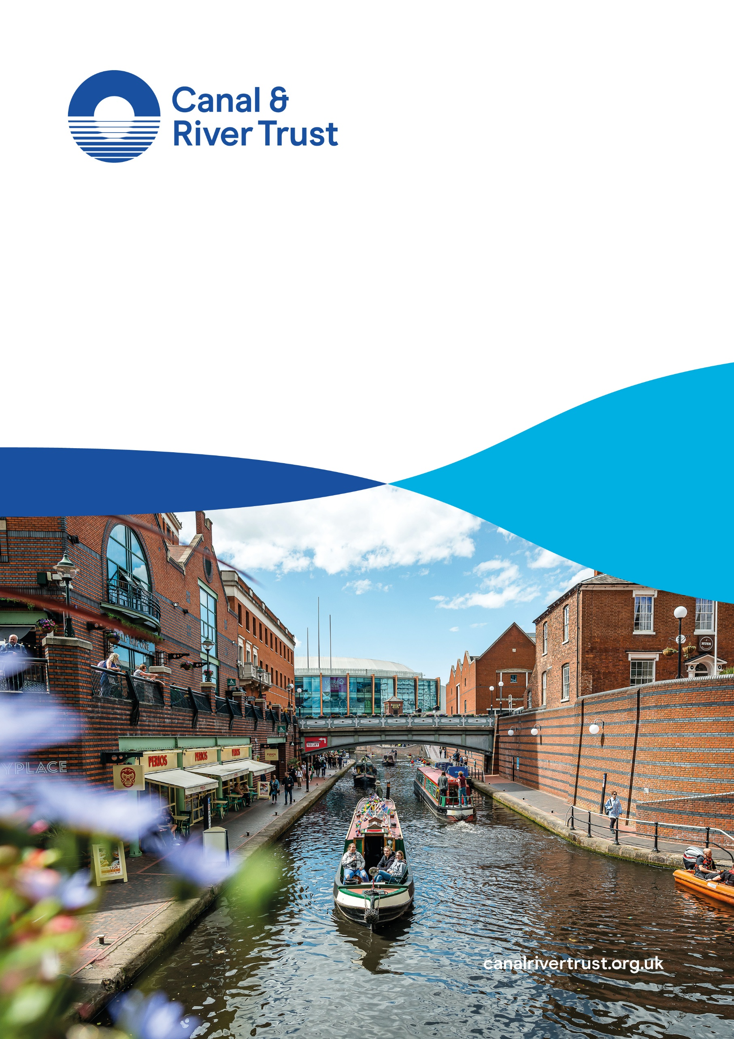
Economic Impact of the Canal Network
June 2026

Contents
Introduction 2
Methodology and Definitions 3
Key National Findings 5
Key Regional Findings 9
International Tourism on the Towpath 12
Appendix: Detailed Results Tables 14

Introduction
The Canal & River Trust is the charity responsible for the management and upkeep of approximately 2,000 miles of canals and towpaths, navigable rivers, docks, and reservoirs across England and Wales. The canal network includes 2,963 bridges, 1,575 locks, 276 aqueducts and thousands of miles of towpaths, which provide important spaces for leisure activities such as walking and cycling.
These assets generate economic value in several ways. First, their upkeep and maintenance involve significant expenditure, supporting economic activity among the individuals and businesses responsible. Second, they support a variety of wider economic activity, including boating activity and recreational activity along towpaths, with associated contributions to the economy. The Canal & River Trust’s waterways therefore function not only as public amenities but also as vital infrastructure that supports jobs, spending and economic activity across multiple channels.
The Canal & River Trust aims to capture the long-term social value delivered by its assets through a multidimensional approach. This report focuses on the economic contribution of the Canal & River Trust’s canal network, assessed through measures of Gross Value Added (GVA) and Full-Time Equivalent (FTE) employment, as well as the wider indirect and induced impacts generated by Canal & River Trust-linked activity in England and Wales in 2022.
This is not the first time that the Canal & River Trust has estimated the economic impact of its waterway network. The Valuing Our Waterways report highlighted that the Canal & River Trust’s waterways made a direct and indirect contribution to UK GVA of £1.5 billion in 2018/19. When updated to 2022 prices, this would be equivalent to £1.7 billion. However, these previous estimates were focused on the boating economy.
These new estimates include the economic impact of the domestic and international towpath visitor economy and construction and maintenance activity, in addition to the boating economy. The towpath visitor economy accounts for 57% of the GVA associated with the canal network and 35% of employment. Its inclusion therefore changes the overall picture of the analysis.
Across all three channels, the Canal & River Trust’s waterways directly contributed £5.1 billion in GVA and supported 150,400 FTE jobs in 2022. This contribution is comparable in scale to that of the event catering and food service activities sector. Although the waterways generated almost £2 billion less GVA than the travel agency activities sector, they supported around 115,000 more FTE jobs. This indicates that the economic activity associated with the waterways, particularly that linked to the boating economy, is labour-intensive, generating substantial employment relative to its GVA contribution. These comparisons show that, while the canal network is not an economic “sector”, the combined activities it supports represent a substantial source of economic value.
In terms of economic impact per canal mile across regions, London & South East and Wales & South West emerge as the most productive regions. This high productivity per canal mile is largely because these regions contain a relatively small share of Canal & River Trust-managed waterways mileage while still generating sizeable GVA and employment contributions. However, while London & South East accounts for a relatively high proportion of total waterway GVA, this is broadly in line with the overall scale of the regional economy. In contrast, regions such as the North West and West Midlands support a larger share of waterway-related GVA than would be expected based on their share of the UK economy. This indicates that waterways play a more economically significant role in these regions, reflecting their historic concentration of canal infrastructure and the way waterways are embedded in local visitor economies and patterns of everyday use.
For every £1 of GVA directly generated by activity along the Canal & River Trust’s canal network, a further £0.49 of GVA is supported in upstream supply chains. In addition, a further £0.81 of GVA is supported when employees linked to canal activity and its supply chains spend their earnings in the wider economy. This means that a total of £2.31 of GVA is supported for every £1 of GVA directly generated by activities along the Canal & River Trust’s canal network.
For every one FTE job directly supported by activity along the Canal & River Trust’s canal network, a further 0.23 FTE jobs are supported through indirect effects and 0.30 FTE jobs through induced effects. Consequently, each directly supported FTE job generates a total employment footprint of 1.53 FTE jobs across the wider economy. In relative terms, the indirect and induced effects are more pronounced in economic output than in employment.
To enable the inclusion of international visits to the towpath alongside domestic towpath visits, we adapted an innovative technique from the article Putting the periphery on the map: Tourism activity measured with big data by Borowiecki et al published in the peer-reviewed journal Tourism Economics in 2025. International towpath visits account for 10.5 million visits a year, mainly from the United States (22.5%), Australia (16.3%), Canada (7.7%), Spain (4.6%) and New Zealand (4.2%).
We would like to thank British Marine for providing the data on the boating economy. We would also like to thank the Centre for Economics and Business Research (Cebr) for their support in the production of this report.

Methodology and Definitions
The Canal & River Trust’s economic contribution can be summarised through three impact channels:
1) Construction and maintenance work undertaken by the Canal & River Trust to preserve canals and other waterways. This includes expenditure on maintaining and upgrading canal and canal network infrastructure, including towpaths, locks, bridges and dredging.
2) Domestic and international boating expenditure taking place on Canal & River Trust-managed waterways. Consistent with wider research conducted by British Marine, this is segmented into:
- Boating expenditure, referring to spending directly linked to boating activities, such as marina services, boat hire and related services.
- Wider boating expenditure, referring to broader spending by visitors, including hire-boat users, private boaters and passengers, who engage in boating activities on Canal & River Trust-managed waterways. This includes spending on accommodation, food and drink, on-land transport and associated services.
3) Towpath users of Canal & River Trust-managed waterways and their associated expenditure. This includes spending by individuals using Canal & River Trust towpaths for walking, running, cycling and other leisure activities, typically as part of recreational visits. It includes both domestic and international visits.
This report estimates the Gross Value Added (GVA) and Full-Time Equivalent (FTE) employment supported by activities on, or associated with, Canal & River Trust-managed waterways:
- GVA measures the value of output produced after subtracting the costs of generating that output. It reflects the contribution of a sector or activity to the overall economy.
- FTE employment is a standardised measure of employment that converts part-time and full-time jobs into a common unit. For example, two part-time jobs might equate to one FTE role.
This report also captures the wider indirect and induced economic impacts supported by Canal & River Trust-related activity. A further summary of these impact layers is presented in Figure 1 below.
Figure 1: Diagram illustrating total aggregate impact
(1) Direct impact
The value generated, and jobs supported directly by Canal & River Trust-managed waterways.
(2) Indirect impact
The value generated, and jobs supported in domestic industries that supply the sector.
(3) Induced impact
The value generated, and jobs supported in the wider economy when employees associated with direct & indirect impacts spend their earnings in the wider economy.

Aggregate Impact = Direct + Indirect + Induced Impacts

To estimate the economic contributions associated with indirect and induced effects, all direct-impact activity is mapped to Standard Industrial Classification (SIC) codes. These codes enable us to apply a bespoke input-output (I-O) model based on the UK’s national accounting framework, published by the Office for National Statistics (ONS). The model uses data on the supply-chain spending patterns of activities taking place on Canal & River Trust-managed waterways to trace how this demand flows through the wider economy, linking direct spending to the associated indirect and induced impacts. While the model draws on ONS input-output tables as a structural foundation, the aggregate results are produced through Cebr’s bespoke I-O model, tailored to reflect the nature and scale of Canal & River Trust-related activity. This approach ensures that the outputs show the distinctive economic structure and sectoral mix of the Canal & River Trust’s operations, rather than relying on standardised economy-wide multipliers.
The direct economic impact of the boating sector was estimated using the 2022–23 Economic Benefits of the Leisure, Superyacht & Small Commercial Marine Industry report produced by British Marine. This report includes a disaggregation between inland and coastal activity, allowing the analysis to isolate the economic contribution attributable to inland waterways and, more importantly, to identify the contribution of Canal & River Trust’s canal network.
The direct economic impact of towpath visitors was estimated using the Waterways Engagement Monitor survey and the Inland Waterways Visitor Survey. Together, these nationally representative surveys of adults living in England and Wales provide information on the number of visits to waterways, the activities undertaken in them and the associated spending.
To estimate international tourist visits to Canal & River Trust towpaths, we applied an innovative evidence-based approach adapted from previous work by Borowiecki et al. (2025), published in the peer-reviewed journal Tourism Economics. Publicly available information from TripAdvisor reviews was used to estimate the proportion of waterway visitors who are international, by identifying the country of residence of reviewers across Canal & River Trust waterways. These international visitor shares were then applied to established domestic visit counts from the Waterways Engagement Monitor, adjusted to reflect tourism-like visits.
Estimates of spending per international visitor, based on visit activity and the Inland Waterways Visitor Survey produced by the Canal & River Trust, were then applied to the total tourism estimates before being input into Cebr’s I-O model, as described above. This approach allows international tourism to waterways to be incorporated in a manner that is consistent with, and additive to, existing domestic visitor estimates, while remaining conservative by focusing only on spending directly attributable to waterway visits. British Marine data already capture international tourism associated with inland boating activities; this was therefore excluded from the activities international tourists can undertake, to avoid double-counting within the boating-sector economic impact estimates.
To validate the international tourism estimates, we compared them with the share of international tourism recorded through fieldwork at Pocklington Canal, Dundas Aqueduct, Pontcysyllte Aqueduct and Birmingham’s canals between June and October 2025. The results were very close to those obtained from the TripAdvisor reviews. Further data-quality validation was carried out by comparing the seasonal trends in TripAdvisor reviews, among both domestic and international reviewers, with the corresponding patterns for domestic tourists in the Great Britain Tourism Survey (GBTS) and international tourists in the International Passenger Survey (IPS).
Within this report, results are disaggregated to show national and regional patterns in the impact of Canal & River Trust-managed waterways. The Canal & River Trust operates within six self-defined regional boundaries, which we applied for regional reporting: London & South East, Yorkshire & North East, East Midlands, North West, West Midlands, and Wales & South West. Please see Map 1.

Map 1: Canal & River Trust canal network and regions

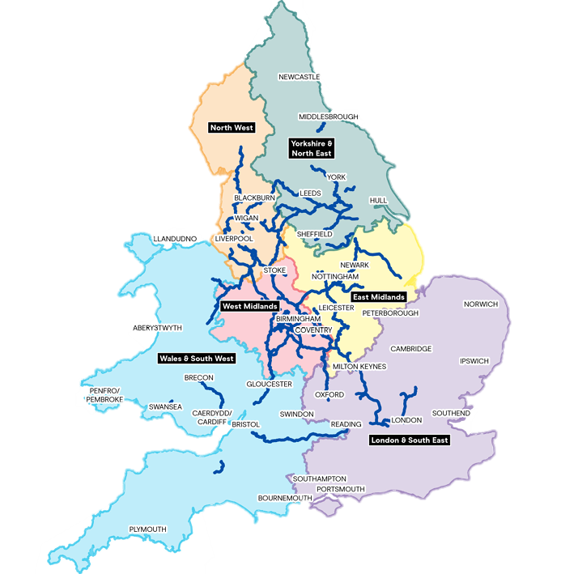

Key National Findings
In 2022, activities taking place on and alongside the Canal & River Trust’s waterways generated a total of £5.1 billion in direct Gross Value Added (GVA).
The largest share of this value (57%) is associated with towpath visitor activity, reflecting spending by people using the canal network for walking, cycling and other leisure activities. Please see Figure 2.
Boating-related activity accounts for a further 42% of direct GVA, the majority of which comes from wider visitor expenditure linked to boating, such as spending on accommodation, food and drink, and local transport, rather than from boating services alone.
The construction and maintenance of waterways contribute the smallest share of GVA, at less than 1%. This channel is based solely on the Canal & River Trust’s direct annual expenditure on infrastructure works. This distribution reflects the nature of activities taking place on Canal & River Trust-managed waterways. While the Canal & River Trust undertakes essential construction and maintenance work to preserve the canal network, these activities are relatively infrequent and concentrated in time and scope. By contrast, towpath and wider boating expenditure occurs continuously throughout the year and stimulates daily economic activity across a wide range of sectors, including food, accommodation, retail and transport.
While construction and maintenance contribute the smallest share of GVA, this does not imply a lack of economic importance. On the contrary, these activities are essential to ensuring that the canal network remains safe, accessible and attractive to visitors. Without this foundational work, the larger and more frequent boating- and towpath-related economic activity that generates the bulk of GVA would not be possible.

Figure 2: Breakdown of direct GVA by economic impact channel, 2022
Total:
£5.1bn
Total:
£5.1bn

In 2022, activities associated with the Canal & River Trust’s waterways directly supported approximately 150,400 FTE jobs across England and Wales.
While the employment supported broadly follows a similar pattern to GVA across impact channels, a key difference is that boating-related activity supports the majority of direct employment (around 65%). This is largely driven by labour-intensive services connected to wider boating tourism, including hospitality, retail and visitor services. Towpath visitor activity accounts for a further 35% of direct jobs, illustrating the importance of freely accessible, everyday recreation along canals and rivers in sustaining local employment. Please see Figure 3.

Figure 3: Breakdown of direct employment by economic impact channel, 2022
Total:
150,400 FTEs

To provide a sense of the relative economic contribution of the Canal & River Trust’s waterways to the UK economy, Figures 4 and 5 show that activity associated with Canal & River Trust-managed waterways makes an economic contribution comparable in scale to several established UK leisure- and tourism-related sectors, both in terms of value added and employment.
Waterways support a level of direct economic output similar to, or greater than, several recognised sectors within the visitor economy, including the operation of sports facilities and holiday accommodation sectors. Please see Figure 4.
This comparison highlights that, while waterways are not typically thought of as an economic “sector” in their own right, the combined activities they support represent a substantial source of economic value at the national level. The scale of direct GVA reflects the breadth of spending enabled by waterways, spanning everyday recreation, tourism, boating-related services and associated visitor expenditure.
In 2022, activities associated with Canal & River Trust-managed waterways supported around 150,000 direct jobs, placing waterways on a comparable footing with several other labour-intensive leisure and visitor-facing sectors. Please see Figure 5.
The relatively high level of employment supported reflects the service-based nature of much waterway-related activity, particularly hospitality, retail and visitor services linked to towpaths and boating. As with GVA, this underlines the role of waterways as widespread economic infrastructure supporting jobs across many local economies, rather than employment being concentrated within a single industry.

Figure 4: Comparison of direct GVA generated by Canal & River Trust-managed waterways and other sectors of comparable size or related to tourism, £ billion, 2022

Figure 5: Comparison of direct FTE employment supported by economic activity along Canal & River Trust-managed waterways and other sectors of comparable size or related to tourism, 2022

If we also consider the supply chains activated by economic activity on Canal & River Trust-managed waterways, together with employee spending supported by that activity, the direct economic activity translates into a total contribution of around £11.8 billion in GVA in 2022. While direct activity accounts for £5.1 billion of GVA, the additional impacts generated through supply chains and employee spending more than double the initial value. Please see Figure 6.
This reflects the way waterway-related activity is embedded across the economy, particularly through sectors such as hospitality, retail, construction and professional services. Spending enabled by waterways therefore supports economic activity well beyond the businesses and locations immediately adjacent to the network, extending its economic footprint nationally.
The indirect and induced effects on employment are relatively smaller, as shown in Figure 7. Canal & River Trust-managed waterways support around 231,000 full-time equivalent jobs in total, compared with approximately 150,000 jobs supported directly by activity taking place on and around waterways.
The scale of the total employment impact highlights the role of waterways as an enabling form of economic infrastructure. By supporting visitor activity and related services, waterways help sustain jobs across a wide range of sectors and regions, including many roles that are not directly linked to the operation or maintenance of the waterway network itself.
Figure 6: Aggregate GVA contribution
Total contribution = ❶+❷+❸ = £11.8bn
❶ DIRECT
£5.1bn
❷ INDIRECT
£2.5bn (0.49X)
❸ INDUCED
£4.2bn
(0.81X)
GVA

Figure 7: Aggregate employment contribution
Total contribution = ❶+❷+❸ = 230,600 FTE workers
❶ DIRECT
150,400
❷ INDIRECT
34,800
(0.23X)
❸ INDUCED
45,400
(0.30X)
Employment (FTE)

Key Regional Findings
The Canal & River Trust’s waterway network is not evenly distributed, with the West Midlands and North West accounting for the largest shares of total mileage, reflecting their historic role at the centre of the canal system. Other regions, including London & South East and Wales & South West, have a smaller share of overall canal length. This variation in physical scale provides important context for interpreting the figures that follow, as regions with more extensive networks would be expected to support higher levels of activity simply because of their size, all else being equal. Please see Figure 8.
While there is a broad relationship between network length and economic contribution, Figure 9 shows clear differences in the value generated by each region relative to canal mileage. London & South East stand out as supporting a comparatively high share of direct GVA despite accounting for a relatively limited share of the network. This reflects more intensive use of waterways, higher visitor spending and the concentration of economic activity in densely populated urban areas. In contrast, regions such as the West Midlands and North West generate direct impacts that are more closely aligned with their share of canal length, consistent with waterways supporting everyday recreation and tourism across a wider geography.
As with GVA, employment impacts are distributed unevenly across regions, reflecting differences in visitor intensity and the labour-intensive nature of local service economies. Please see Figure 10. Regions with strong urban visitor economies, including London & South East, support a higher share of employment relative to their network size.
Figure 8: Regional breakdown of Canal & River Trust-managed waterway mileage, % of total length of managed waterways

Figure 9: Breakdown of direct GVA by region, 2022
Total:
£5.1bn

Figure 10: Breakdown of direct employment by region, 2022
Total:
150,400 FTEs

From a regional perspective, while London & South East accounts for a relatively high proportion of total waterway GVA, this is broadly in line with the overall scale of their regional economy. As a result, waterways make a smaller contribution relative to the size of the economy in these regions, despite high absolute levels of activity and spending.
In contrast, regions such as the North West and West Midlands support a larger share of waterway-related GVA than would be expected based on their share of the UK economy. This indicates that waterways play a more economically significant role in these regions, reflecting their historic concentration of canal infrastructure and the way waterways are embedded in local visitor economies and patterns of everyday use. Please see Figure 11.
Figure 11: Regional comparison of direct waterway GVA relative to regional economic size

The distribution of aggregate GVA broadly mirrors the pattern of direct impacts set out earlier, with larger regional economies accounting for a greater share of the total contribution. Please see Table 1.
The aggregate figures illustrate how the wider economic effects of waterway activity are retained within regions, depending on the size and structure of local economies. Regions with larger and more diversified economic bases capture a greater absolute level of aggregate GVA, reflecting the extent to which spending associated with waterways is absorbed within regional supply chains and household expenditure.
As shown in Table 1, aggregate GVA totals across regions do not sum to the national total reported earlier. This is because Table 1 includes only impacts that occur within each region; wider supply-chain and spending effects that fall outside the region, but remain within the UK, are not included in the regional breakdown.
In employment terms, the regional distribution of aggregate employment is similar to that observed for aggregate GVA, with regions that support higher levels of economic activity overall also supporting a larger number of jobs linked to waterway activity. Please see Table 2.
The figures highlight the role of Canal & River Trust-managed waterways in supporting employment across regional economies, particularly through sectors such as hospitality, retail and visitor services. These impacts extend beyond employment directly associated with waterways themselves and reflect the wider economic activity supported through supply chains and household spending.
As with aggregate GVA, aggregate employment totals shown in Table 2 do not add up to the national employment figures presented earlier, as only employment supported within each region is included.
Table 1: Regional breakdown of direct and aggregate GVA, (£ million)
Canal & River Trust region | Direct GVA (£m) | Share of total | Aggregate GVA (£m) | Share of total
London & South East | 1,444 | 28% | 2,911 | 30%
West Midlands | 837 | 16% | 1,296 | 13%
North West | 804 | 16% | 1,521 | 16%
Wales & South West | 676 | 13% | 1,375 | 14%
East Midlands | 686 | 13% | 1,396 | 14%
Yorkshire & North East | 687 | 13% | 1,306 | 13%

Table 2: Regional breakdown of direct and aggregate employment (FTEs)
Canal & River Trust region | Direct FTE | Share of total | Aggregate FTE | Share of total
London & South East | 49,000 | 33% | 69,500 | 33%
West Midlands | 20,800 | 14% | 25,700 | 12%
North West | 20,500 | 14% | 28,100 | 14%
Wales & South West | 23,300 | 16% | 33,200 | 16%
East Midlands | 18,000 | 12% | 25,900 | 12%
Yorkshire & North East | 18,700 | 12% | 25,600 | 12%

International Tourism on the Towpath
International visitors make a meaningful contribution to towpath use across the network. In 2022, they made an estimated 10.5 million visits to Canal & River Trust-managed waterways in England and Wales.
These visits originate from a wide range of countries. Visitors from the United States represent the largest group (22.5%), followed by Australia (16.3%), Canada (7.7%), Spain (4.6%) and New Zealand (4.2%), reflecting the global appeal of the UK’s canal network and its role as part of wider tourism itineraries.
The regional pattern reflects broader tourism dynamics. London & South East accounts for the largest number of international visits (around 4.9 million) and also has the highest ratio of international to domestic visitors, indicating the importance of waterways in areas with high concentrations of international tourism (see Table 3).
Other regions also support substantial numbers of international visits, including the West Midlands (around 2.1 million) and the North West (around 1.7 million). In these regions, international visitors form a smaller share of total tourism activity, but still represent a consistent component of overall use.
Taken together, the figures show that international use of towpaths is spread across the network but is most concentrated in regions that are already prominent destinations for inbound visitors, while remaining present as part of the broader visitor mix in all regions.

Table 3: Domestic tourism-like visits, international-to-domestic ratio, and international visits by region
Canal & River Trust region | Domestic tourism visits, million | International-to- domestic ratio | International visits, million
London & South East | 13.0 | 38% | 4.9
North West | 13.7 | 13% | 1.7
West Midlands | 13.9 | 15% | 2.1
East Midlands | 11.0 | 6% | 0.6
Wales & South West | 5.5 | 13% | 0.7
Yorkshire & North East | 10.4 | 5% | 0.5
Total | 67.4 | 16% | 10.5

Appendix: Detailed Results Tables
Table 4: Total direct economic contributions of visits to Canal & River Trust network by impact channel, 2022
Impact source | Expenditure (£m) | % of total | GVA (£m) | % of total | FTEs | % of total
Towpath visitor activity | 9,423 | 64% | 2,945 | 57% | 52,700 | 35%
Of which:
International towpath visitor activity | 124 | <1% | 38 | <1% | 700 | <1%
Domestic towpath visitor activity | 9,299 | 63% | 2,907 | 57% | 52,000 | 35%
Boating activity | 5,220 | 35% | 2,152 | 42% | 97,500 | 65%
Of which:
Direct boating expenditure | 1,034 | 7% | 380 | 7% | 9,600 | 6%
Wider boating expenditure | 4,186 | 28% | 1,772 | 35% | 87,900 | 58%
Waterway construction and maintenance | 101 | <1% | 37 | <1% | 300 | <1%
Total | 14,745 | 100% | 5,134 | 100% | 150,400 | 100%

Table 5: Aggregate economic contribution of Canal & River Trust network by economic activity measure, 2022
Economic activity measure | Direct | Indirect | Induced | Aggregate
Expenditure (£m) | 14,745 | 9,872 | 13,197 | 37,815
GVA (£m) | 5,134 | 2,536 | 4,159 | 11,830
FTEs | 150,400 | 34,800 | 45,400 | 230,600

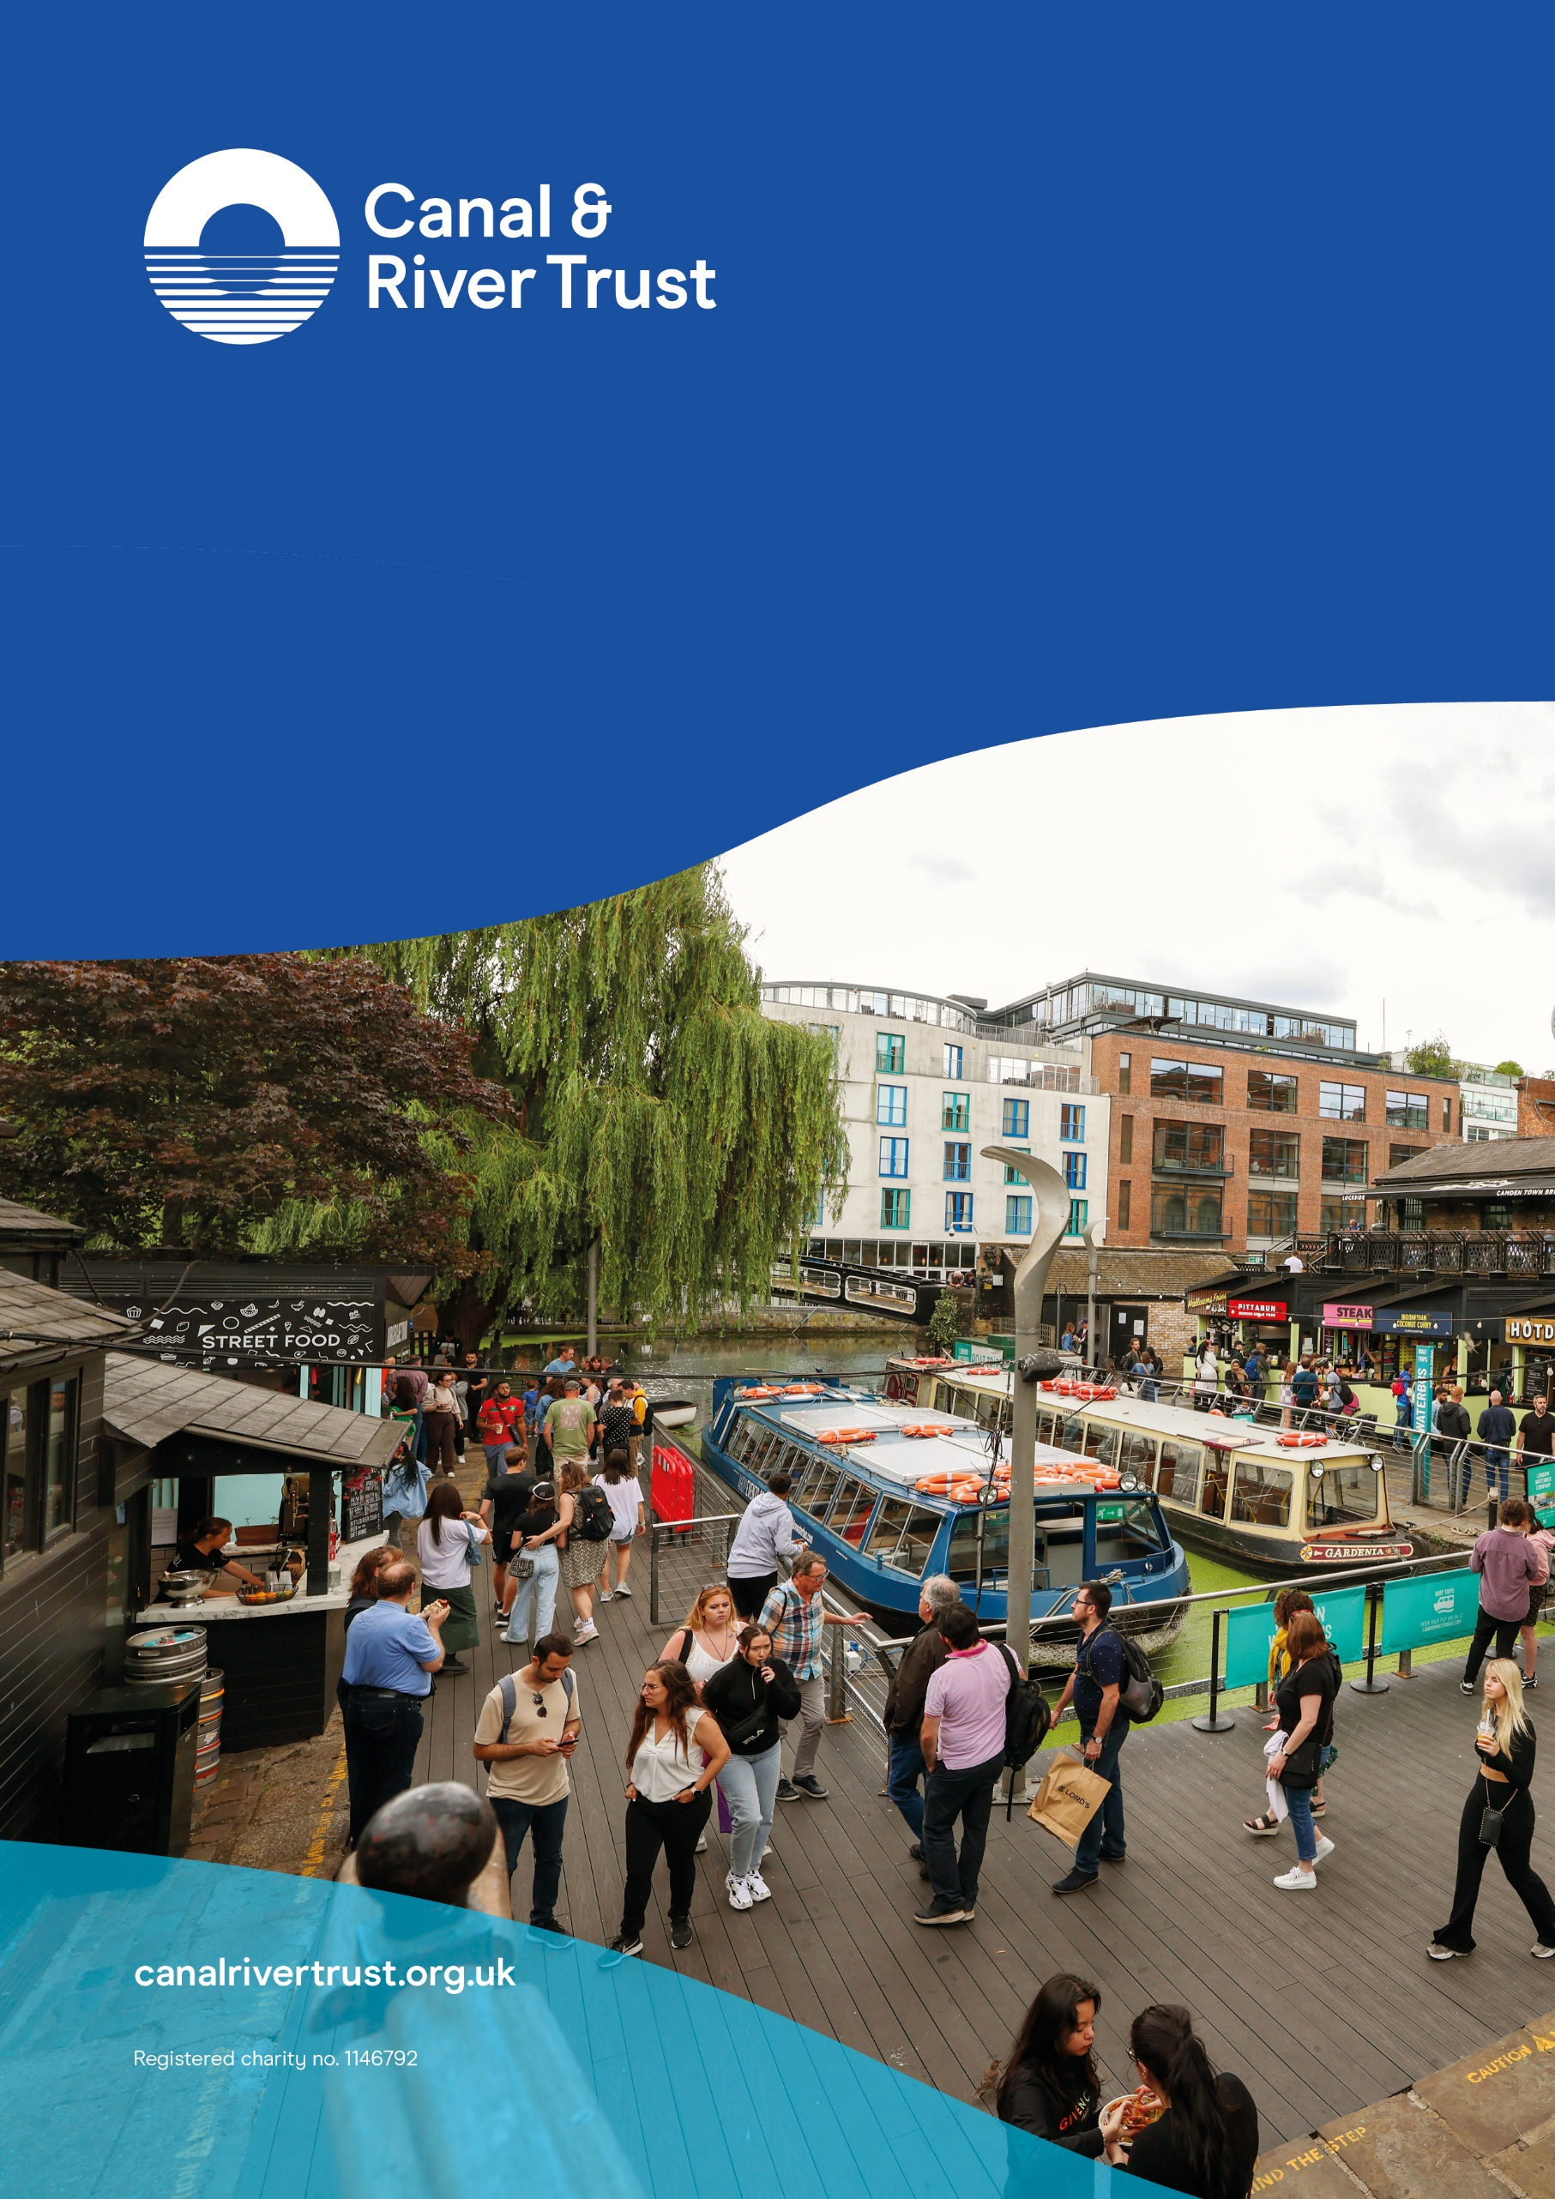
For any queries, please contact Brenda Dorpalen (Insights and Economics Team Manager) at
Brenda.Dorpalen@canalrivertrust.org.uk

