MEDIA GUIDE - Volunteer Partner GroupS
The following Guide is to help you showcase the work you’re doing as part of your partnership with the Canal & River Trust. By promoting your efforts, and how we’re working together to make the canals better, we can encourage more people to take an interest in the waterways and support the work of the Canal & River Trust. Publicity will help to highlight the great work you are doing and tell the story of how the Trust needs groups like yours to make every mile matter.

Please keep your main contact at the Trust informed of any media activity or press releases you plan to send out, and remember that your local Trust press officer is here to offer support and advice.

Finding your story

The first thing to do before approaching a journalist with a story is to decide what you think the most newsworthy thing about it is and whether it would be something you would enjoy reading about in the news.

- People are usually interested to read about anything new – whether it’s a new project, a new way of working or a first for the waterway you’re working on
- Think about what’s most impressive about your project and whether you can put it into numbers – whether you’ve collected 20 bags of rubbish or clocked up 200 volunteer hours or completed a significant project
- Have you come across anything unusual on the canal? Whether it’s an odd bit of rubbish or a great wildlife spot it could be a good story – as long as you’ve got a photo
- Have you got an appeal for the local community – whether it’s to join in with your event or to donate money to help the Trust look after the canal?

Your story has to pass the journalists’ ‘so what’ test i.e. why would their readers be interested in what you’re telling them.

Identify your target media

Whether you’d like to be featured in the local paper or on Countryfile, bear in mind that different outlets will look for different things. Have a look at the content in the media you’d like to be featured in and double check that the story you’ve got fits. In general, local and regional media will be looking for stories that involve local people, so local papers and radio stations will often be your first port of call. Newspapers will often want photos, radio stations will want to speak to a spokesperson, so make sure you’ve got both ready to go.

Writing your press release

Sending out a press release is the easiest way to get your story out to journalists – they’re designed to contain all of the information needed to write a news story. A basic structure to work from is below.
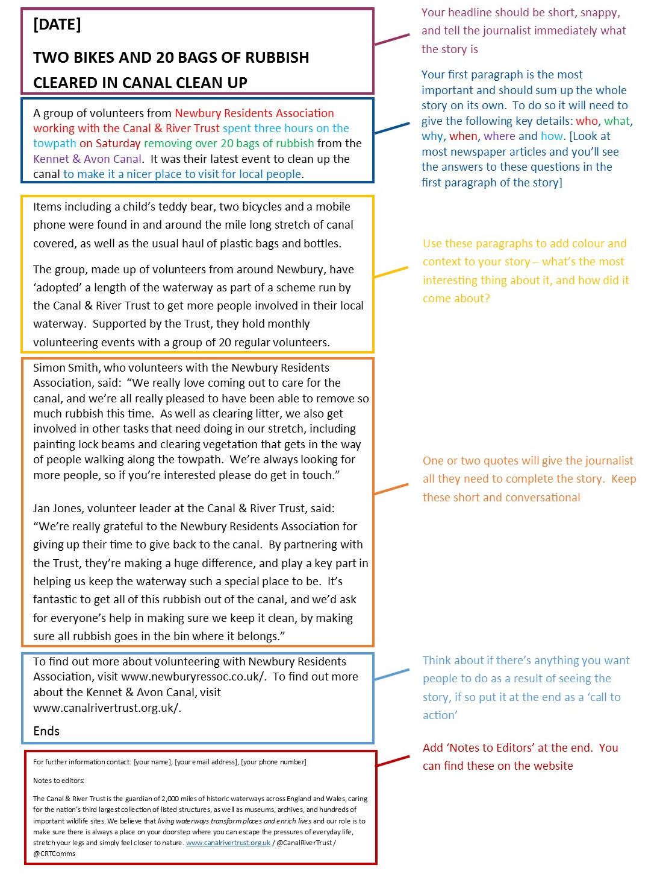
Tips for writing press releases:

- Keep things short – journalists won’t read long releases and are only interested in key details. Choose your most ‘newsworthy’ angle and cut out anything not relevant
- Avoid using too many adjectives outside the quotes, most news stories aim to sound objective
- Use your quotes to add personality to the release, and include any details that won’t fit in the body of the text

Think about your photo

Whether it’s of your volunteer group, what you’ve found on the canal, or anything else, you can double your chances of getting your release in the press by sending it with a good photo.

Make sure the photo is good enough quality to be printed, but won’t break everyone’s inboxes – files around 1MB are about right. If you want to send more than one, save smaller versions and say you have higher res photos available.

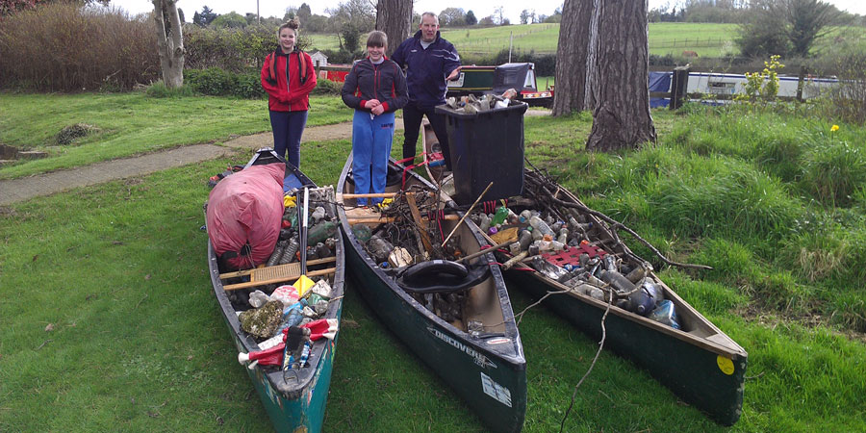
Think creatively about what will make the best picture, bearing in mind local media like to feature local people, and they’ll be looking for things people might not have seen before. Don’t be afraid to take a few different angles so you can choose the best one. Pictures of people looking at the floor or the backs of peoples’ heads are unlikely to make it into the paper!

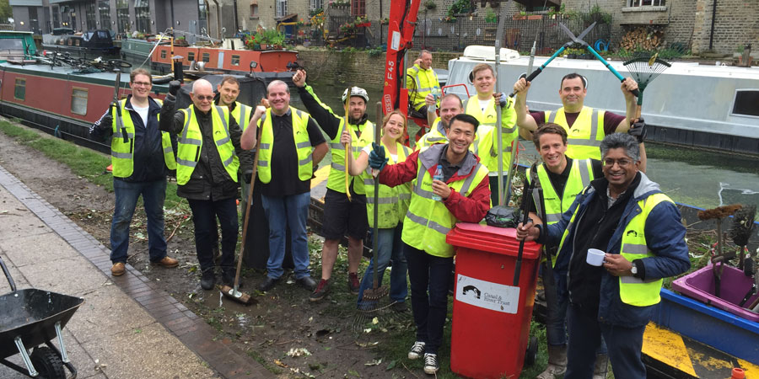
Double check everyone in the photo is happy for you to send it to the media, and if children are featured, you’ll need signed permission from their parents. Include a caption, especially if the photo features any VIPs.

Ensure that anyone pictured has the right safety equipment – for example, lifejackets should be worn if working on the water. Any queries on this, speak to your main contact at the Trust

Do your ‘sell-in’

You’ve got the best chance of getting your story in the newspaper if you speak to a journalist about it. Have a look online for a journalist that covers the area you’re working in, or call the general news desk number. You won’t have long to explain your story, so make the time count! Tell the journalist the most newsworthy thing about it as soon as you get them on the line, and have an email with your press release ready to send to them.

Make it accessible

Think about putting your press release up online, and make sure you share it with your main contact at the Trust, who should be able to promote it through our regional social media channels.

Help and support

If you’ve got any questions, you can always ask your local Trust press officer for support and advice. Your Trust contact will be able to tell you who they are and how to contact them.

